Section 3.1 Extra Practice

1. Identify the hypotenuse, opposite side, and adjacent side associated with each indicated angle.

a)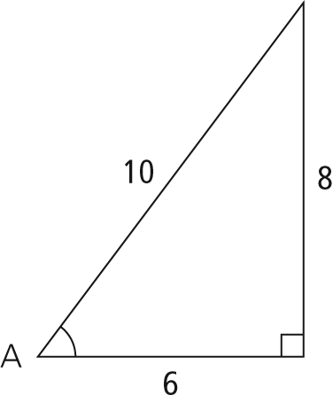 | b)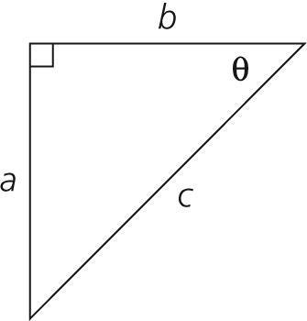
2. Determine each tangent ratio, to four decimal places.
a) tan 30° b) tan 12°
c) tan 48° d) tan 80°
3. Determine the measure of each angle, to the nearest degree.
a) b)
c) d)
4. Draw and label a right triangle to show each tangent ratio. Then, determine the measure of each angle, to the nearest degree.
a) b)

5. Determine the measurement of the indicated side. Express your answer to the nearest tenth of a centimetre.

a)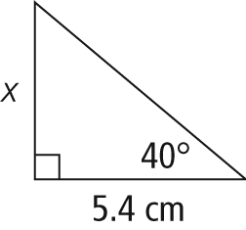 | b)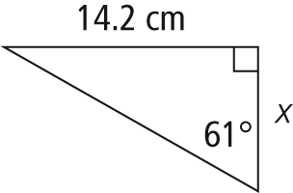
6. Determine the value of each variable, to the nearest degree.

a)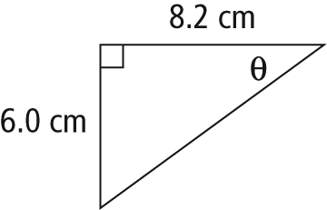 | b)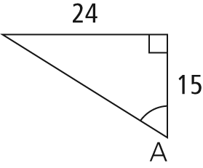
7. Mary wishes to determine the height of the tree in her yard. She measures the angle of elevation to the top of the tree to be 25° at a point 20 m from the base of the tree. How tall is the tree, to the nearest tenth of a metre?
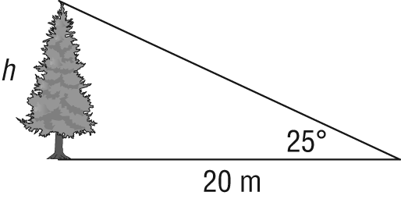
8. Matt is 1.65 m tall and his shadow is 1.43 m long. Determine the angle of elevation of the sun, to the nearest degree.
