Section 3.2 Extra Practice

1. Write each ratio in lowest terms.

a) sin A | 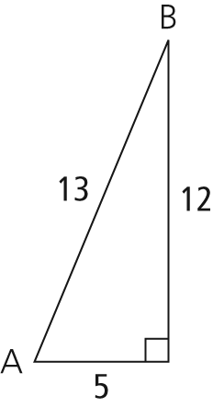
b) cos A
c) sin B
d) cos B

2. Evaluate each trigonometric ratio, to four decimal places.
a) sin 35° b) cos 12°
c) sin 78° d) cos 85°
3. Determine the measure of each angle, to the nearest degree.
a) b)
c) d)
4. Determine each length of x. Express your answer to one decimal place.

a) 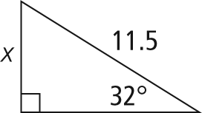
b) 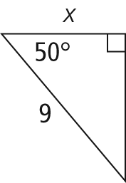
c) 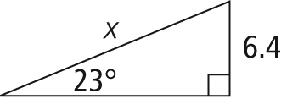
d) 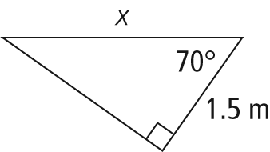
5. Determine the measure of each indicated angle. Express your answer to the nearest degree.

a) 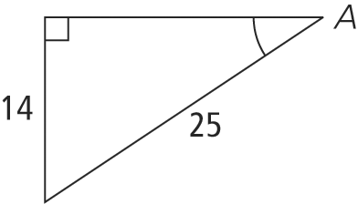 | b) 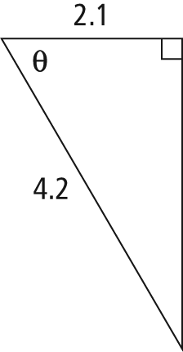
c) 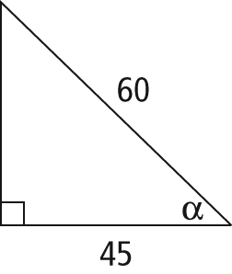 | d) 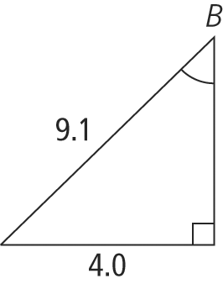
6. If the kite string in the figure is 120 m long, calculate the height of the kite. Express your answer to the nearest tenth of a metre.
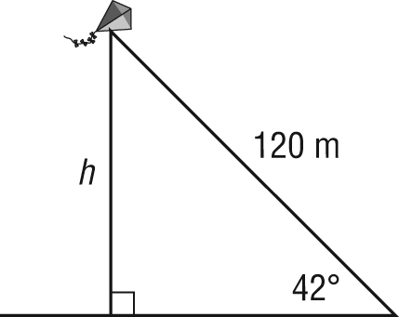
7. Bill is renovating his house. He braces a wall with an 8-ft wall brace, as shown. The distance from the wall to the lower end of the brace (on the floor) is 2.4 ft. Calculate the angle at which the brace meets the wall. Express your answer to the nearest degree.
