Section 3.3 Extra Practice

1. Solve each triangle. Express your answer to one decimal place.
a) 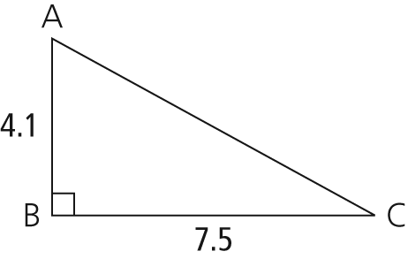
b) 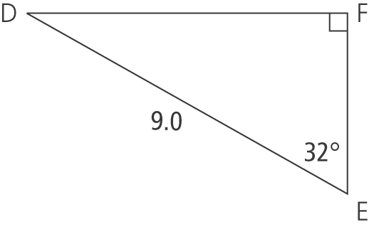
c) 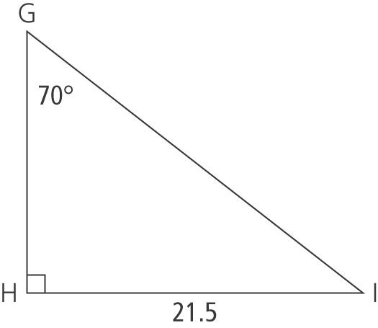
d) 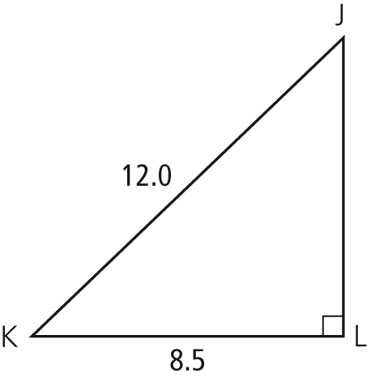
2. a) In and Determine the measure of , to the nearest degree.
b) In , and Determine the measure of to the nearest tenth of a centimetre.

3. A peregrine falcon has built a nest on a ledge of a building in Calgary, AB. The ledge is
34 m from the ground. Alain wants to take a photograph of the bird with his telephoto lens. He has set his camera up, waiting for the bird to return to the nest. His camera, sitting on a tripod, is 2 m from the ground. The angle of depression from the nest to Alain's camera
is
a) How far is the tripod and camera from the building, to the nearest tenth of a metre?
b) At what angle does Alain have to set the tripod to take a picture of the nest? Express your answer to the nearest degree.
c) If Alain’s lens can focus on objects up to 75 m away, can he focus on the falcon’s nest? Justify your answer.
(Hint: Remember to take the height of the tripod into account.)

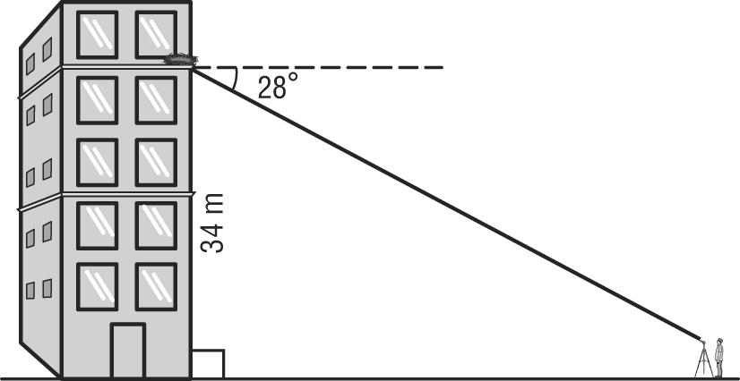

4. Calculate the measure of to the nearest degree.
