Chapter 3 Test

Multiple Choice
For #1 to 4, select the best answer.
1. Angelina was sketching a replica of the flag of the Jeux de la francophonie, as shown. Which statement regarding the measurements on the picture is false?
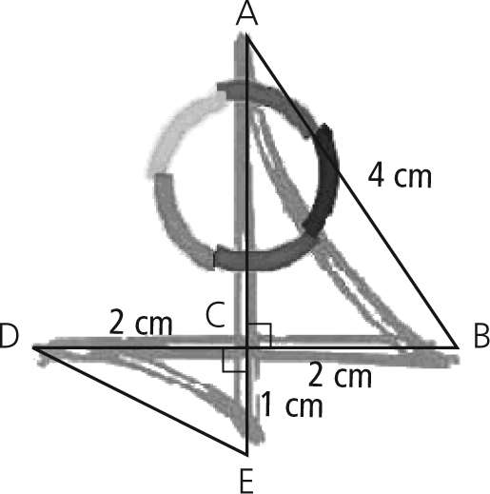
A = 30°
B
C
D
2. A teacher was preparing her students for the Cayley Contest of the Canadian Mathematics Competition. Students were asked to determine the length of using the information in the given diagram. If each student were to complete their partial solution without making an error, which student’s partial solution would not lead to a correct solution?
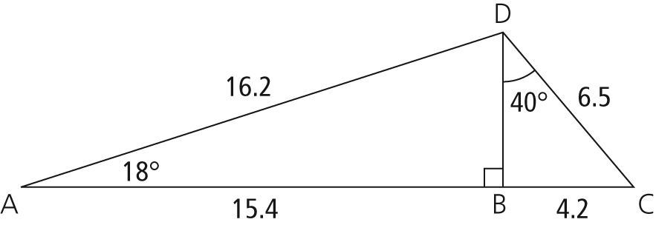
A Joel
B Kevin
C Elise
D Marielle

3. What is the length of side y in the following diagram, to the nearest tenth of a centimetre?
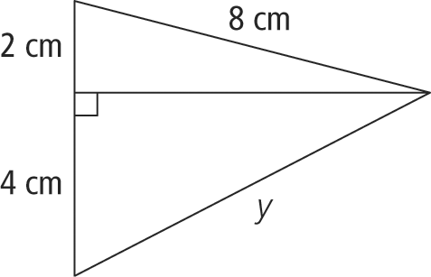
A 7.7 cm B 8.7 cm
C 9.1 cm D 16.0 cm
4. An auger is used to move grain from a combine to a truck that will transport the grain to a bin for storage. The angle of elevation of the auger is 25° and the spout makes a right angle with the falling grain. If the top of the spout of the auger is 78 in. above the truck box, what is the length of the auger, to the nearest inch?
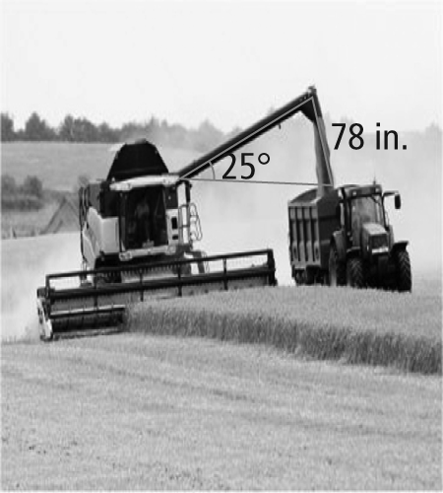
A 36 in. B 185 in.
C 167 in. D 71 in.

Short Answer
5. Determine the value of each ratio, to four decimal places.
a) sin 53°
b) cos 28°
c) tan 30°
6. Determine the measure of each acute angle, to the nearest degree.
a) tan θ = 0.7
b) sin α = 0.3746
c) cos β =
7. Ron was solving a right triangle when he determined that. What is the value of?
8. Determine the measure of ∠θ, to the nearest tenth of a degree.
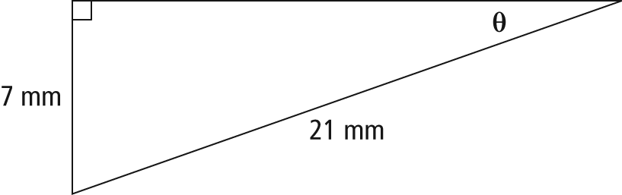
9. Determine the measure of ∠β, to the nearest degree.
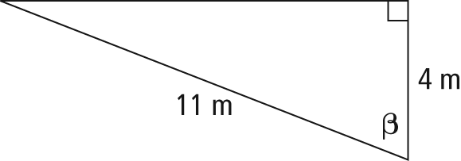
10. Daniel’s math class went on a field trip to Métis Crossing, AB. At the park gates, a Canadian flag is raised on a flagpole. Daniel stands directly under the flagpole and walks 10 ft away. He then turns around and uses the clinometer he brought with him to determine the angle of elevation to the top of the flagpole to be 58°. If Daniel’s eyes are 6 ft from the ground, what is the height of the top of the flagpole, to the nearest foot?
11. Determine the missing measurements in the right triangle. Express side lengths to the nearest tenth of a centimetre and angles to the nearest degree.
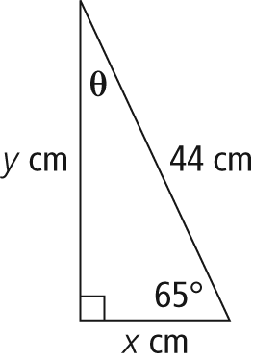
Extended Response
12. The Saskatoon Balloon Festival is organized by Sundance Balloons and the Canada Remembers Airshow. In Kinsmen Park, Wayne has tethered his balloon to the ground at points B, C, and D, using three guy wires, as shown.
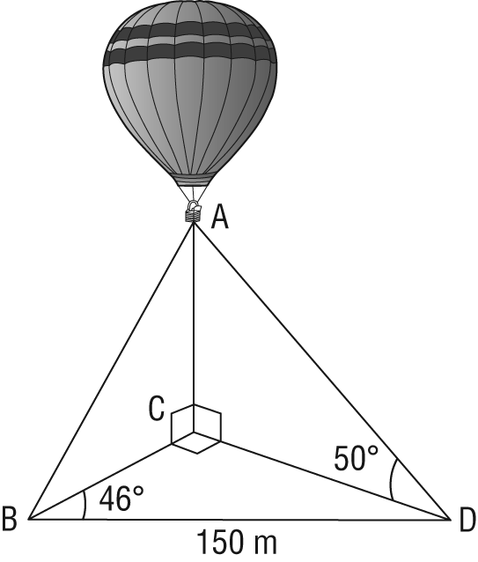
a) Write an equation involving a trigonometric function that could be used to calculate the length of CD.
b) What is the length of CD, to the nearest tenth of a metre?
c) What is the height of the hot air balloon, to the nearest tenth of a metre?
13. Nicole is standing in the field in front of First Nations University of Canada in Regina, SK. The angle of elevation from where she stands to the top of the right side of the building is 40°. The angle of elevation to the top of the left side of the building is 68°. Nicole thinks the four-storey building is 12.6 m tall.
a) Is Nicole standing closer to the left side or the right side of the building? Justify your answer.
b) Determine the difference in the distance that Nicole is standing from the two sides of the building.

