Chapter 4 Prerequisite Skills

Show all your work.
1. What are the prime factors of each number?
a) 54
b) 864
c) 7203
d) 900
2. Write each expression as a power.
a) (6)(6)(6)(6)
b) (–4)(–4)(–4)(–4)(–4)
3. The area of a square on grid paper is 49 units. Draw the square and label its area and side length.
4. A cube has an edge length of 5 cm. What is its volume
a) in repeated multiplication form?
b) in exponential form?
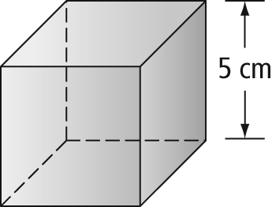
5. Write each expression as a single power.
a) (−3)²(−3)⁵
b)
c)
d) (4)³ (8)²
e)

6. Evaluate each expression.
a) 8³
b) (3⁴)(2⁵)
c)
d)
7. The stopping distance, d, in metres, for a car is given by the formula d = 0.008s², where s is the speed of the car, in kilometres per hour.
a) What is the stopping distance if the car is travelling at 105 km/h when it starts to brake?
b) What is the speed of the car if it takes
51.2 m to come to a stop?
8. The formula for the volume of a sphere is where V is the volume and r is the radius of the sphere. What is the volume of a sphere with a radius of 4 cm? Give the answer to the nearest cubic centimetre.
