Chapter 4 Unit 2 Project
Section 4.1
1. The mural shown below was originally created to celebrate Alberta’s Centennial in 2005. It was installed at the Centre d’arts visuels de l’Alberta in Edmonton, AB. The mural symbolizes the unity of the francophone communities throughout Alberta.
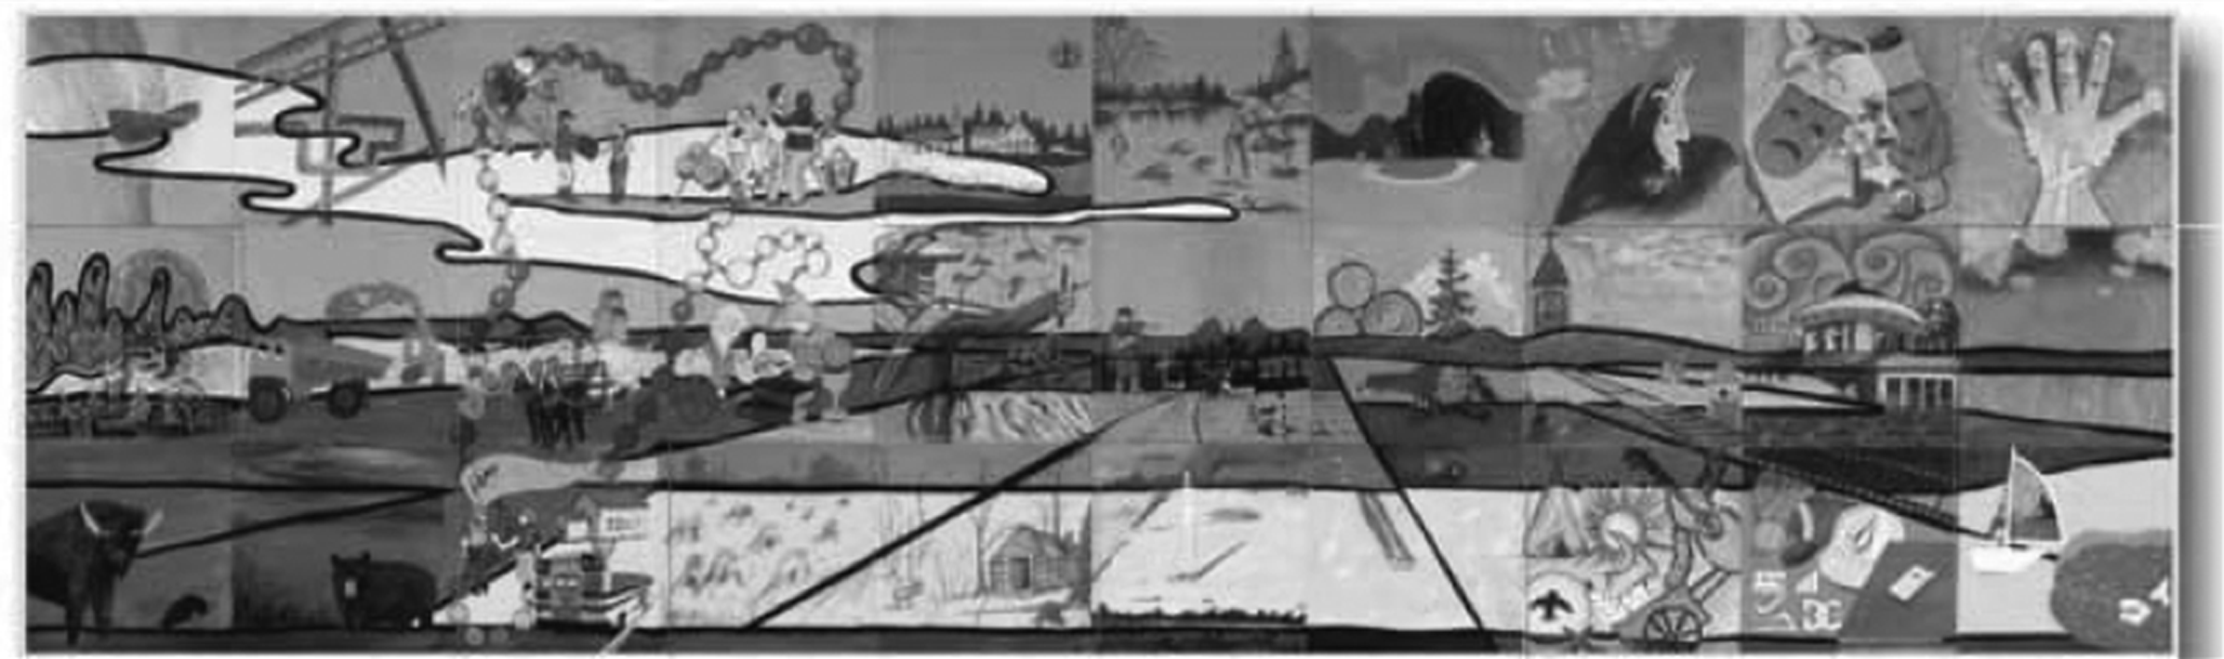
Les régions se racontent (The regions tell their story)
Your art class decides to create a mural mosaic. Your mosaic will highlight the regions of the province or territory where you live.
a) The class mosaic will be composed of 15-cm by 15-cm squares. How many squares will be needed to create a mural that covers an area of 2.7 m²?
b) Design a mural to show a geometric representation of square roots.
c) How is the mural a geometric representation of square roots?
2. The cubic sculpture shown here is made of steel with copper leaf. It was created by Tony Bloom, an artist from Canmore, AB.  a) If it has a volume of 4913 in.³, what is the length of one edge of the cube?  b) Explain how the sculpture is a geometric representation of a cube root. | 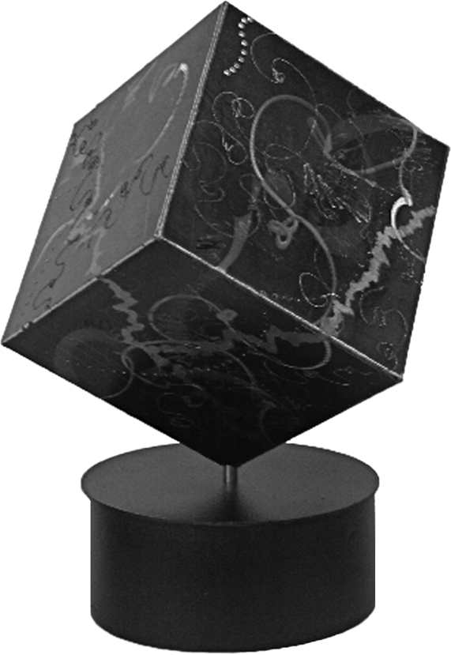
Section 4.4
3. Draw a square on a blank sheet of paper. Label the vertices of the square ABCD. Measure and record the side length of the square.
4. Complete the following steps.  • Mark the midpoint of side BC as E.  • Extend line BC so that it is about double in length.  • Use compasses to draw an arc with radius DE so  that it intersects line BC at point F. |  | 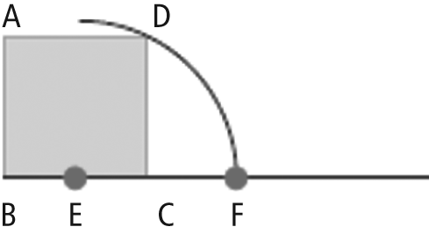
 | 5. Complete the golden rectangle by drawing DG and FG. |  | 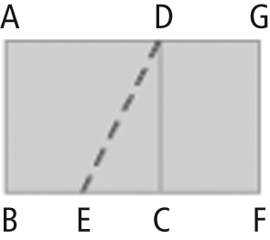
6. a) Calculate the length of DE to four decimal places.
b) Measure the length of DE. How does the actual measurement compare to your calculated value?
c) Calculate the length of BF to four decimal places. Hint: DE is the same length as EF.
d) Measure the length of BF. How does the actual measurement compare to your calculated value?
7. a) The ratio of the length to the width in a golden rectangle is called the golden ratio. Write an exact expression for the golden ratio.
b) What is the approximate value of the golden ratio, to two decimal places?
c) In the painting on page 184 in the student resource, describe the golden rectangles you see. Discuss your ideas with a classmate.
8. a) Look for three rectangular shapes in the classroom that you think may be in the golden ratio. Use a table to organize your findings.
• Measure the length and width of each shape.
• Calculate the ratios of the sides as you did for the rectangle you drew.
b) How do the ratios compare? How close were the rectangles you chose to golden rectangles?
c) Compare your results with those of a classmate.
9. Christina is a weaver in Pangnirtung, NU. The dimensions of the tapestry that she is working on represent the golden ratio.
a) If the longer dimension of the tapestry is 60 cm, what is the shorter dimension? Give the answer to the nearest hundredth of a centimetre.
b) What is the total area of the tapestry?
10. Many aspects of nature, such as the spiral patterns of leaves and seeds, can be described using the Fibonacci sequence. The sequence is 1, 1, 2, 3, 5, 8, 13, … . The expression for the nth term of the Fibonacci sequence is called Binet’s formula. The formula is Use Binet’s formula to find .
11. Use what you have learned about radicals to analyse the golden ratio. Use the following methods as a guide.
• Make a timeline about the history of the golden ratio.
• Explain the exact relationship between the dimensions of the golden rectangle and the golden ratio.
• Use a visual to help describe one other example of the golden ratio.

