Chapter 5 Warm-Up

Section 5.1 Warm-Up
1. Evaluate each expression for x = 2 and
y = –3.
a) (x + y)(x – y)
b) x² + 5xy – 7y²
2. For each expression, multiply the monomial by the polynomial.
a) 3x(x – y + 5)
b) –2y(5y – 8)
3. Simplify each expression.
a) (x² – 5x + 9) + (x² + 10x – 12)
b) (5x² + 7xy – 4) – (8x² – xy + 3)

4. a) A ruler is 26 cm in length. A piece x cm in length breaks off. Write an expression for the length that is left.
b) The radius of a circle is y cm. What is an expression for the diameter of the circle?
5. Write an expression to represent the area of the figure.
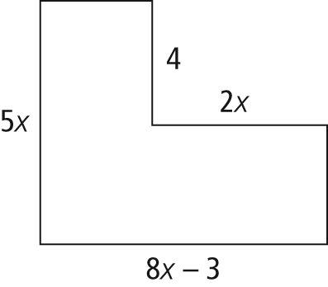

Section 5.2 Warm-Up

1. Write each number as a product of prime numbers.
a) 72
b) 100
2. List all the factors of each number.
a) 72
b) 100
3. List the first five multiples of each number.
a) 72
b) 100
4. a) List all the factors of 24.
b) List all the factors of 40.
c) What is the greatest common factor of 24 and 40?
5. Expand.
a) (3x – 2)(x – 5)
b) 6x(x² + 6x – 11)

Section 5.3 Warm-Up
1. Expand.
a) (3x – 5)(x + 4)
b) (x + 4y)(2x – 5y)
2. Factor out the greatest common factor.
a) 3x² + 9x
b) 8xy – 6y²
3. Factor by grouping.
a) x(x – 5) + 2(x – 5)
b) 2x(x + 2y) + 5y(x + 2y)
4. Write all the pairs of integers that multiply to
a) 12
b) 7
c) –7
5. a) Write all the pairs of integers that multiply to –6.
b) Which pair in part a) adds to 1?
c) Which pair adds to –5?

Section 5.4 Warm-Up

1. Expand each expression.
a) (x – 5)(x + 5)
b) (x + 4)(x – 4)
2. Multiply.
a) (x + 5)(x + 5)
b) (x – 4)(x – 4)
3. Multiply.
a) (2x + 3)(2x – 3)
b) (6x – 7)(6x + 7)

4. Expand each expression.
a) (2x + 3)²
b) (6x – 7)²
5. a) What does it mean to factor x² + 6x + 9?
b) Factor x² + 6x + 9.
c) Explain how you could check your answer.

