Chapter 5 Unit 2 Project
Section 5.1
1. Sketch an area model or an algebraic model to represent each multiplication. Use specific polynomials for each multiplication. Label your diagrams. Then, write the result of each multiplication as an equation.
a) (monomial)(binomial) b) (binomial)(binomial) c) (binomial)(trinomial)

2. Use an arrangement of algebra tiles to show combining like terms of polynomials. Arrange them artistically. Use the style of Piet Mondrian’s paintings, shown here and on page 204 in the student resource. Write the corresponding algebraic equation that summarizes your result.
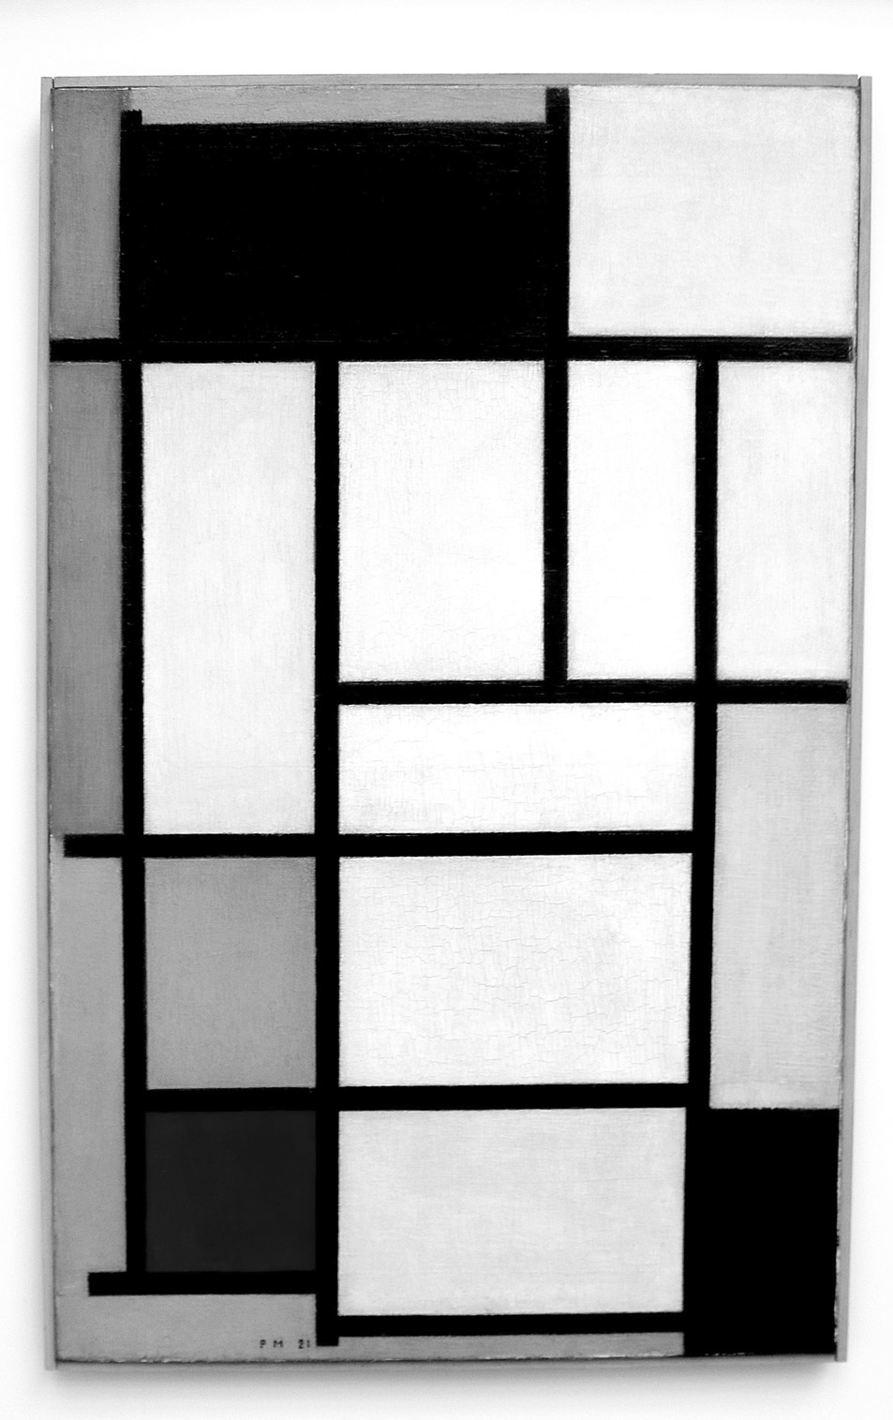

Section 5.3
3. Use algebra tiles or area models to show the following relationships. Create a poster displaying your models.
a) the relationship between a monomial multiplied by a binomial and common factoring
b) the relationship between a binomial multiplied by a binomial and factoring a trinomial of the form ax² + bx + c, where a, b, and c are integers

4. a) Use algebra tiles to create a model of a polynomial of your choice.
b) Create a piece of art that includes your polynomial in some way. Your artwork may be a drawing, painting, sculpture, or other form of your choice.
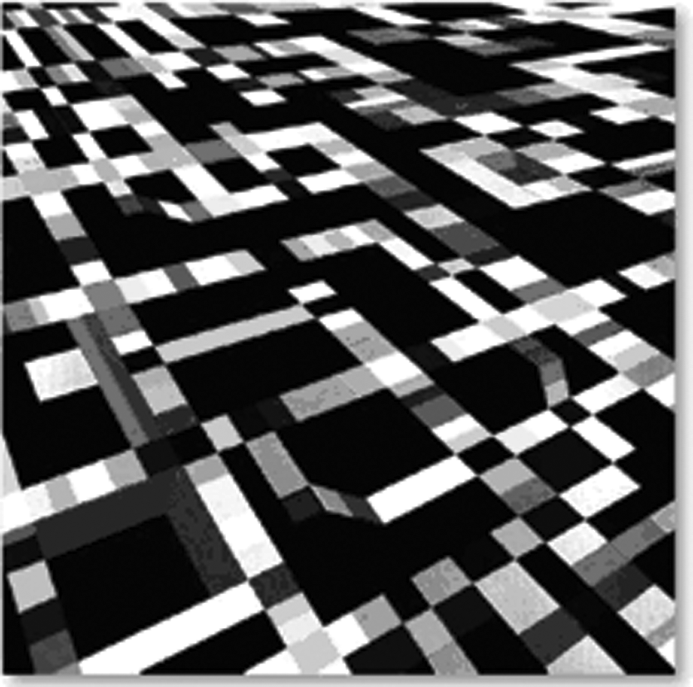

Section 5.4
5. Use models or diagrams to show what happens to the middle terms when you multiply two factors that result in a difference of squares. Include at least two specific examples.
6. a) Use models or diagrams to show the squaring of a binomial. Include at least two specific examples.
b) Create a rule for squaring any binomial. Show how your rule relates to your models or diagrams.

