Section 5.1 Extra Practice

1. Multiply using algebra tiles.
a) (x + 2)(x + 4)
b) (x + 1)(x – 2)
2. a) What product does the algebra tile model show?
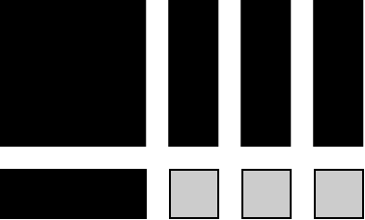
b) What are the dimensions of the model?
3. Multiply using the distributive property.
a) (x – 3)(x – 6)
b) (y + 10)(y – 5)
c) (2x + 3)(x – 4)
d) (5 – 3a)(4 + a)
e) 3(x – 2y)(x + y)
4. Multiply using the distributive property.
a) (x – 5)(x + 5)
b) (m + 10)(m – 10)
c) (2x + 3)(2x – 3)
d) (4 – 3a)(4 + 3a)
e) 5(2x – y)(2x + y)
5. Use the distributive property to determine each product.
a) (x + 4)²
b) (x – 7)²
c) (6 + y)²
d) (2x + 5y)²
e) 2(2a + 3b)²
6. Use the distributive property to determine each product.
a) 2x(x² + x – 1)
b) 3a(a² + 3a – 5)
c) (x + 2)(x² – 2x + 5)
d) (2a – 3)(3a² + 5a – 2)
e) (x² + 2x – 1)(x² – 2x + 1)
7. Multiply. Then, combine like terms.
a) (x + 2)(x – 3) – (x – 4)
b) (x – 1)(x – 2) + (x + 1)(x + 2)
c) (a – 3)² + (a + 4)(2a – 3)
d) (y + 2z)(y + 10z) – (y – 5z)²
e) (2x + 3) – 4x(x + 4)(3x – 1)
8. Multiply.
a) (x – 3y)²(2x + y)
b) (x + 3)²(x – 3)
c) (x – 2)²(x + 1)²
d) (x – 3)³
e) (y + 4)³
9. Write an expression to represent the area of the figure.
