Section 5.2 Extra Practice

1. What is the greatest common factor (GCF) of each set of numbers?
a) 28 and 98
b) 243 and 162
c) 192 and 216
d) 90, 105, and 165
e) 48, 120, and 168
2. Determine the least common multiple (LCM) of each set of numbers.
a) 12 and 26
b) 9 and 36
c) 6 and 15
d) 4, 5, and 12
e) 16, 20, and 44
3. Determine the GCF of each set of terms.
a) 15x⁴ and 5x²y
b) –24xy and 8xy
c) ax² and –bx
d) 18y⁴, –9y³, and –27y²
e) 2πxr, –2πxr, and 2πxh
4. Factor each polynomial, if possible.
a) 5x + 35
b) 4x + 23
c) 14x – 8y
d) 6x² + 24x
e) 3x + 9xy + 6xz
5. Identify each missing factor.
a)
b)
c)
d)
e)
6. Factor each polynomial.
a) 8x² + 32y³
b) 10a + 5a² – 25a³
c) 24abc – 6ab + 8bc
d) –12x²y² + 3xy³ – 15x³y
e) 9πx² – 6xy + 12πxy²
7. Write each expression in factored form, if possible.
a) x(y + 1) + 4(y + 1)
b) 3x(a + b) – y(a + b)
c) 4y(y + 3) + (y + 3)
d) 5a(2x + 1) + 3(2x – 1)
e) 3y(x – 5) – 4(5 – x)
8. Factor by grouping.
a) 5x + 15y + mx + 3my
b) xy + 4x + 5y + 20
c) 3ab – 3ac + 2b² – 2bc
d) –5y + 3 – 6x + 10xy
e) 2x² + xz + 6xy + 3yz
9. Write an expression in factored form to represent the area of each shaded region.
a) 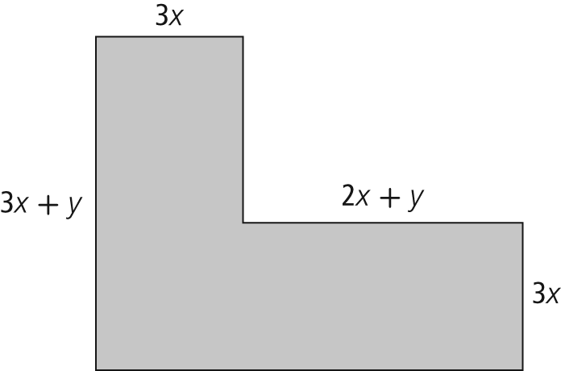
b) 