Chapter 5 Test
Multiple Choice
For #1 to 5, select the best answer.
1. What binomial product does the area diagram represent?
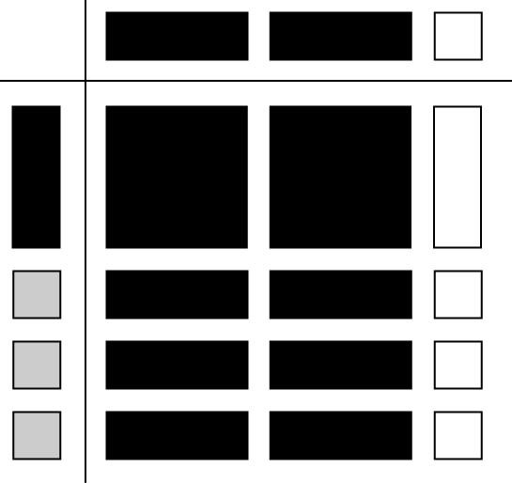
A (2x – 1)(x + 3)
B (x – 3)(2x + 1)
C (3x + 1)(x – 2)
D (x + 2)(3x – 1)
2. Two students were asked to model the multiplication of two numbers. Their work is shown.
Dolores
(78)(80) = (80 – 2)(80 + 2)
= 80² – 2²
= 6400 – 4
= 6396
Frank
49² = (50 – 1)²
= 50² – 2(50 – 1)²
= 2500 – 100 – 2 + 1
= 2399
Which of the following statements is true?
A Both students have a correct procedure.
B Neither Dolores nor Frank has a correct procedure.
C Frank has an error and Dolores does not have an error.
D Dolores has an error and Frank does not have an error.
3. Devin was asked to multiply the expressions 4x – 1 and 2x – 5. His work is shown.
(4x – 1)(2x – 5) Step 1
= 4x(2x – 5) – (2x – 5) Step 2
= 8x² – 20x – 2x – 5 Step 3
= 8x² – 22x – 5 Step 4
Devin verified his answer and realized he had made an error. In which Step did he make his first error?
A Step 1 B Step 2
C Step 3 D Step 4
4. Carly wanted to factor the expression
x² + 25. Which of the following statements is true?
A x² + 25 = (x + 5)²
B x² + 25 = (x + 5)(x – 5)
C x² + 25 = (x + 5)(x + 5)
D Carly cannot factor x² + 25 over the integers.
5. Which of the following expressions represents the factors of 3x² – 17x + 10?
A (x – 2)(x – 15)
B (x – 5)(3x – 2)
C (3x – 2)(x – 15)
D (x – 5)(x – 2)
Short Answer
6. a) Draw a diagram to model the product of (x – 3)(2x + 1).
b) Multiply and then combine like terms.
7. Determine the product and then combine like terms.
a) (y + 3)(y + 8)
b) (5c – 9)(4c – 1)
c) (7a – 6y)²
d) (t – 4)(3t² – 5t + 7)
8. Determine the GCF of the terms in each polynomial.
a) 24x³ – 32x² – 40x⁴
b) 5r²s³(r + 3) – 4rs²(r + 3)
9. Factor each expression fully.
a) 21a²bc – 3a²b² + 24a³b³
b) x² – 7x – 30
c) x² – 16xy + 64y²
d) x² – 225
Extended Response
10. The volume of a rectangular prism can be expressed as 60x³ + 168x² + 45x.
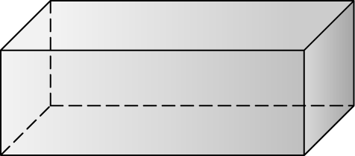
a) Determine a possible set of expressions for the length, width, and height of the rectangular prism.
b) Verify the product you arrived at in part a) by showing the multiplication of the factors.
c) Determine the volume of the prism if
x = 2 cm.
11. The side length of square A can be expressed as (3x + 2) cm. The area of rectangle B is equal to the area of square A increased by (6x + 5) cm².
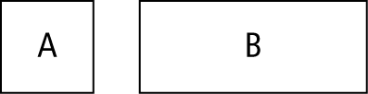
a) Write an expression in fully factored form to represent the area of square A.
b) What expression in fully factored form represents the area of rectangle B?
c) If the expression (x + 1) cm represents the width of rectangle B, what expression represents its length?

