Chapter 6 Test

Multiple Choice
For #1 to 4, select the best answer.
1. Which of the statements is true for the graph shown?
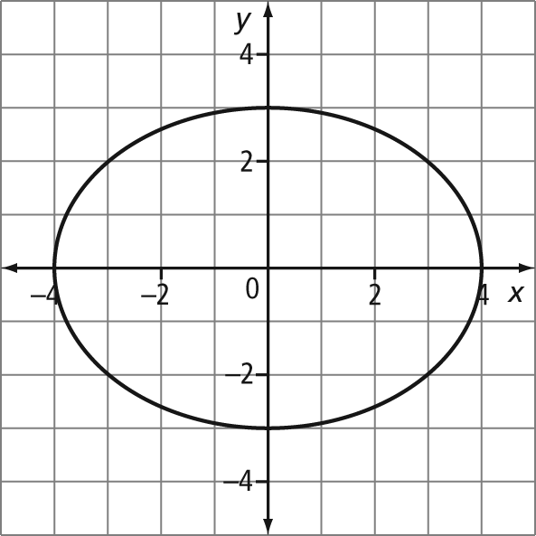
A The domain is –4 < x < 4.
B The range is –4 ≤ x ≤ 4.
C The graph represents a function.
D The graph represents a relation.
2. Which situation could be represented by the graph shown?
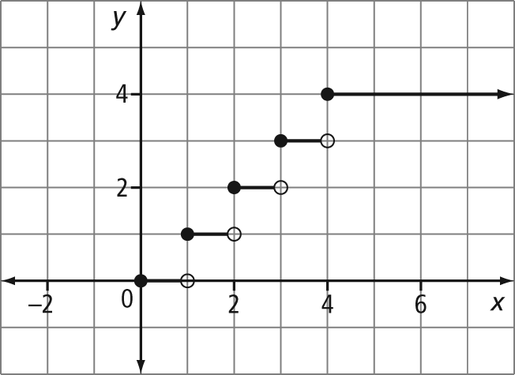
A the cost of movie tickets per person
B the distance travelled by a bus as it makes regular stops, as a function of time
C the cost of parking in a lot per hour, with a daily maximum
D the height of a person climbing stairs, as a function of time

3. Which equation represents a vertical line?
A y = 7 B y = 2x
C x = 4 D x = y
4. Determine the range of the relation.
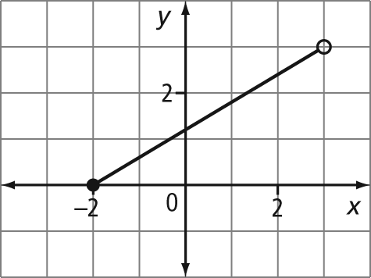
A {0, 1, 2, 3}
B {y | 0 ≤ y < 3, y ∈ R}
C (0, 3]
D all numbers between 0 and 3, inclusive

Numerical Response
Complete the statements in #5 to 7.
5. The slope of the line that contains the points (3, –2) and (5, 6) is .
6. A line has a slope of and passes through the point (3, 7). A point on this line is
(0, ).
7. The top speed at which a polar bear can run over a short distance is 40 km/h. The distance, d, in kilometres, a polar bear runs as a function of time, t, in hours, can be expressed as d(t) = 40t. In 2 min, a polar bear could run  km, rounded to the nearest tenth of a kilometre.
Short Answer
8. The graph indicates a relationship between the distance from home and time as Jeremy went for a jog one day.
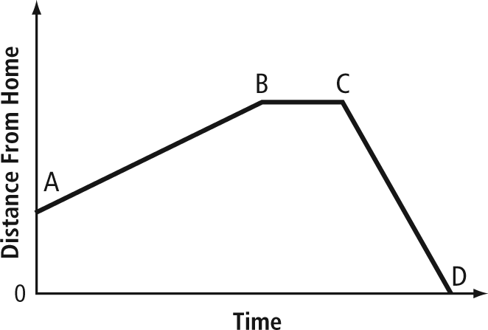
a) Describe a possible situation for each segment of the graph.
b) What do the slopes of the different line segments represent?
c) During which segment is Jeremy jogging the fastest?
9. The altitude of an airplane after 5 min of flight was 1220 m. After 20 min, the altitude was 6860 m.
a) Identify the dependent variable and the independent variable in this situation.
b) What is the meaning of the slope of the graph in this situation?
10. Select and graph the function that represents continuous data.
Function A: f(x) = 2x + 1, where the domain is {0, 1, 2, 3, 4, 5}
Function B: h(x) = x + 3, where the domain is {x ∈ R}

Extended Response
11. a) Determine whether each relation is a function or is not a function. Give the domain and range of the graph of each relation.

i) 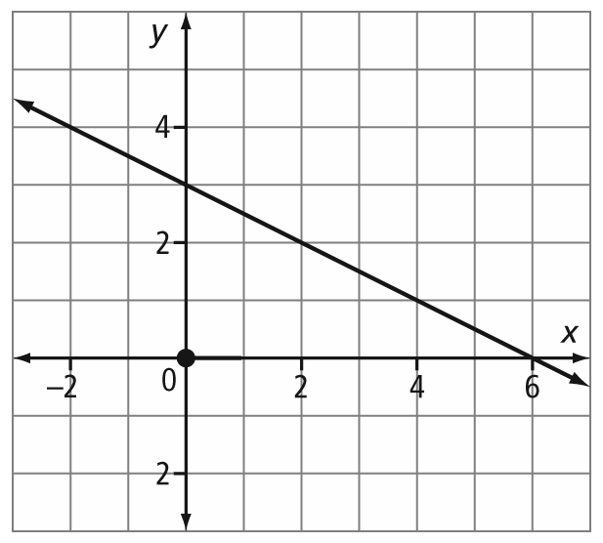
ii) 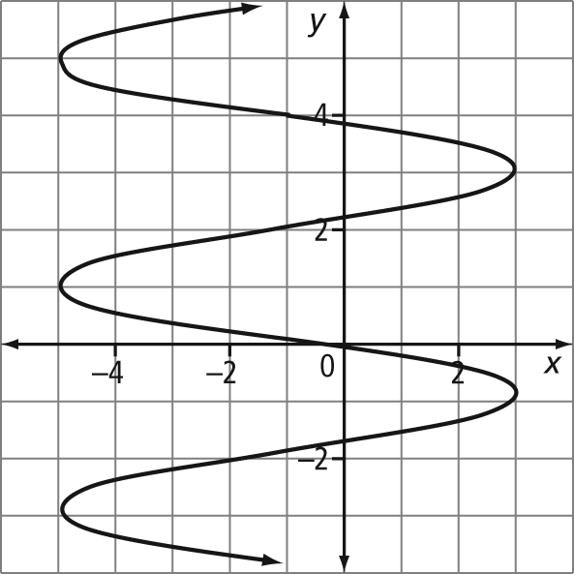
iii) 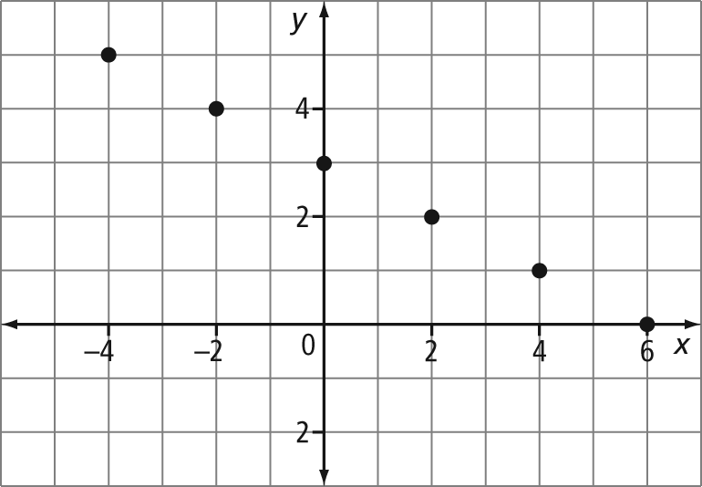
iv) 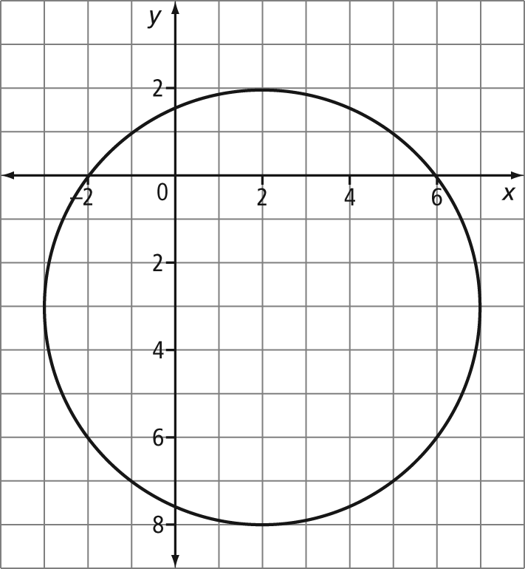
b) Sketch a possible graph to represent a relation for each given domain and range.
i) domain [0, 5], range [2, 8]
ii) domain {x ∈ R}, range {3}
iii) domain {x | 0 < x ≤ 5, x ∈ R},
range {y | 1 < y ≤ 4, y ∈ R}
12. Fresh Bing cherries from the Okanagan Valley of British Columbia are a popular treat during early summer months. A healthy diet includes dietary fibre from a variety of sources. The table represents the amount of fibre from various quantities of cherries.

Mass of Cherries (g) | Amount of Fibre (g)
140 | 3
280 | 6
560 | 12

a) Does the data represent a linear or
non-linear relationship between amount of fibre and mass of cherries?
b) Would the graph of the relation be continuous or discrete? Explain.
c) Determine the slope of the graph of the relationship. Explain the meaning of this rate of change.
d) Determine the amount of fibre in 420 g of cherries.

