Chapter 6 BLM Answers

BLM 6–2 Chapter 6 Prerequisite Skills
1. a) 0.50, 50% b) 0.60, 60%
c), d) 3, 300%
2. a) 108 km/h b) 160 m/km c) 50 m/min
3. 1.99 m
4. a)
Time Worked, t (h) | Earnings, E ($)
2 | 30
4 | 60
6 | 90
7 | 105
b) (0, 0). Example: This means that for 0 time worked, the earnings are $0.
5. a) 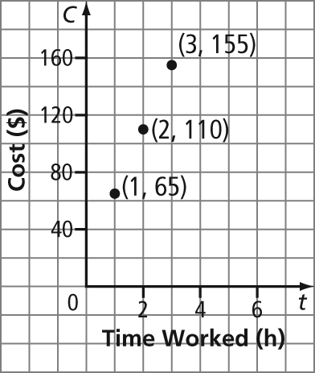
b) $290 c) C = 45L + 20
6. a) y = 8.04 b) t = –14.56
c) r = d) n = 15
7. a) $50.25 b) 48 hotdogs

BLM 6–3 Chapter 6 Warm-Up
Section 6.1
1. a)
Time, t (s) | Distance Walked, d (ft)
30 | 50
60 | 100
90 | 150
120 | 200

b) 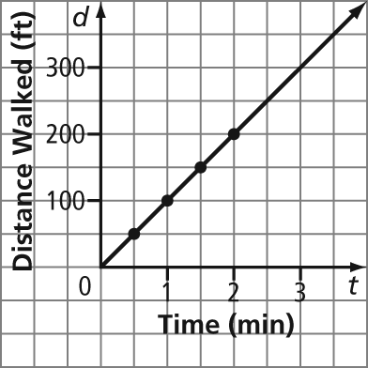

2. a)
Time, t (s) | Distance Walked, d (ft)
30 | 75
60 | 150
90 | 225
120 | 300
b) 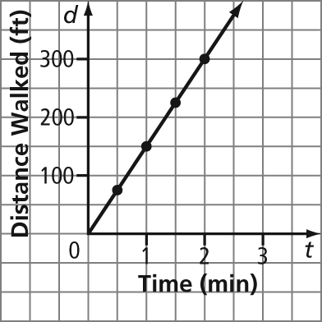
3. Example: The scenario with the faster speed creates a steeper line than the scenario with the slower speed.
4. a)
Time t, (min) | Distance From School d, (km)
0 | 5
2 | 5
4 | 5
6 | 5
b) 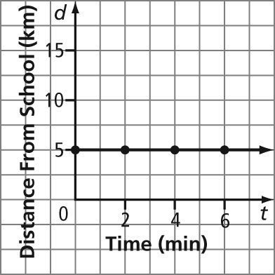
5. a) 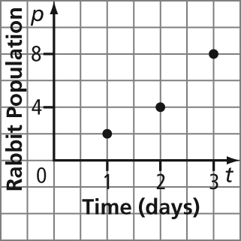
b) Example: No. The data does not lie in a line.
Section 6.2
1. a) 1 b) 2 c) 3 d) 0 2. A
3. Example: number of stock of various shoe sizes over time
4. Example: distance travelled by a vehicle moving at a constant speed over time
5. Example: distance travelled by a soccer ball after it is kicked into the air over time
Section 6.3
1. all real numbers greater than and including 3
2.
3. all real numbers greater than or equal to –2 and less than or equal to 3
4.
5. Examples:
a) multiples of 1; start at 0; end at 5
b) multiples of 100; start at 0; end at 300
Section 6.4
1. a) 1, 2, 9 b) –3, –1, 0 c) all real numbers
2. a) 3, 4, 5 b) 1, 4, 7 c) all real numbers
3. a) y = 32 b) y = 14
4. a) x = 5 b) x = –7
5. 65 min
Section 6.5
1. a) 2 b) 3 2. a) 9 b) 4
3. a)
b) 
c) 
4. a) Example: 0. There is no rise or steepness.
b) Example: undefined or no number. There is no run. Division by zero is not defined.
5. Examples:
a) (3, 7) b) To go from (0, 4) to (2, 5), you move two right and one up. So, the next point that is two right and one up is (3, 7).

BLM 6–5 Section 6.1 Extra Practice
1. Example: AB: constant increase, since the line rises from left to right; BC: increase that is not constant, since the curve rises from left to right; CD: constant decrease, since the line falls from left to right; DE: constant increase, since the line rises from left to right; EF: constant decrease, since the line falls from left to right; FG: no increase, since the line is horizontal; GH: decrease that is not constant, since the curve falls from left to right
2. a) Graph D b) Graph A
c) Graph B d) Graph C
3. Examples:
a) the price of a new TV over time
b) the amount of memory new computers are sold with over time
c) the temperature of a cake out of the oven as it cools, remains at room temperature, then cools again in the refrigerator
d) population increase over time
4. Example: The graph shows the temperature in my home for a 24-h period, starting at 12 a.m.
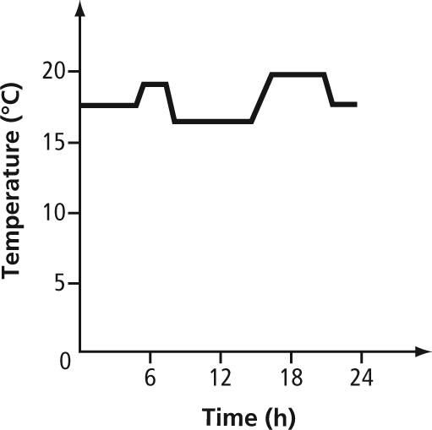
5. Examples:
a) 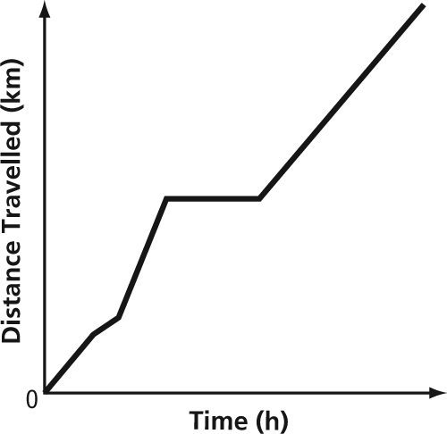
b) 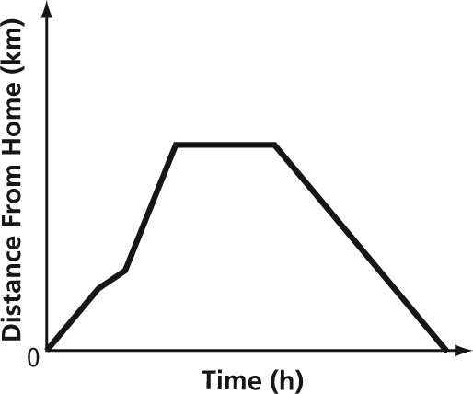
c) 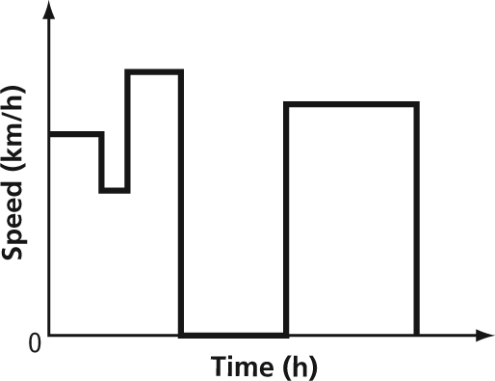
6. Example: Take off, rise to 3000 ft, and cruise at 3000 ft. Then, climb to 4000 ft, cruise at 4000 ft, return to 3000 ft and cruise at 3000 ft, and then return to the ground.
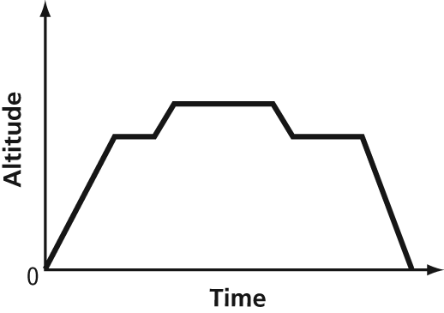

BLM 6–6 Section 6.2 Extra Practice
1. a) (4, –2), (1, –1), (0, 0), (1, 1), (4, 2)
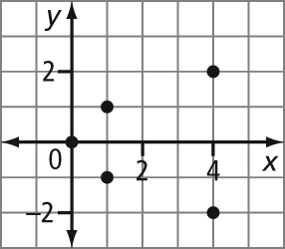
b) … (–2, –7), (–1, –5), (0, –3), (1, –1), (2, 1), …
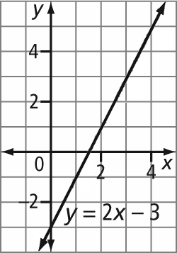
2. a)
x | y
–1 | –2
0 | 0
1 | 2
2 | 4
3 | 6
The y-values are double the x-values.
b)
x | y
0 | 0
1 | 1
2 | 4
3 | 9
4 | 16
The y-values are the squares of the x-values.
3. a) Linear. Example: The graph is a straight line.
b) Non-linear. Example: The y-values do not increase at a constant rate.
c) Linear. Example: The values of x and y increase at a constant rate.
d) Non-linear. Example: The graph is not a straight line.
4. a) independent: r, dependent: V
b) independent: age of a person, dependent: height
c) independent: time of day, dependent: height of the tide
5. a) Linear. Example: The values of x and y increase at a constant rate.
b) Example: Let n represent the independent variable, the number of tickets. Let C represent the dependent variable, cost.
c) Discrete. Example: You cannot buy half of a ticket.
d) 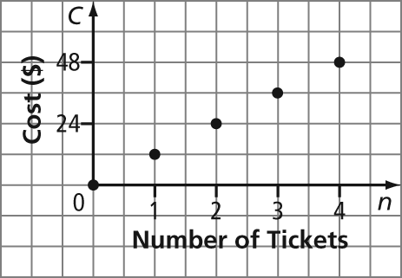
6. a) Example: Let t represent the independent variable, time. Let d represent the dependent variable, distance.
b)
t | d
0 | 0
1 | 8
2 | 16
3 | 24
c) 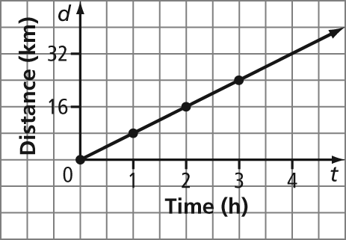
d) Linear. Example: The graph is a straight line.
e) Continuous. Example: Both variables, time and distance, are continuous.

BLM 6–7 Section 6.3 Extra Practice
1. a) all real numbers greater than –4 and less than or equal to 3, (–4, 3]
b) all real numbers greater than or equal to 3, [3, ∞)
c) all real numbers less than or equal to 2, (–∞, 2]
d) all real numbers less than or equal to –1 as well as all real numbers greater than 4, (–∞, –1] or (4, ∞)
2. a)
b)
3. a) domain: all real numbers, (–∞, ∞ ), {x ∈ R}
range: real numbers, (–∞, ∞ ), {y ∈ R}
b) domain: all real numbers, (–∞, ∞ ), {x ∈ R}
range: all real numbers greater than or equal to –1,
[–1, ∞), {y | y ≥ –1, y ∈ R}
c) domain: all real numbers greater than or equal to 0 and less than or equal to 4, [0, 4],
{x | 0 ≤ x ≤ 4, x ∈ R}
range: all real numbers greater than or equal to 0 and less than or equal to 2, [0, 2], {y | 0 ≤ y ≤ 2, y ∈ R}
d) domain: negative one, [–1, –1], {x = –1}
range: all real numbers greater than 1, (1, ∞),
{y | y > 1, y ∈ R}
4. a) domain: {–2, –1, 1, 2}, range: {–1, 1, 2}
b) domain: {7, 5, 3, 1}, range: {3, 2, 1, 0}
c) domain: {10, 8, 6, 4, 2}, range: {5, 4, 3, 2, 1}
5. a) [–30, 40] b) x: [–10, 10, 1], y: [–30, 40, 5]
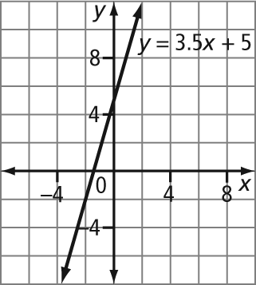
6. Example: (0, 1), (1, 2), (2, 5), (3, 10), (4, 17)
7. Examples:
a) domain: the years greater than 1900
range: the number of vehicles greater than or equal
to zero
b) 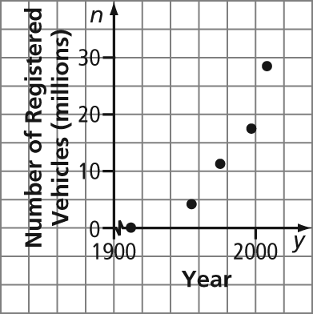
8. Examples:
a) domain: the buildings Suncor Energy Centre West Tower, Bankers Hall, TransCanada Tower, Canterra Tower, First Canadian Centre, Western Canadian Place North, TD Canada Trust Tower, Scotia Centre, and Nexen Building, or all whole numbers greater than or equal to 1 and less than or equal to 9
range: Example: building heights greater than 0 m
b) For the horizontal axis, the buildings are represented by their ranking.
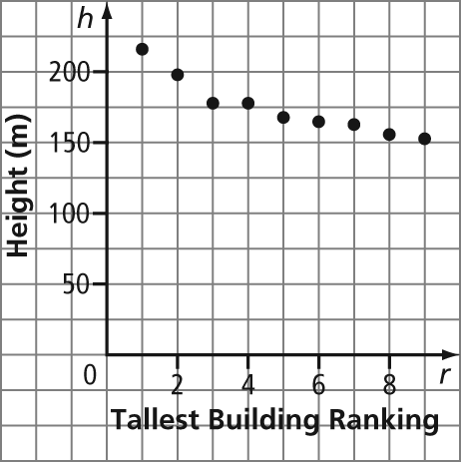

BLM 6–8 Section 6.4 Extra Practice
1. a) Not a function. Example: It fails the vertical line test.
b) Function. Example: It passes the vertical line test.
c) Function. Example: It passes the vertical line test.
d) Not a function. Example: It fails the vertical line test.
2. A(n) = 500(1.06)^{n} 3. C = 50 + 9n
4. a) 8 b) 1 c) 9
5. a) 2 b) 0 c) –9
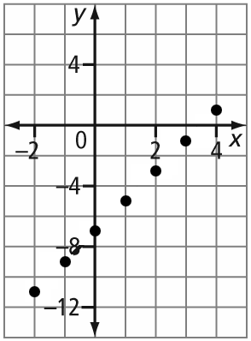
6. a)
x | y
–2 | –11
–1 | –9
0 | –7
1 | –5
2 | –3
3 | –1
4 | 1

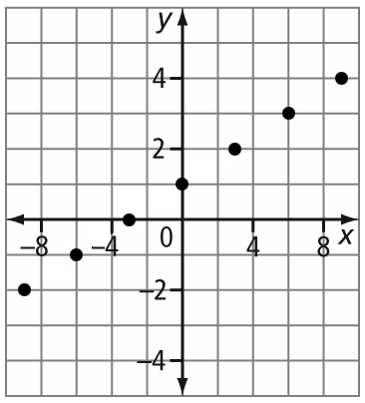
b)
x | y
–9 | –2
–6 | –1
–3 | 0
0 | 1
3 | 2
6 | 3
9 | 4
7. a) 36π ≈ 113.1 b) ≈ 4188.8
c) d) approximately 1.14
8. a) 300 calories b) 19 crackers
9. a) approximately 20.96 m b) approximately 2.55 s
c) domain: {t | 0 ≤ t ≤ 2.55, t ∈ R},
range: {h | 0 ≤ h ≤ 32, h ∈ R}

BLM 6–9 Section 6.5 Extra Practice
1. AB: m =; CD: m =; EF: m = undefined;
GH: m = 0
2. a) 5 b) 0 c) d) undefined
3. approximately 2.9 m
4. a) 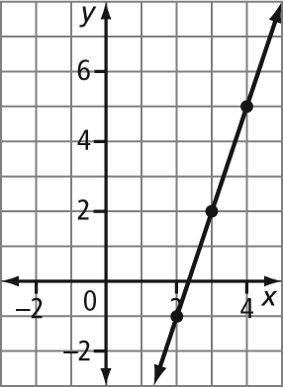 b) 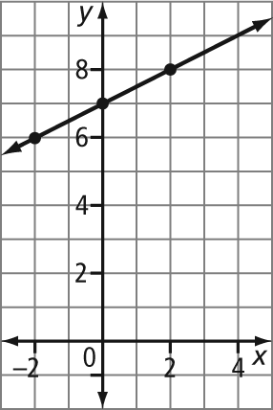
c) 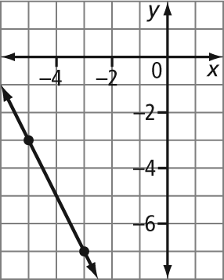 d) 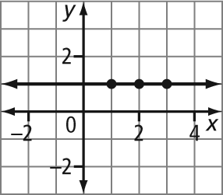
5. a) Example: (0, 0), (2, 4), (3, 6)
b) Example: (5, 0), (11, –2), (14, –3)
6. a) 3 b) –4
7. a) 14 cabinets b) slope = daily quota
8. 0.061 billion/year

BLM 6–10 Chapter 6 Test
1. D 2. C 3. C 4. B
5. 4 6. 5 7. approximately 1.3
8. a) Point A: He starts at a distance away from home. AB: He jogs at a constant rate away from home. BC: He stops. CD: He runs home at a constant rate, faster than AB.
b) velocity c) CD
9. a) dependent: altitude, independent: time
b) rate of ascent, 376 m/min
10. 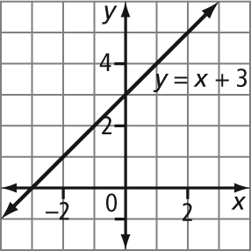
11. a) i) function; domain: {x ∈ R}, range: {y ∈ R}
ii) not a function; domain: {x | –5 ≤ x ≤ 3, x ∈ R}, range: {y ∈ R}
iii) function; domain: {–4, –2, 0, 2, 4, 6}, range:
{5, 4, 3, 2, 1, 0}
iv) not a function; domain: {x | –3 ≤ x ≤ 7, x ∈ R}, range: {y | –8 ≤ y ≤ 2, y ∈ R}
b) Examples:
i) 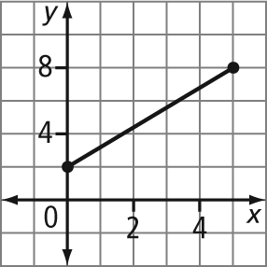 ii) 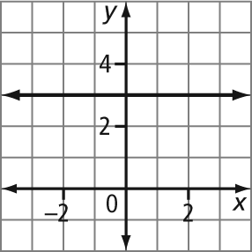
iii) 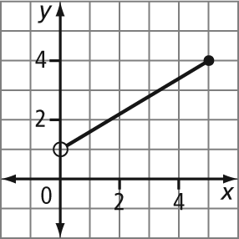
12. a) linear
b) Continuous. Example: You may have amounts between the given data points.
c) approximately; grams of fibre per 1-g mass of cherries
d) 9 g

