Chapter 6 Prerequisite Skills

Show all your work.

1. Express each ratio as a decimal number and as a percent.
a)
b)
c)
d)
2. What is the unit rate in each scenario?
a) A car travels 324 km in 3 h.
b) A hiker reaches a height of 800 m while walking for 5 km.
c) A submarine dives to a depth of 450 m in 9 min.
3. A 12-m tree casts a shadow that is 4.1 m long. What is the height of a fence post that casts a shadow that is 0.68 m long?
4. The graph shows the relationship between earnings and time.
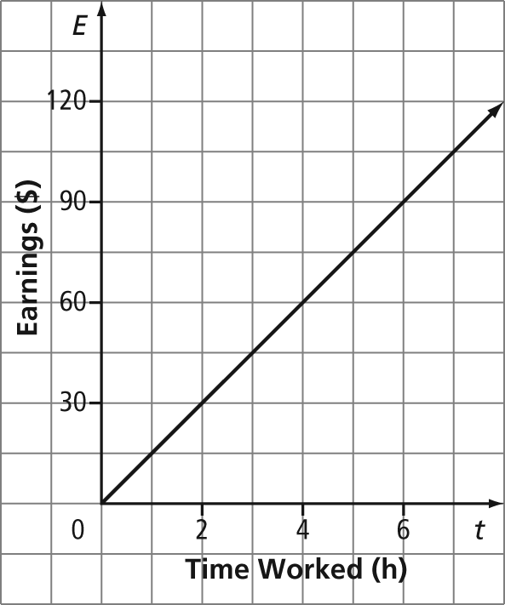
a) Copy the table. Use the graph to help you complete the table.

Time Worked, t (h) | Earnings, E ($)
2
 | 60
6
 | 105
b) What are the coordinates where the graph intersects the vertical axis? What is the meaning of this point?
5. A plumber charges $65 for any part of the first hour of a repair call and $45 for every additional hour. This relation is shown in the table.

Time Worked, t (h) | Cost, C ($)
1 | 65
2 | 110
3 | 155
a) Graph the relation.
b) What is the repair cost for a 6-h job?
c) What is the linear equation for the graph?
6. Solve and check.
a) 2.68 =
b)
c)
d)
7. Rubin works at a football stadium selling hotdogs. He is paid $8/h plus $0.75 commission for every hotdog he sells.
a) How much does Rubin make if he sells 35 hotdogs in 3 h?
b) How many hotdogs would he have to sell to earn $68 in 4 h?

