Chapter 6 Warm-Up

Section 6.1 Warm-Up

1. You are walking to school at a rate of 100 ft/min.
a) Copy and complete the table of values for this scenario.

Time, t (s) | Distance Walked, d (ft)
30
60
90
120
b) Graph your data using a grid similar to the one shown.
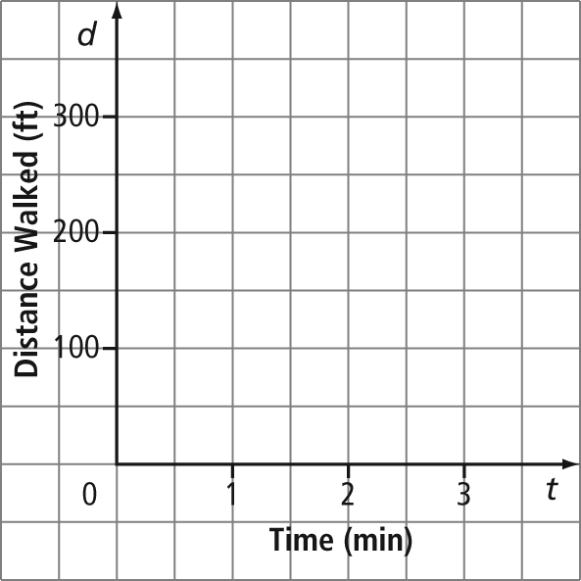
2. You are walking to school at a rate of 150 ft/min.
a) Copy and complete the table of values for this scenario.

Time, t (s) | Distance Walked, d (ft)
30
60
90
120
b) On the same grid as described in #1, graph the new walking data.
3. Describe the difference between the two lines on your graph from #1 and 2.
4. You live 5 km from school. You are supposed to go to school, but sleep in for the first 10 min of class.
a) Complete the table of values for this scenario.

Time (min), t | Distance From School, d (km)
0
2
4
6
b) Graph your data using a grid similar to the one shown.
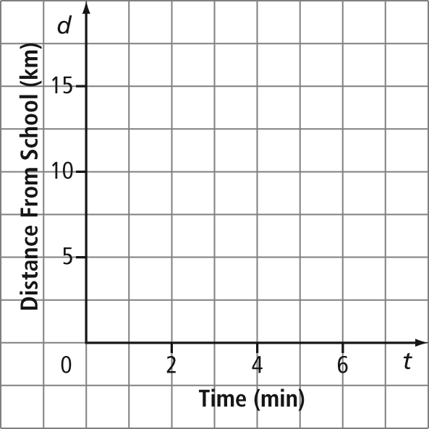
5. A rabbit population grows so that the first day there are two rabbits, the second day there are four rabbits, and the third day there are eight rabbits.
a) On grid paper, graph the scenario.
b) Does the population increase at a constant rate? Explain your answer.

Section 6.2 Warm-Up
1. Determine the degree of each of the following equations.
a) y = 2x + 3
b) y = x² + x – 5
c) y = 4x³ – 1
d) y = 6
2. Which of the following tables of values shows a constant change in the y-values and a constant change in the x-values?
A B
x | y |  | x | y
4 | 5 |  | 1 | 1
6 | 9 |  | 2 | 4
8 | 13 |  | 3 | 9

3. Describe a scenario that would be graphed as points that are not joined together by a line.
4. Describe a scenario that would be graphed as points that are joined together in a straight line.
5. Describe a scenario that would be graphed as points that are joined together in a curved line.

Section 6.3 Warm-Up

1. Describe in words the values represented by the number line.
2. Draw a number line to represent all numbers that are less than –2.
3. Describe in words the values represented by the number line.
4. Draw a number line that represents all numbers that are greater than 4 and less than or equal to 7.
5. A car travels at 60 km/h for 5 h. Suppose you were to create a graph of this scenario.
a) What scale would you use along the time axis? What value would you start at? What value would you end at?
b) What scale would you use along the distance axis? What value would you start at? What value would you end at?

Section 6.4 Warm-Up
1. List all the values of x in each relation.
a) (1, 3), (2, 5), (9, 4)
b)
x | y
–3 | 4
–1 | 7
0 | 1
c) y = 2x – 3
2. List all the values of y in each relation.
a) (1, 3), (2, 5), (9, 4)
b)
x | y
–3 | 4
–1 | 7
0 | 1
c) y = 2x – 3
3. Evaluate y = 2x² – 3x + 5 for each of the given values.
a) x = –3 b) x = 3
4. Evaluate y = 3x – 5 for each of the given values.
a) y = 10 b) y = –26
5. A cell phone plan promotion charges
a monthly fee of $20 for unlimited
local calling. It charges $0.04/min for
long-distance calls within North America. You paid $22.60 (before taxes) in the first month. How many long-distance minutes did you use?

Section 6.5 Warm-Up

1. On grid paper, plot the points (2, 3) and
(–1, 5).
a) What is the vertical distance between these two points?
b) What is the horizontal distance between these two points?
2. On grid paper, plot the points (–3, 7) and
(–7, –2).
a) What is the vertical distance between these two points?
b) What is the horizontal distance between these two points?
3. Sketch a line to show each rate of change.
a) zero
b) positive
c) negative
4. What number (if any) would you use to describe the steepness of each of the following lines? Explain your answer.
a)
b)
5. On grid paper, plot the points (0, 4) and
(2, 5). Join these two points.
a) Name another point that would continue to make a straight line with these other two points.
b) Explain how you chose your point.

