Chapter 6 Unit 3 Project

Section 6.4
1. Using skeletal remains, a forensic anthropologist can accurately determine the sex, race, age, and height of a person.
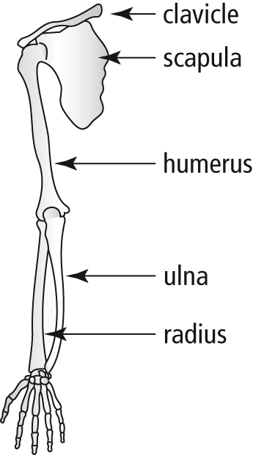
a) The height, h, in centimetres, of a male can be determined using the function h(L) = 2.9L + 70.6, where L is the length, in centimetres, of his humerus. Suppose you find a humerus of a male and measure the bone to be 36.87 cm in length. How tall was the man?
b) The function h(L) = 2.8L + 71.4 can be used to determine the height, h, in centimetres, of a female, where L is the length, in centimetres, of her humerus. Determine h(36.87). What does h(36.87) represent?
c) Height, h, in centimetres, can also be determined using the functions h(L) = 3.3L + 86.4 for a male and h(L) = 3.3L + 81.3 for a female.
In these functions, L represents the length of the radius bone, in centimetres. What is an appropriate range for each of these functions? Explain.
d) Based on the range you determine in part c), what is the span of values (the domain) for the radius bone in males and in females?
e) Measure the length of your radius bone. Use the appropriate function to determine your height. How accurate is the prediction?
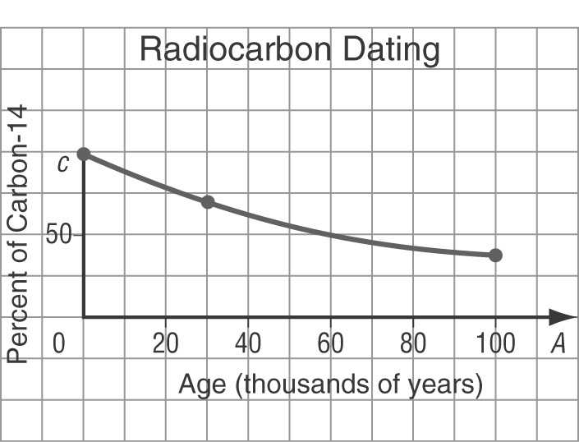
2. After an animal dies, the amount of radioactive carbon-14 in its bones declines. Archaeologists use this fact to determine the age of a bone based on the percent of carbon-14 remaining in the fossilized bones. The relation shows the age, A, in years, of an animal based on the percent, c, of carbon-14 remaining.
a) Is this relation a function? Why?
b) At Head-Smashed-In Buffalo Jump, in southwestern Alberta, the most recent bison bones found had 98% of the carbon-14 still remaining. From the graph, estimate the age of these bones.
c) The oldest bison bones found at Head-Smashed-In Buffalo Jump were about 5800 years old. Estimate the percent of carbon-14 still remaining in these bones.

