Section 6.1 Extra Practice

1. The graph shows how quantity Y is changing relative to quantity X. Describe each section of the graph as representing a constant increase, a constant decrease, an increase that is not constant, a decrease that is not constant, or no change. Explain your answers.
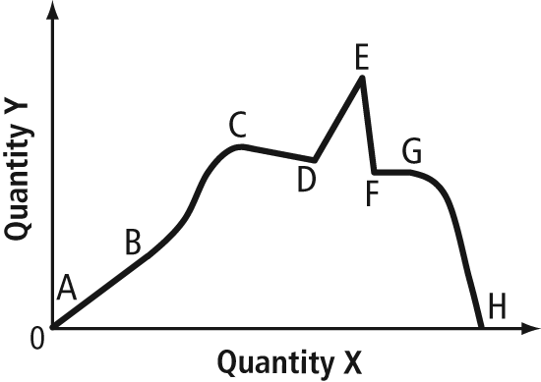
2. Match each scenario with its appropriate graph.
a) the height of a bungee jumper after a jump
b) the vertical growth of a tree
c) the temperature of a cup of hot chocolate as it sits on a table
d) Calgary’s daily mean temperature
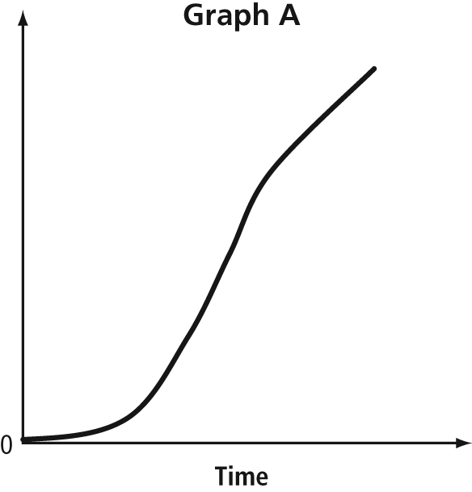
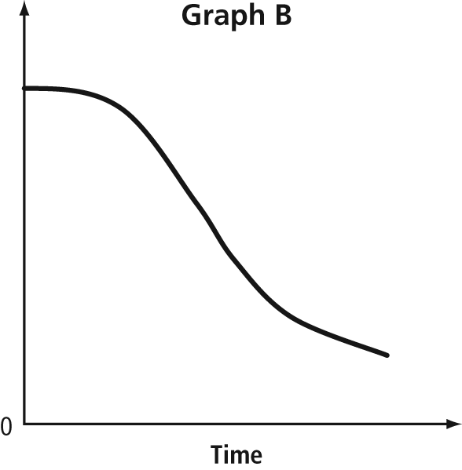
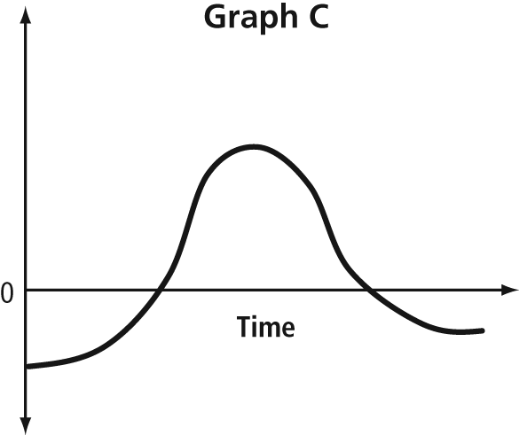
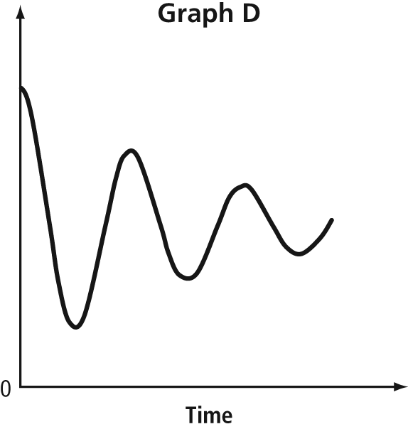
3. Describe a situation for each of the following graphs.
a) 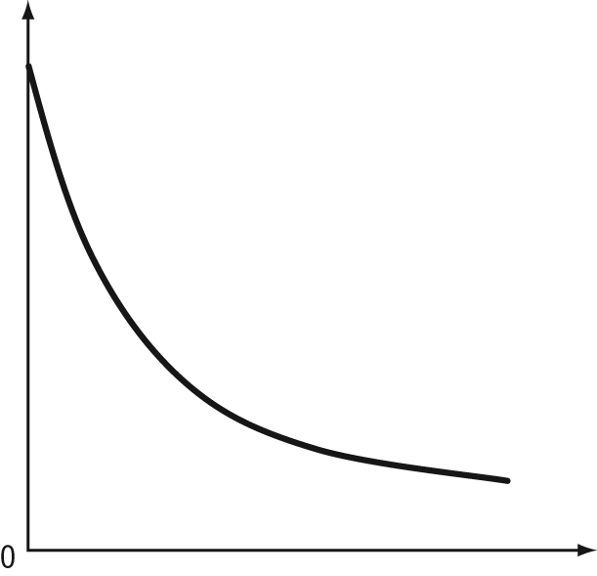
b) 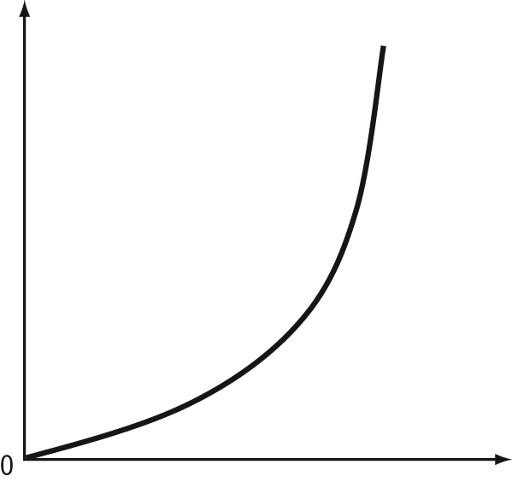
c) 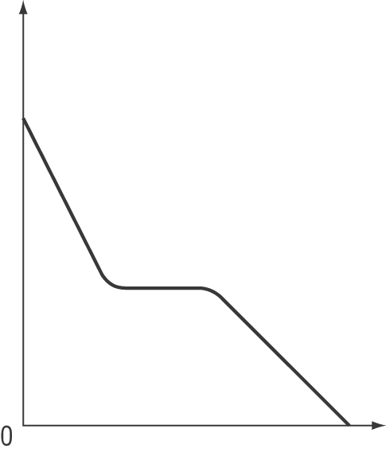

d) 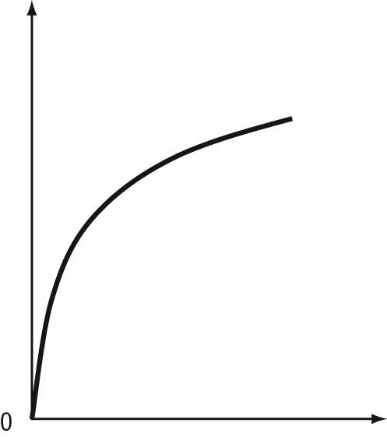
4. Create a graph to represent the temperature in your home for a 24-h period.
5. Sakura leaves home and travels at a steady speed of 100 km/h for 1 h, slows to 80 km/h for h due to construction, then continues at 110 km/h for another hour. She stops for 2 h for a meeting. She returns home at a steady 100 km/h. Sketch a graph of each scenario.
a) distance travelled versus time
b) distance from home versus time
c) speed versus time
6. Sunseeker II is a lightweight solar-powered airplane. The four packs of lithium
polymer batteries provide power for takeoff and climbing. Once it hits its cruising altitude of 3000 ft, Sunseeker II uses solar power to maintain altitude. Create an
altitude-versus-time graph for your ride of a lifetime. Provide a scenario with your graph.

