Section 6.2 Extra Practice

1. Convert each relation from its current representation to a set of ordered pairs and to a graph.
a)
x | y
4 | –2
1 | –1
0 | 0
1 | 1
4 | 2
b) y = 2x – 3
2. Convert each relation from its current representation to a table of values and to words.
a) … (–1, –2), (0, 0), (1, 2), (2, 4), …
b) 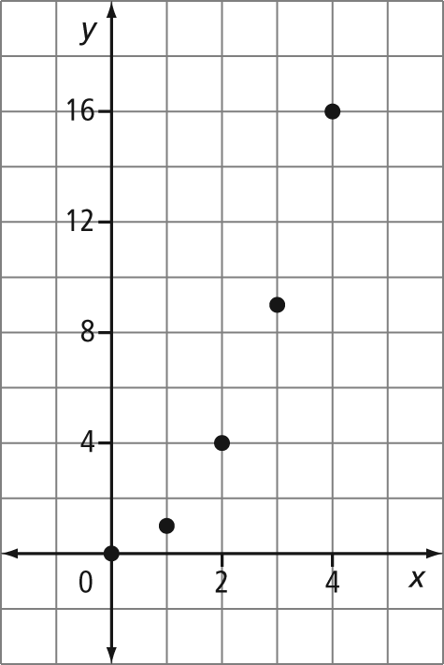
3. Determine whether each relation is linear or non-linear. Explain your decision.
a) y = x + 32
b)
x | y
1 | 1
2 | 1
3 | 2
4 | 3
5 | 5
c) (–5, 0), (–2, 1), (1, 2), (4, 3), (7, 4)
d) 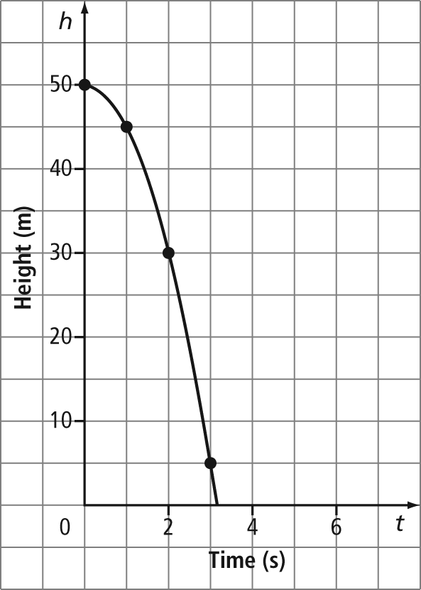
4. For each relation, state the dependent variable and the independent variable.
a)
b)
Age of a Person  (years) | Height  (cm)
2 | 87
3 | 96
4 | 104
5 | 110
c) 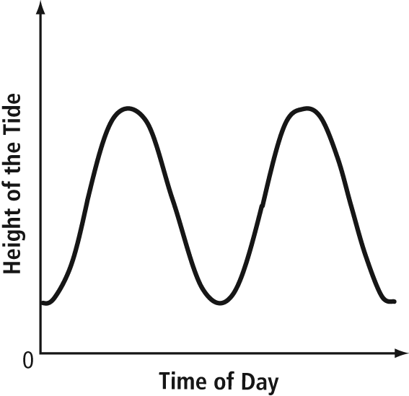

5. The table of values shows the cost of movie tickets at a local theatre.

Number of Tickets | Cost  ($)
1 | 12
2 | 24
3 | 36
4 | 48
a) Is this a linear or non-linear relationship? Explain how you know.
b) Assign a variable to represent each quantity in the relation. Which variable is the dependent variable and which is the independent variable?
c) Are the data discrete or continuous? Explain how you know.
d) Graph the data.
6. A white-tailed deer can sprint up to 48 km/h. One deer is walking at 8 km/h. Consider the relationship between the total distance, in kilometres, travelled by this deer and time, in hours.
a) Assign a variable to represent each quantity in the relation. Identify the dependent variable and the independent variable.
b) Assume the deer walks for 3 h without stopping. Create a table of values for this relation.
c) Graph the relation.
d) Is the relation linear or non-linear? Explain.
e) Is the relation continuous or discrete? Explain.

