Section 6.3 Extra Practice

1. Describe the set of numbers indicated by each number line using words and interval notation.
a)
b)
c)
d)
2. Represent the set of numbers indicated using a number line.
a) all real numbers less than 5 but greater than or equal to 0
b) (–4, 7]
3. Give the domain and range of each graph using words, a number line, interval notation, and set notation.
a) 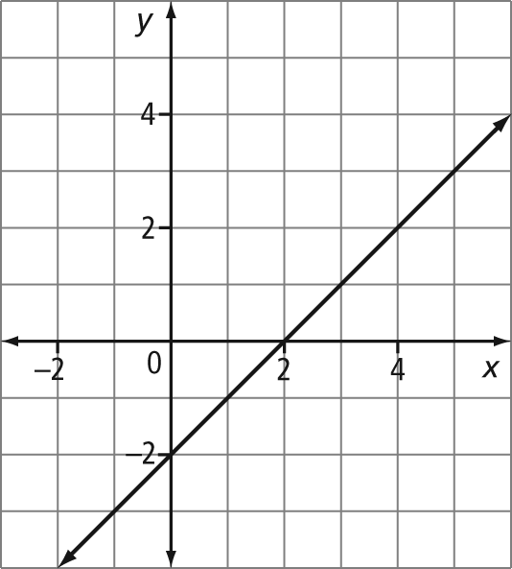
b) 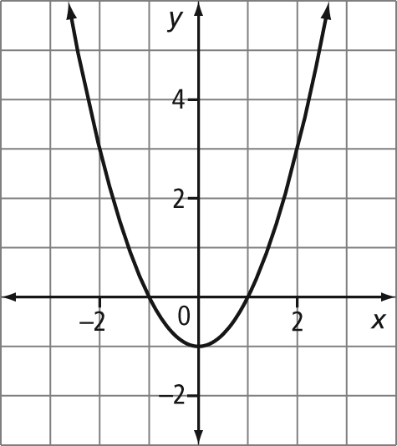
c) 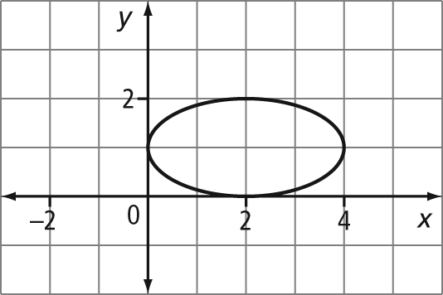
d) 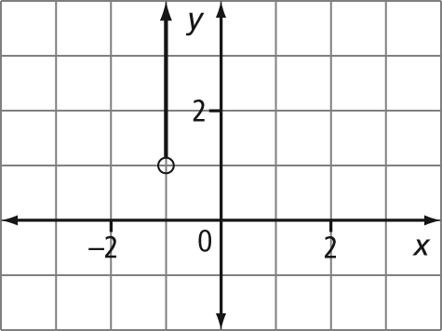
4. List the domain and range of each relation.
a) 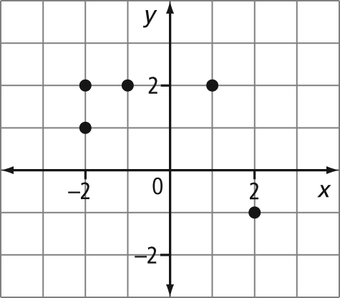
b)
x | y
7 | 3
5 | 2
3 | 1
1 | 0
c) (10, 5), (8, 4), (6, 3), (4, 2), (2, 1)
5. A relation is given by the formula
y = 3.5x + 5.
a) If the domain of the relation is [–10, 10], what is the range?
b) Graph the relation on a graphing calculator. Record the window values you chose and sketch a graph of the relation.
6. A relation consists of integers, where the second number is one more than the square of the first number. Write five ordered pairs for this relation.
7. The table shows the number of registered vehicles in Canada for various years.

Year | Number of Registered Vehicles
1916 | 128 328
1956 | 4 200 000
1975 | 11 200 000
1997 | 17 400 000
2008 | 28 500 000
a) Give the domain and range for this relation.
b) Graph the relation.

8. The table shows the heights of the tallest buildings in Calgary.

Building | Height (m)
1. Suncor Energy Centre West Tower | 215
2. Bankers Hall | 197
3. TransCanada Tower | 177
4. Canterra Tower | 177
5. First Canadian Centre | 167
6. Western Canadian Place North | 164
7. TD Canada Trust Tower | 162
8. Scotia Centre | 155
9. Nexen Building | 152
a) Give the domain and range for this relation.
b) Graph the relation.

