Section 6.4 Extra Practice

1. Determine whether each relation is a function or is not a function. Give reasons for your answer.
a) (4, 1), (5, –2), (6, –5), (7, –8), (6, –11), (5, –14), (4, –17)
b)
x | y
–2 | –2
–1 | 4
0 | –8
1 | 16
2 | –32
c) 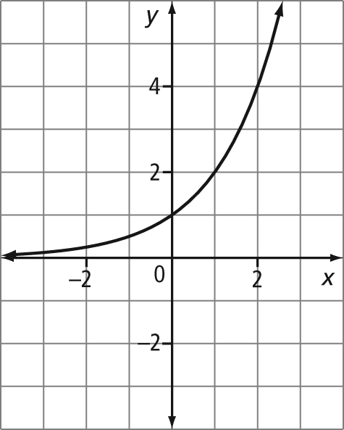
d) 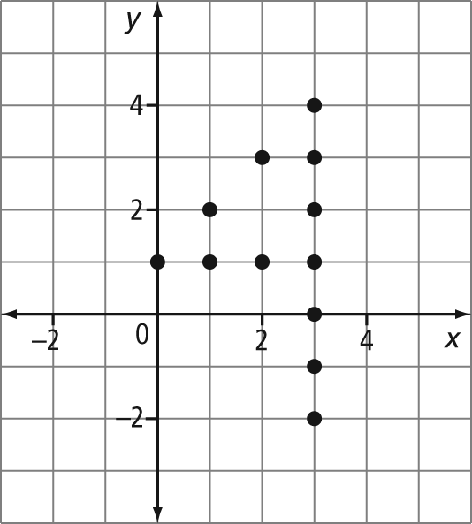
2. The formula for the value of a $500 investment at 6% interest, compounded annually, is A = 500(1.06)^{n}. Write this formula using function notation.
3. The cost of T-shirts for the basketball team is given by the function C(n) = 50 + 9n,
where n is the number of T-shirts and C is the cost, in dollars. Write this function as a formula with two variables.
4. If f(x) = 3x + 7, determine
a) b) f(–2) c) x if f(x) = 34
5. If g(x) =, determine
a) g(5) b) g(–3) c) x if g(x) =
6. Make a table of values and graph each function.
a) f(x) = 2x – 7 for the domain
{–2, –1, 0, 1, 2, 3, 4}
b) g(x) = x + 1 for the domain
{–9, –6, –3, 0, 3, 6, 9}
7. The formula for the volume of a sphere is f(r) = πr³. Determine
a) f(3) b) f(10)
c) d) r if f(r) = 6.28
8. The function C(n) = 25n describes the number of calories, C, in n crackers. Determine
a) C(12) b) n when C(n) = 475
9. The height of a diver on a board can be described by the function h(t) = 32 – 4.905t², where h is the diver’s height above the water, in metres, t seconds after jumping off the board.
a) Determine the diver’s height after 1.5 s.
b) Estimate how long the diver is in the air.
c) Determine an appropriate domain and range.

