Section 6.5 Extra Practice

1. Determine the slope of each line segment.
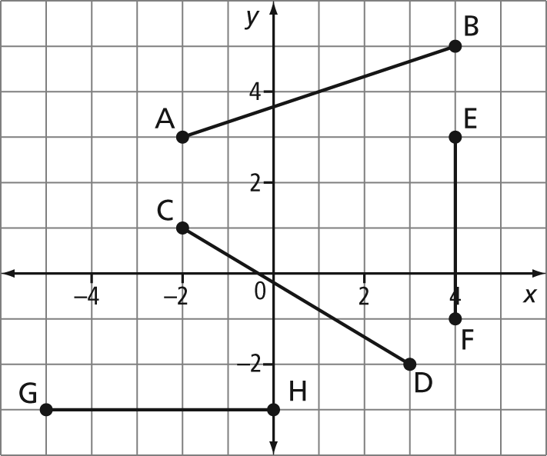
2. Use the slope formula to determine the slope of the line passing through each pair of points.
a) A(2, –1), B(3, 4)
b) C(0, 7), D(–3, 7)
c) E(2, –5), F(7, 6)
d) G(4, –2), H(4, –5)
3. The slope of a set of stairs is . If the stairs must rise 2.0 m, determine the horizontal length of the stairs, to the nearest tenth of a metre.
4. Graph each line, given a point on the line and its slope.
a) (4, 5), m = 3
b) (–2, 6), m =
c) (–5, –3), m = –2
d) (3, 1), m = 0

5. Determine three other points on the line defined by the given point and slope.
a) (1, 2), m = 2
b) (8, –1), m =
6. The line segment joining each pair of points has the given slope. Determine each value
of k.
a) (3, k) and (4, 7), m = 4
b) (–1, –2) and (k, k + 1), m =
7. A carpenter makes cabinets for a construction company and must meet a daily quota. The manager checks his inventory after 4 days and finds that there are 56 cabinets. After 9 days, the same carpenter has made 126 cabinets.
a) What is the carpenter’s daily quota?
b) How does his daily quota relate to the slope of the line through the points
(4, 56) and (9, 126)?
8. The world population increased from 5.76 billion in 1996 to 6.37 billion in 2006. Determine the rate of change in the world’s population.

