Chapter 7 Test

Multiple Choice
For #1 to 5, select the best answer.
1. Which of the statements is true for the graph shown?
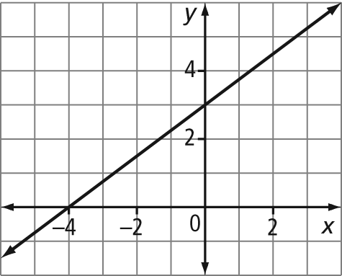
A The slope is .
B The intercepts are at –4 and 3.
C The x-intercept is at (–4, 0).
D The y-intercept is at (3, 0).

2. Which of the statements is true for the graph shown?
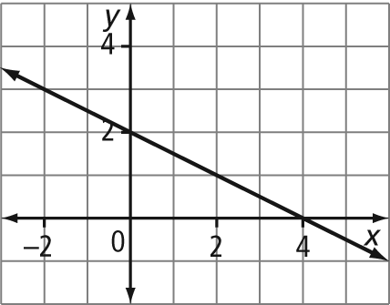
A The domain is {x| x ≥ 4, x ∈ R}.
B The range is {y| y ≤ 4, y ∈ R}.
C The domain and range are both [2, 4].
D The domain and range are both (∞, ∞).

3. To rewrite the equation –2x + 2y = 5 in the form y = mx + b, a possible approach could be
A subtract 2x from both sides and then divide both sides by 2
B add 2x to both sides and then divide both sides by 2
C add –2x to both sides and then multiply both sides by 2
D subtract 2x from both sides and then multiply both sides by 2

4. Which equation represents a linear relation that has an infinite number of intercepts?
A y = x B y = 2
C y = 0 D y = x – 1

5. Which graph shows a line with a slope of and a y-intercept of 2?
A 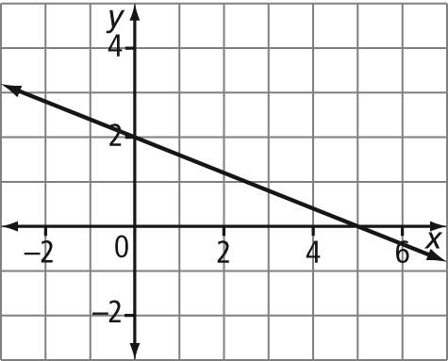
B 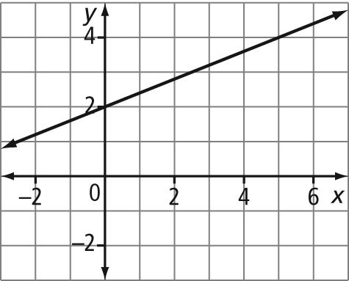
C 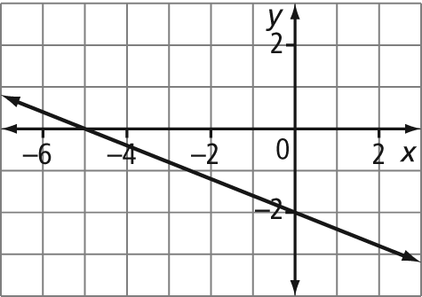
D 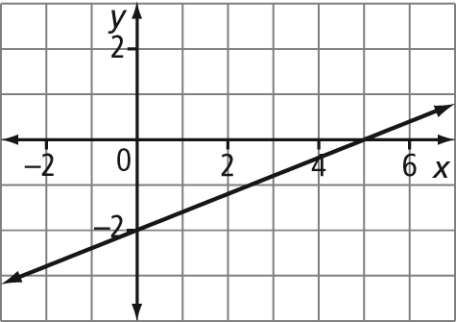

Short Answer
Complete the statements in #6 to #8.
6. The x-intercept of the graph of
5x – 3y – 15 = 0 is .

7. The slope of the graph of the relation
x = y + 2 is .

8. The y-intercept of the graph of the line
y – 3 = (x + 10) is .

9. Identify the slope and y-intercept of each line.
a) 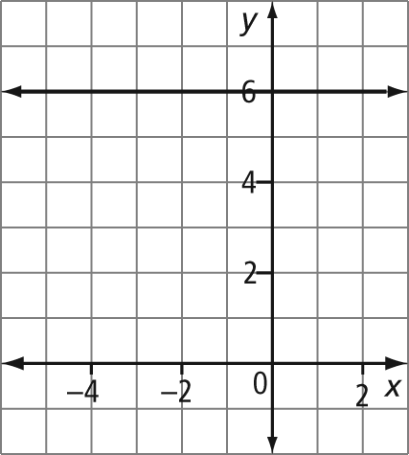
b) 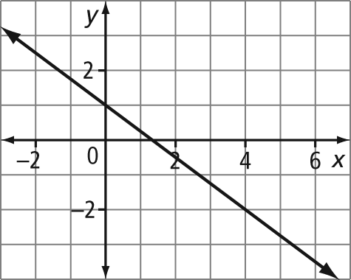
c) 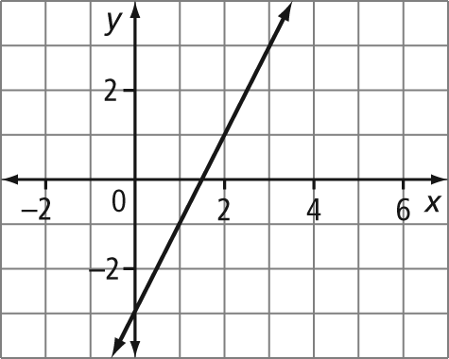
d) 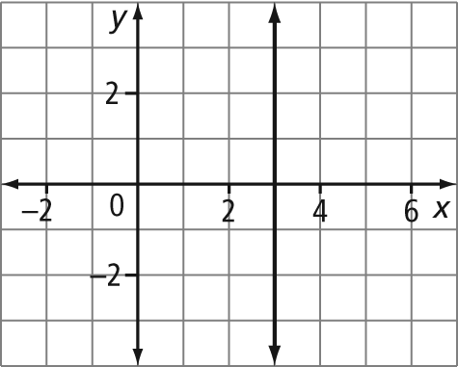

10. Identify the slope of a line parallel to each given line.
a) y = x + 9
b) 4x + 6y = 20

11. Identify the slope of a line perpendicular to each given line.
a) y = 2x – 4
b) 3x + 5y = 35

Extended Response
12. A hot-air balloon is rising at a constant rate of 0.75 m/s. The equation that represents the height of the balloon, h, in metres, as a function of time, t, in seconds, is
h = 0.75t + 3.
a) What does the h-intercept of the graph of the relation represent?
b) State a suitable domain for this situation. Explain what the domain means.
c) How high will the balloon be after 20 s?
d) How long will it take the balloon to reach a height of 15 m?

