Chapter 7 BLM Answers

BLM 7–2 Chapter 7 Prerequisite Skills
1. a) 12 b) 10 c) 6 d) 18 e) 30 f) 16 g) 60 h) 18
2. a) 4 b) –1 c) –2 d) –3 e) –10 f) –14
3. a) 2 + 7r + 4z b) 9y − 3 c) −3 + 4r d) x + 3y + 4
e) −5k − 5t + 2 f) −8t + 22 g) 6x − 8y − 6z
h) 4q + 4p − 1
4. a) 3x + 6 b) 13q + 6 c) −11p + 17
d) 11k − 11 or 11(k − 1) e) 10e − 6 or 2(5e − 3)
f) 20k + 24 or 4(5k + 6) g) −7x + 20 h) 7r + 11
5. a) 5 b) 7 c) 1 d) –9 e) 0 f)
6. Shaded tiles are positive and white tiles are negative.
a) 
b) 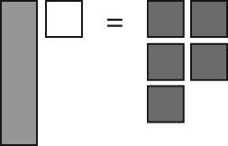
c) 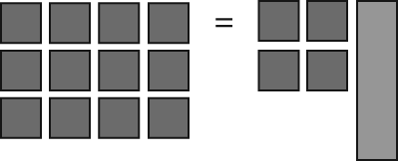
d) 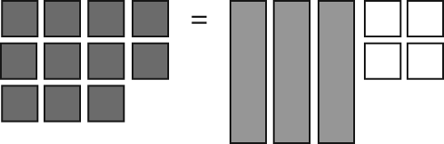
e) 
f) 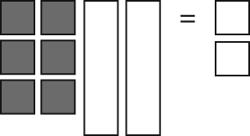

BLM 7–3 Chapter 7 Warm-Up
Section 7.1
1. a) b) c) undefined
2. a) b) 2
3. a) x-intercept: (9, 0), y-intercept: (0, 6)
b) x-intercept: (1, 0), y-intercept: (0, –2)
4. a) $240 b) $400
c) Example: Let C represent the cost, in dollars. Let t represent time, in hours. C = 200 + 4t
5. a) or b) d =
Section 7.2
1. a) y = x + 6 b) y = 2x – 2
2. a) y = –4 b) x = 5
3. a) 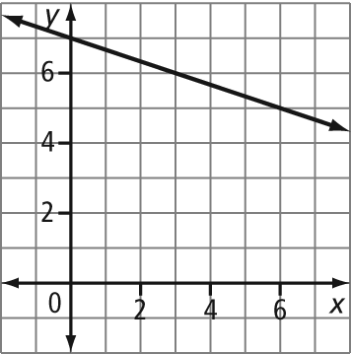
y = x + 7
b) 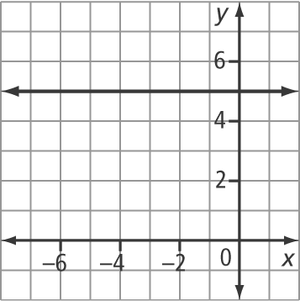
y = 5
4. a) x = b) x = –28
5. a) y = x + 3 b) y = x + 4
Section 7.3
1. a) 2x – 3y + 3 = 0 b) x + 5y + 15 = 0
2. a) 2x – y + 13 = 0 b) 4x – y – 6 = 0
3. a) 3x – 12 b) 4x – 4
4. a) y = x – 5 b) y = x + 2
5. a) 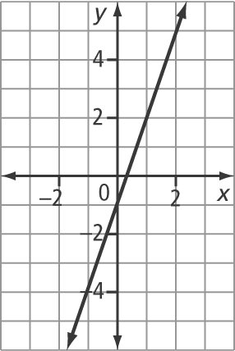
y = 3x – 1
b) 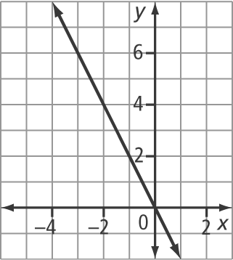
y = –2x
Section 7.4
1. a) 3 b)
2. a) y – 5 = (x + 1) b) y – 2 = (x – 4) or
y – 3 = (x – 8)
3. a) y = –4x + 15 b) y = x + 6
4. 4x + y – 19 = 0
5. a) b) c) 5

BLM 7–6 Section 7.1 Extra Practice
1. a) m = 5, y-intercept: (0, –3)
b) m = 0.1, y-intercept: (0, –5.7)
c) m = , y-intercept: (0, 4)
d) m = , y-intercept:
2. a) 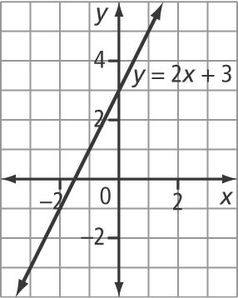
b) 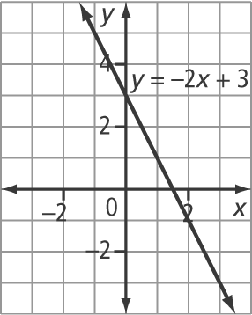
c) 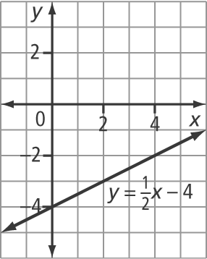
d) 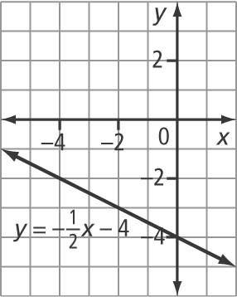
3. a) y = x + 4; m = , y-intercept: (0, 4)
b) y = x + 4; m = , y-intercept: (0, 4)
c) y = x – 2; m = , y-intercept: (0, –2)
d) y = 5x – 12; m = 5, y-intercept: (0, –12)

4. a) y = 2x – 5 b) y = 6 c) y = x d) y = –6x + 2
5. a) ; 2x – 6y = –3
b) ; 8x + 20y = 5
6. a) m = 1, y-intercept: (0, –2); y = x – 2
b) m = , y-intercept: (0, –1); y = x – 1
c) m = –2, y-intercept: (0, 3); y = –2x + 3
d) m = , y-intercept: (0, –2); y = x – 2
7. a) y = 2x + 2 b) y = x – 3 c) y = x + 4

BLM 7–7 Section 7.2 Extra Practice
1. a) 3x + y – 5 = 0 b) 2x – 3y – 12 = 0
c) 9x + 6y – 2 = 0 d) 8x – 20y – 3 = 0 e) y – 1 = 0
f) x + 2 = 0
2. a) x-intercept: (–4, 0), y-intercept: (0, 12)
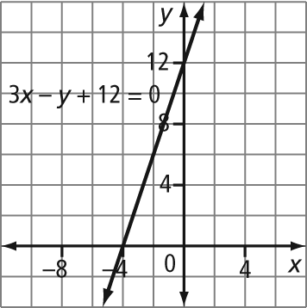
b) x-intercept: y-intercept: (0, 3)
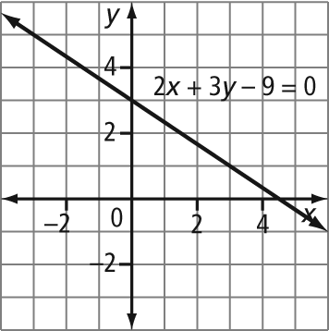
c) x-intercept: y-intercept: (0, –3)
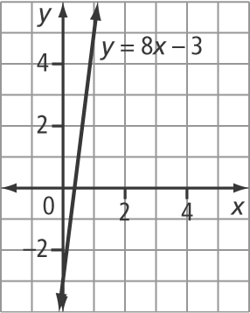
d) x-intercept: y-intercept:
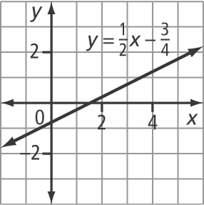
3. a) x-intercept: (4, 0), no y-intercept; domain {4}, range {y ∈ R}
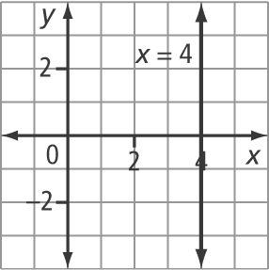
b) no x-intercept, y-intercept: (0, –1); domain {x ∈ R}, range {–1}
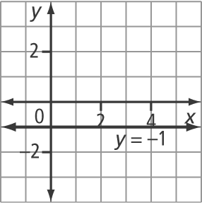
c) no x-intercept, y-intercept:
domain {x ∈ R}, range y =
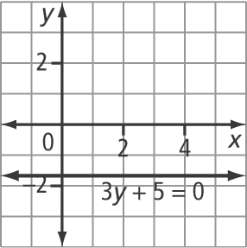
d) x-intercept: no y-intercept; domain , range {y ∈ R}
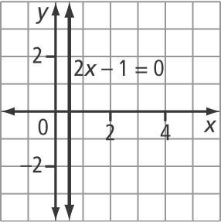
4. a) x – 3 = 0 b) y + 2 = 0
5. a) 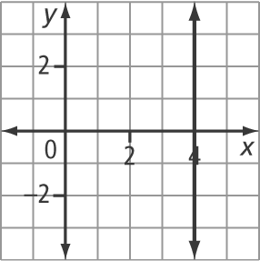
x – 4 = 0
b) 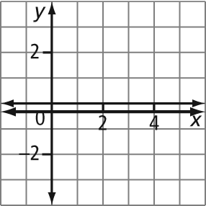
3y + 1 = 0
6. a) E b) A c) C d) B e) D
7. a) x + 1 = 0 b) y – 2 = 0

BLM 7–9 Section 7.3 Extra Practice
1. a) y = 5x – 11, 5x – y – 11 = 0
b) y = x + , 3x – 4y + 2 = 0
c) y = x – , 2x – 2y – 9 = 0
d) y = 2x – , 10x – 5y – 18 = 0
2. a) y – 3 = 2(x – 3) b) y – 1 = (x – 2)
c) y – 3 = (x – 5)

3. a) y – 4 = –5(x + 3); y = –5x – 11; 5x + y + 11 = 0
b) y – 1 = y = 2x; 2x – y = 0
c) y – 3 = 3(x – 0); y = 3x + 3; 3x – y + 3 = 0
d) y – 0 = (x + 5); y = x + ; x – 2y + 5 = 0
4. a) y = x – 3; x – y – 3 = 0
b) y = x + 5; x + 3y – 15 = 0
c) y = 2x + 10; 2x – y + 10 = 0
d) y = x + ; x + 3y – 7 = 0
5. a) m = , (–5, 3)
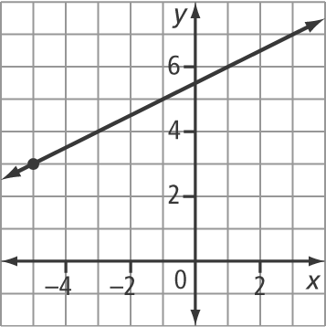
b) m = , (1, –4)
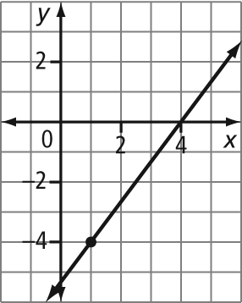
c) m = 2,
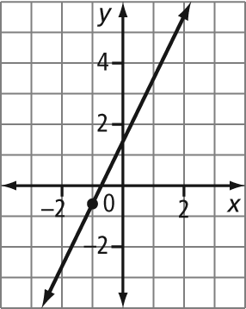
d) m = –4, (–0.4, 5)
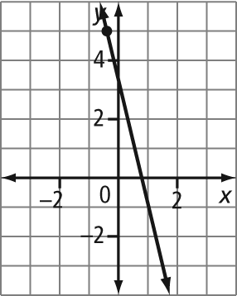
6. a) y + 6 = 0(x + 5); y = –6
b) y – 1 = 2(x – 4); y = 2x – 7
c) y – 0 = (x – 4); y = x + 2
7. a) y – 5 = (x – 0); 15x + 4y – 20 = 0
b) y – 4 = (x – 0); 4x – 5y + 20 = 0
c) y – 0 = (x – 0); 2x – 5y = 0

BLM 7–10 Section 7.4 Extra Practice
1. a) 3, b) –4, c) , –3 d) 0.4, –2.5
2. a) 2, b) , c) , 4 d) ,
3. a) 12, b) 1, –1 c) 2.5, –10 d) 9, –25
4. a) Parallel; the slopes are equal.
b) Neither; the slopes are not equal and they are not negative reciprocals.
c) Parallel; the slopes are equal.
d) Perpendicular; the slopes are negative reciprocals.
5. a) y = 4x – 11 b) y = x + 2 c) x = 4
6. a) y = b) y = x + 5 c) x = –1
7. a) y – 5 = 0 b) x – 1 = 0 c) 3x – 4y – 24 = 0
d) 3x – y – 10 = 0
8. a) Rectangle. Example: The opposite sides are parallel and the adjacent sides are perpendicular.
b) line AB: y = , line BC: y = ,
line CD: y = , line AD: y = – 14
BLM 7–11 Chapter 7 Test
1. C 2. D 3. B 4. C 5. A 6. 3 7. 5 8. 8
9. a) m = 0, y-intercept: (0, 6) b) m = ,
y-intercept: (0, 1) c) m = 2, y-intercept: (0, –3)
d) slope is undefined, no y-intercept
10. a) b)
11. a) b)
12. a) It represents the balloon’s height of 3 m above ground before it begins rising, at time 0 s.
b) {t | t ≥ 0, t ∈ R}; Example: Since time is positive, this results in a restriction on the height of the balloon.
c) 18 m d) 16 s

