Chapter 7 Warm-Up

Section 7.1 Warm-Up

1. Determine the slope of the line segment formed by joining each pair of points.
a) (3, 6) and (1, 5)
b) (3, 6) and (5, 1)
c) (3, 6) and (3, 8)
2. Identify the slope of each line.
a) 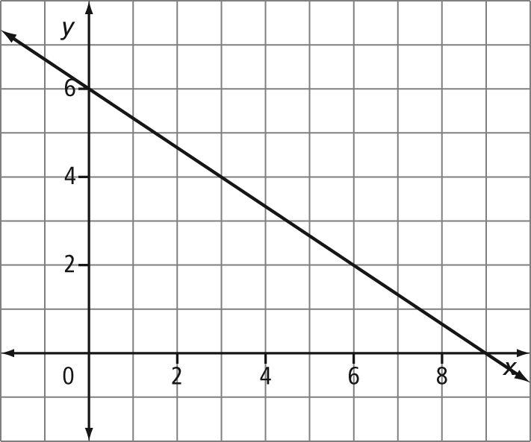
b) 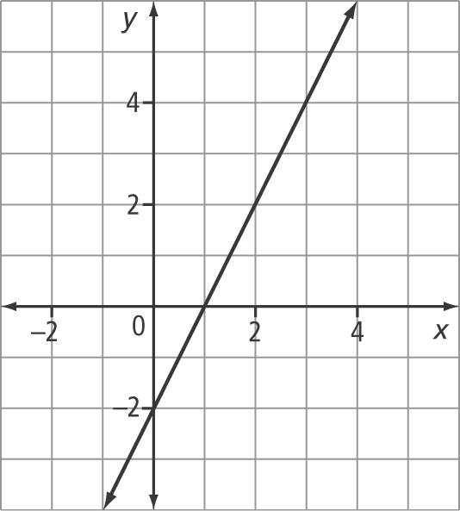

3. Identify the x-intercept and y-intercept of each line. Write your answers as ordered pairs.
a)
b)

4. To rent a venue for a party costs $200. You also pay $40 for each hour of use.
a) How much will it cost for a 1-h party?
b) What would the cost be for a 5-h party?
c) Determine a formula to model the cost of the venue.

5. Solve each equation for the desired variable.
a) P = 2l + 2w; solve for l
b) C = πd; solve for d

Section 7.2 Warm-Up

1. Write the equation of each line in
slope-intercept form.
a)
b)
2. Write the equation of each line in
slope-intercept form.
a) 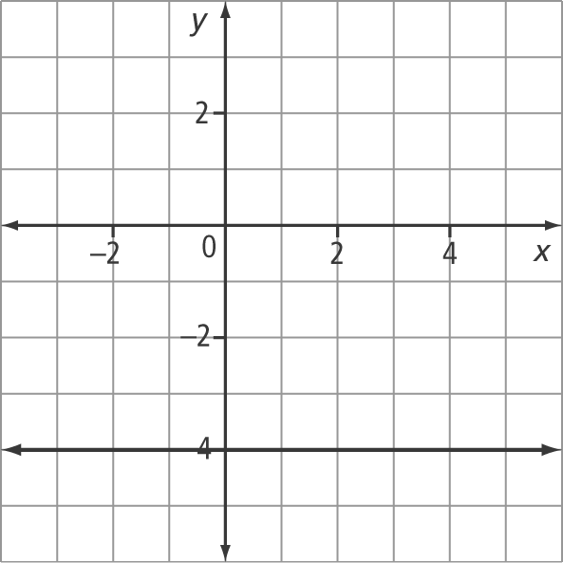
b) 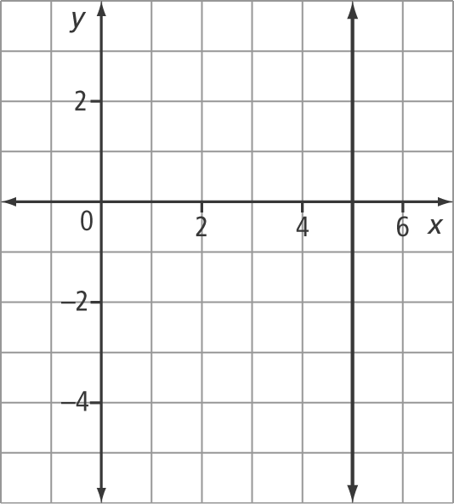
3. On grid paper, draw each line. Then, write the equation of the line in slope-intercept form.
a) The slope is . The line passes through the point (6, 5).
b) The slope is 0. The line passes through the point (–6, 5).
4. Solve each equation.
a) x + 5 = 2
b) x – 7 = x
5. Solve each equation for y.
a) 3x – 4y + 12 = 0
b) 2x + 6y – 24 = 0

Section 7.3 Warm-Up

1. Rewrite each equation in general form.
a) y = x + 1
b) y = x – 3
2. Rewrite each equation in general form.
a) y – 3 = 2(x + 5)
b) y + 2 = 4(x – 1)
3. Simplify.
a)
b)
4. Visualize each of the following lines. Then, write the equation in slope-intercept form.
a) x-intercept of 4 and y-intercept of –5
b) passing through (0, 2) and (4, 0)
5. On grid paper, draw each line. Then, write the equation of the line in slope-intercept form.
a) passing through (2, 5) and (–1, –4)
b) passing through (–3, 6) and (0, 0)

Section 7.4 Warm-Up

1. Identify the slope of each linear equation.
a) 3x – y + 8 = 0
b) 2x – 5y + 7 = 0
2. Write the equation of each line in
slope-point form.
a) slope of and passing through (–1, 5)
b) passing through (4, 2) and (8, 3)
3. Write the equation of each line in
slope-intercept form.
a) slope of –4 and passing through (2, 7)
b) passing through (2, 5) and (0, 6)

4. Write an equation in general form of the line that passes through (3, 7) and (5, –1).
5. Complete each statement.
a) is to as is to .
b) –4 is to as –3 is to .
c) is to –2 as is to .

