Section 7.1 Extra Practice

1. What are the slope and y-intercept of each line?
a) y = 5x – 3 b) y = 0.1x – 5.7
c) d)
2. Sketch the graph of each line using the slope and y-intercept.
a) y = 2x + 3
b) y = –2x + 3
c) y = x – 4
d) y = x – 4
3. Express each equation in slope-intercept form. Determine the slope and y-intercept of each line.
a) 4x + 5y – 20 = 0
b) x – 2y + 8 = 0
c) 2x – 3y = 6
d) 5x – y = 12
4. Write the equation of each line in the form
y = mx + b.
a) m = 2, y-intercept: (0, –5)
b) m = 0, y-intercept: (0, 6)
c) m = , y-intercept: (0, 0)
d) m = –6 , y-intercept: (0, 2)
5. Write the equation of each line in the form
y = mx + b and in the form Ax + By = C, where A, B, and C are integers.
a) m = , y-intercept:
b) m = , y-intercept:
6. What are the slope and y-intercept of each line? Write the equation of each line in the slope-intercept form.
a) 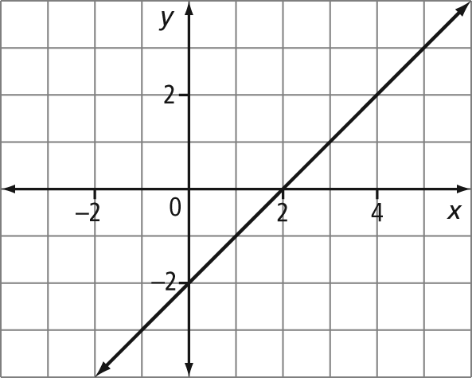
b) 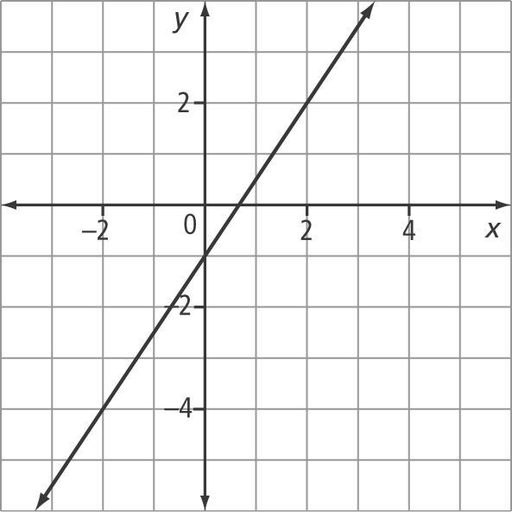
c) 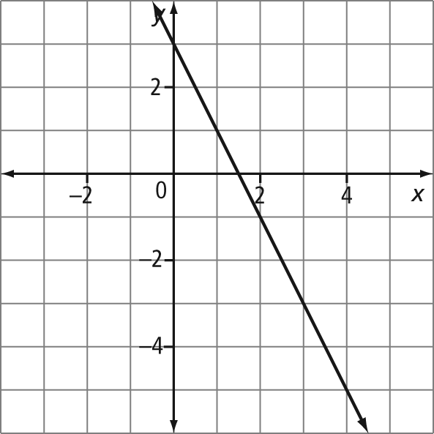
d) 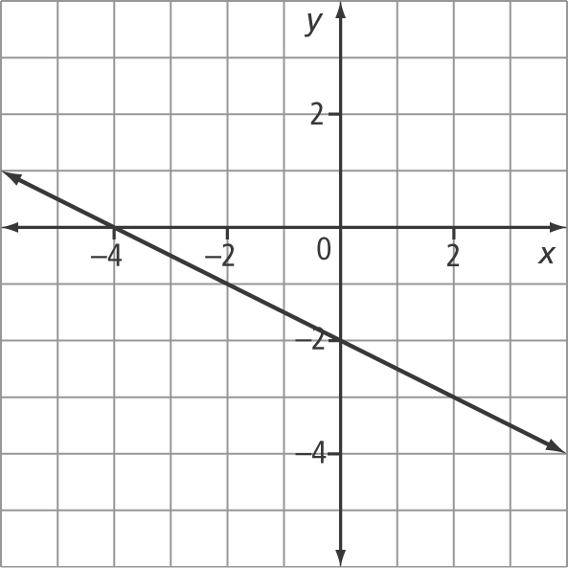
7. Write the equation of each line in the form
y = mx + b.
a) The slope is 2. The line passes through the point (1, 4).
b) The y-intercept is –3. The line passes through the point (–2, 6).
c) The line passes through the points (0, 4) and (2, 6).

