Section 7.2 Extra Practice

1. Express each equation in general form,
Ax + By + C = 0.
a) y = –3x + 5
b) y = x – 4
c) y =
d) y = 0.4x – 0.15
e) y = 1
f) x = –2
2. Determine the intercepts of each line. Then, graph the line.
a) 3x – y + 12 = 0
b) 2x + 3y – 9 = 0
c) y = 8x – 3
d) y =
3. Determine the intercepts of each line and graph the line. Then, state the domain and range.
a) x = 4
b) y = –1
c) 3y + 5 = 0
d) 2x – 1 = 0
4. What is the equation of each line, in general form?
a) 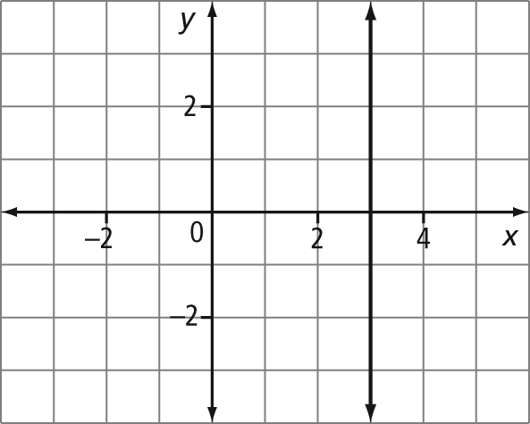
b) 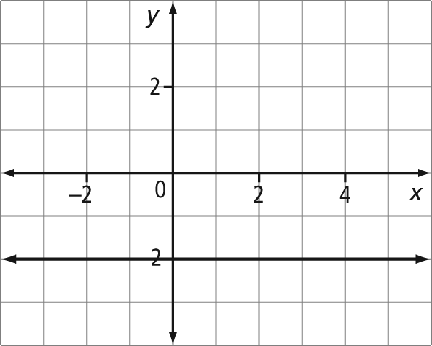
5. Graph each line using the given intercepts. What is the equation of the line?
a) The x-intercept is 4. There is no
y-intercept.
b) There is no x-intercept. The y-intercept
is .
6. Match each equation with a line labelled in the figure.
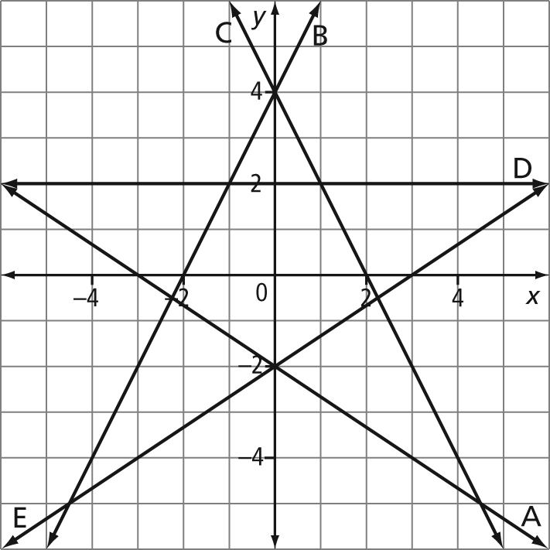
a) 2x – 3y – 6 = 0
b) 2x + 3y + 6 = 0
c) 2x + y – 4 = 0
d) 2x – y + 4 = 0
e) y – 2 = 0
7. Write an equation, in general form, for each line described.
a) a vertical line passing through the
point (–1, 5)
b) a horizontal line passing through the
point (–4, 2)

