Section 7.3 Extra Practice

1. Rewrite each equation from slope-point form to slope-intercept form, y = mx + b, and general form, Ax + By + C = 0.
a) y – 4 = 5(x – 3) b) y + 1 = (x + 2)
c) y – = x – 5 d) y + =
2. Write an equation in slope-point form,
y – y₁ = m(x – x₁), of each line passing through the given point.
a) 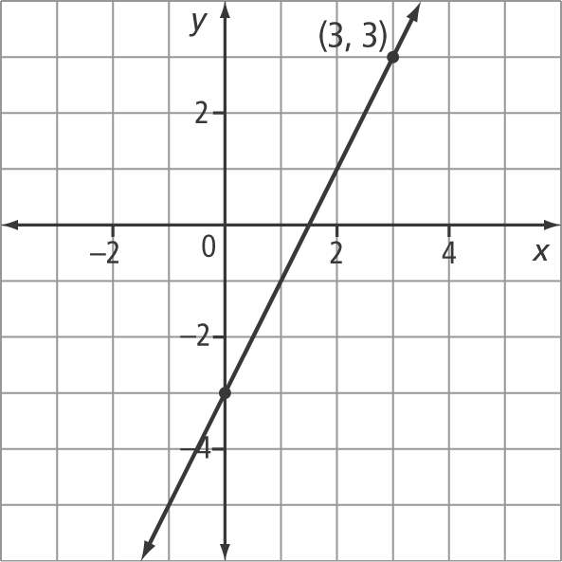
b) 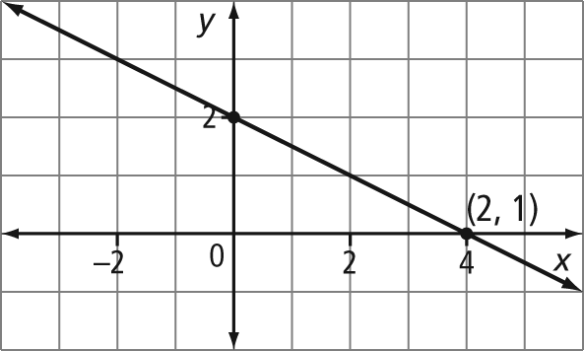
c) 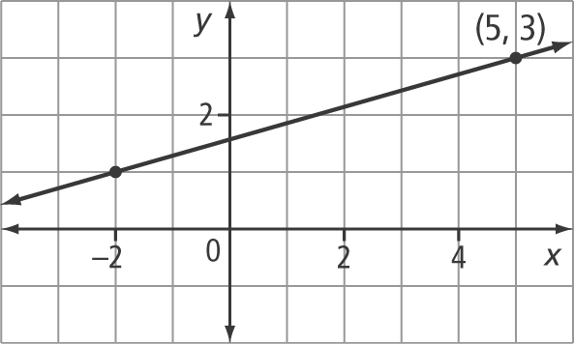
3. Determine the equation of each line using the slope-point form. Then, express each equation in slope-intercept form and in general form.
a) (–3, 4), m = –5 b) m = 2
c) (0, 3), m = 3 d) (–5, 0), m =
4. Use slope-point form to determine an equation of a line through each pair of points. Express each equation in the form y = mx + b and in the form Ax + By + C = 0.
a) (6, 3) and (1, –2) b) (0, 5) and (6, 3)
c) (–3, 4) and (–5, 0) d) (1, 2) and (–8, 5)
5. Identify the slope and one point on each line. Sketch a graph of each line.
a) y – 3 = (x + 5)
b) y + 4 = (x – 1)
c) y + = 2(x + 1)
d) y – 5 = –4(x + 0.4)
6. Write the equation of each line using
slope-point form. Convert to slope-intercept form.
a) slope of 0 and through (–5, –6)
b) same slope as y = 2x – 5 and through
(4, 1)
c) slope of and the same x-intercept as the line 3x – 2y = 12
7. What is the equation of each line in slope-point form? Convert each equation to general form.
a) same x-intercept as the line y = 3x – 4 and through (0, 5)
b) x-intercept of –5 and y-intercept of 4
c) same slope as 2x – 5y + 6 = 0 and through the origin

