Chapter 8 Prerequisite Skills

Show all your work.

1. The length of a spring changes according to the formula L = 12 + 4w, where L represents the length of the spring, in centimetres, and w represents the mass, in grams, hanging on the spring.
a) Create a table of values using whole numbers for w.
b) Can the points on your graph be joined? Explain.
c) Draw the graph.
d) Use your graph to determine the value of L when w = 2.5.
e) Determine the value of w when L = 25.
2. Draw a graph for each linear relation.
a) y = –2x + 5
b) 3x – 2y = 4
c) 5x + 4y – 8 = 0
3. Use the graph shown to answer the following questions.
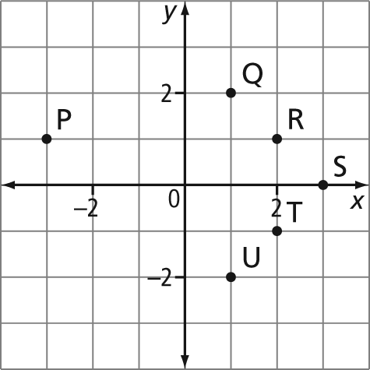
a) Which point has coordinates (2, –1)?
b) What are the coordinates of point S?
c) Which two points have the same
y-coordinate?
d) Which three points could be joined to form a right triangle?
e) What is the horizontal distance between points P and U?

4. The graph shown is supposed to represent a linear relation. However, one of the points was plotted incorrectly.
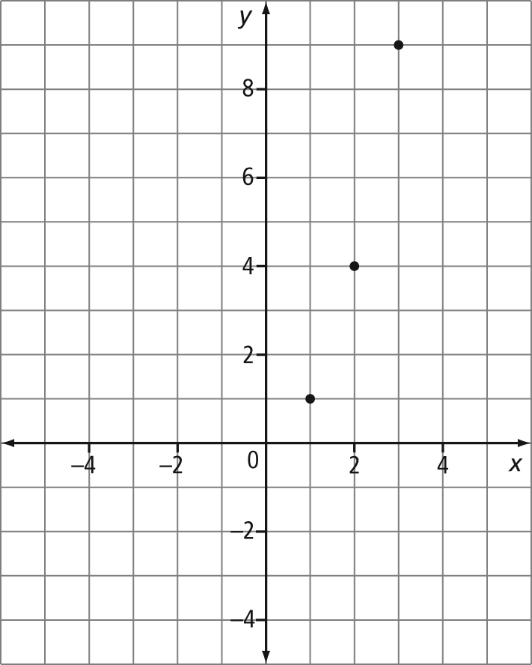
a) If the top point is incorrectly shown, what could its correct coordinates be? Why?
b) If the bottom point is incorrectly shown, what could its correct coordinates be?
5. An isosceles triangle has two equal sides. Sketch an isosceles triangle ABC, where A is located at (3, 2) and B is at (–2, 8). Determine two possible ordered pairs for point C.
6. The following diagrams show a pattern.
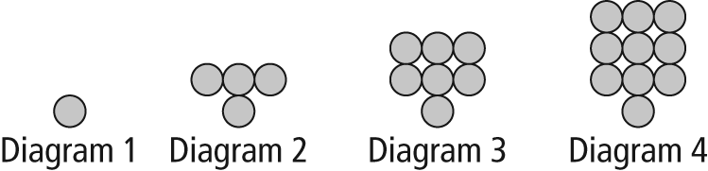
a) Describe the pattern in words.
b) Construct a chart showing the diagram number and the number of circles in the diagram.
c) If x represents the diagram number and
y represents the number of circles, draw a graph showing the pattern.
7. Consider the points W and P, as shown. Draw three rectangles that have points W and P as two of the vertices.
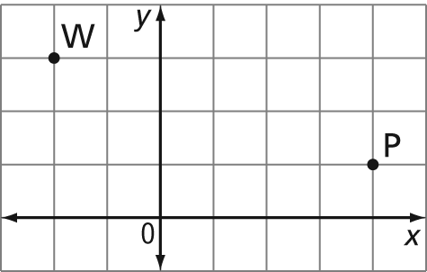
8. Consider the points V and W, as shown.
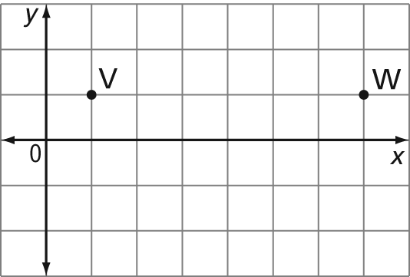
a) Sketch a possible equilateral
triangle UVW.
b) Looking at your sketch, what can you say about the coordinates of point U?

