Chapter 8 Test

Multiple Choice
For #1 to 4, select the best answer.
1. Tickets for the school drama production cost $12 for adults and $9 for students. Suppose 500 people purchased tickets and $5478 was collected. Which of the following systems of linear equations could be used to solve for the number of adults and number of students attending the play?
A
B
C
D
2. The system of linear equations 7x – 2y = 11 and 14x + my = n has an infinite number of solutions if
A m = –4, n = 22
B m = 4, n = 22
C m = –5, n = 18
D m = 5, n = 18
3. If a system of two linear equations has no solution, the graph of this system will be
A two intersecting lines
B two perpendicular lines
C two coincident lines
D two parallel lines
4. Which system of linear equations is shown in the graph?
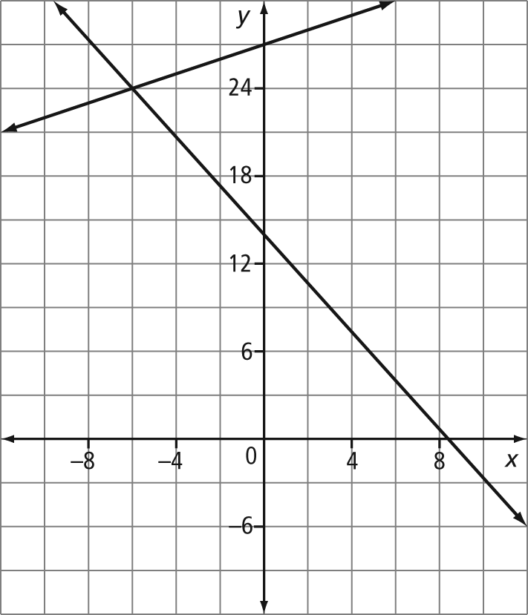
A
B
C
D

Short Answer
For #5 to 7, complete the statement.
5. If the points (2, 5) and (–2, 1) both lie on the line Ax + By = –27, the value of A must be .
6. The x-coordinate, to one decimal place, of the point of intersection of the graph of the system of linear equations 4x + 5y = –18 and 3x + 2y = 7 is .
7. If the sum of two numbers is 83 and the difference of the two numbers is 41, then the smaller number must be .
8. Represent the system of linear equations
y = 5x + 1 and y = x – 6 using a table of values. Then, determine the solution to the linear system from your table of values.
9. Explain the significance of the given point to the graph of each system of linear equations.
a) y = –x + 4
y = 2x + 4
(4, 0)
b) y = –3x + 9
y = –3x + 3
(3, –6)
c) y = x + 1
y = –4x + 1
(0, 1)
10. Solve each system of linear equations graphically. Verify the solution algebraically.
a) y – 7 = 2x
y – 1 = x
b) x + 6y = –7
2x + 12y = –14
c) 3x + y – 1 = 0
x – 2y – 26 = 0

Extended Response
11. Shirley and her younger brother, Aaron, differ in age by six years. Half of Shirley’s age is two less than Aaron’s age.
a) Develop a system of linear equations in two variables that could be used to determine the ages of Shirley and Aaron.
b) The domain of this situation cannot be all real numbers. Explain why.
c) Graph the system of linear equations to determine how old Shirley and Aaron are.
12. Family history books are to be sold at
a family reunion. The cost of the books includes a $500 setup fee plus an additional $6 per book. A book will sell for $35. The cost and the revenue can be represented by the following system of linear equations:
Cost: d = 500 + 6b
Revenue: d = 35b
In the equations, d represents the amount of money, in dollars, and b represents the number of books.
a) Use technology to graph the linear system and determine the point of intersection, to one decimal place.
b) The solution shows the break-even point, or the point at which the cost and revenue are equal. Considering the domain of the situation, how many books must be sold to ensure a profit is made?

