Chapter 8 BLM Answers

BLM 8–2 Chapter 8 Prerequisite Skills
1. a) Example:
w | L
0 | 12
1 | 16
2 | 20
3 | 24
4 | 28
5 | 32
b) Example: Yes. The values of both the domain and range belong to the real numbers.
c) Example: 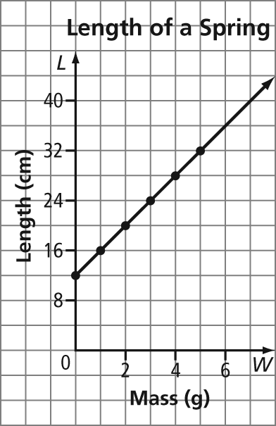
d) 22 cm e) 3.25 g
2. a) 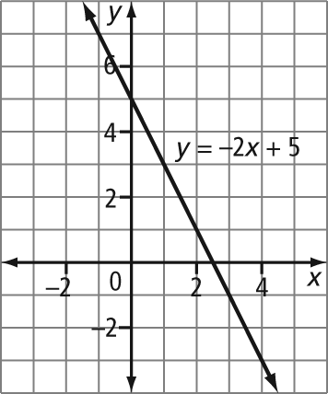
b) 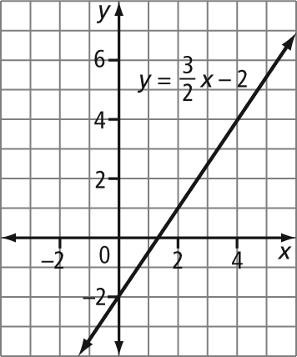
c) 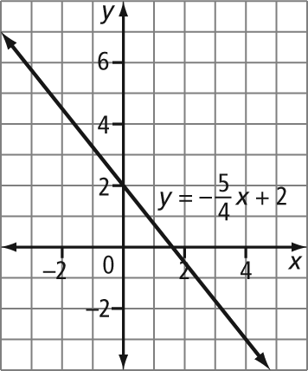
3. a) T b) (3, 0) c) P and R
d) Several combinations are possible. Examples: PRT, QST, QSU, RST, RSU
e) 4 units
4. a) (3, 7). Example: The slope must be constant for these points to represent a linear relation. The slope between the first two points, (1, 1) and (2, 4), is 3. So, the top point should be up 3 and to the right 1. The point must be located at (3, 7).
b) (1, –1)
5. Example: 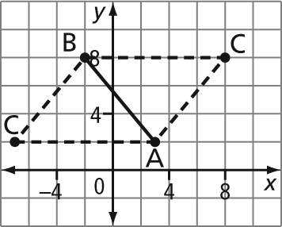
(–7, 2) and (8, 8)
6. a) Example: The pattern starts with one circle. To create each subsequent diagram, a row of three circles is added.
b)
Diagram Number | Number of Circles
1 | 1
2 | 4
3 | 7
4 | 10
c) 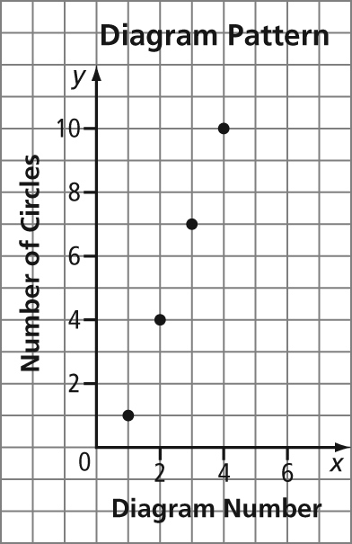
7. Example: 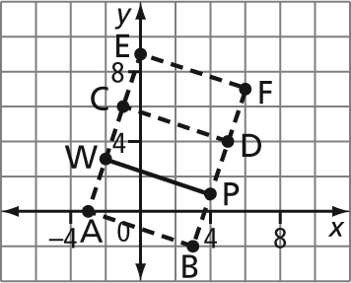
Rectangles ABPW, PWCD, and PWEF
8. a) Example: 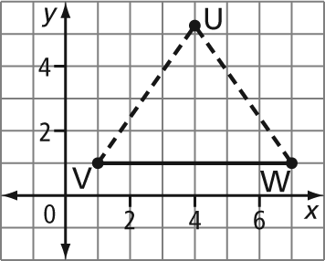
b) Example: The x-coordinate of point U is 4. If U is in quadrant I, the y-coordinate is positive and has a value between 6 and 7. If U is in quadrant IV, the
y-coordinate is negative.

BLM 8–3 Chapter 8 Warm-Up
Section 8.1
1. B
2. (–4, 3); 2x + y = 5
Left Side Right Side
2x + y 5
= 2(–4) + 3
= –8 + 3
= –5
Left Side ≠ Right Side
3. 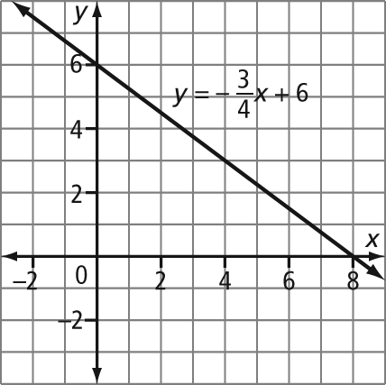
4. y = x – 6; slope, y-intercept –6
5. 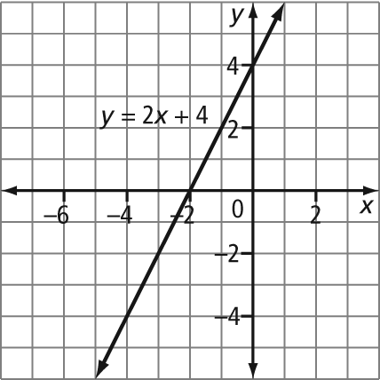
Section 8.2
1. 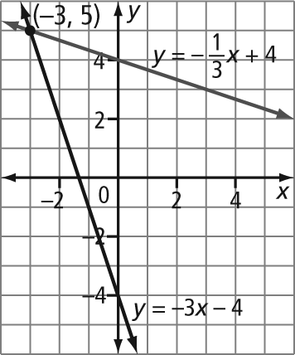
2. 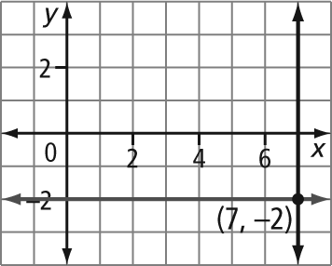
3. a) 2x + 3 b) x – 7 c) 3x –x or 3x – 0.5x
4. a) 12 ft/min b) 3 c) $0.07/min
5. a) 0 km b) $0 c) $500
Section 8.3
1. a) 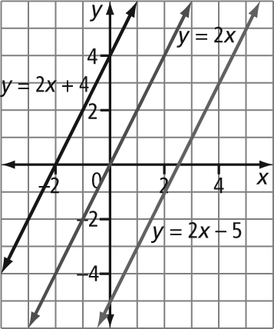
b) They all have the same slope.
c) No
2. a) 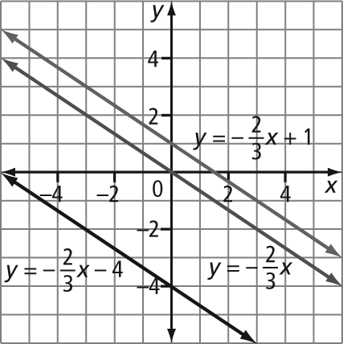
b) Example: These lines are parallel, because they all have the same slope.
c) Example: y = 2x + 1
3. a) 1, 2, 3, 4 b) –2, –1, 0, 1
c) –6, –5, –4, –3, –2
4. Example: 0.1, 0.2, 0.4, 0.7, 0.95
5. Example: There are an infinite number of real numbers between 0 and 1.

BLM 8–5 Section 8.1 Extra Practice
1. a) (2, 7) b) (1, 3) c) (–3, 1)
d) (1.5, 1) e) (–1, –1)
2. a) (–4, 5) b) (4, –5)
3. a) No b) Yes c) Yes d) No
4. 14
5. a) 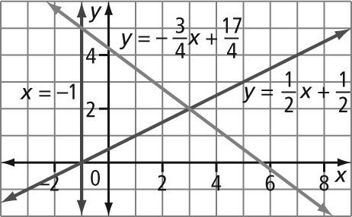
b) (–1, 5), (3, 2), and (–1, 0)
6. a) 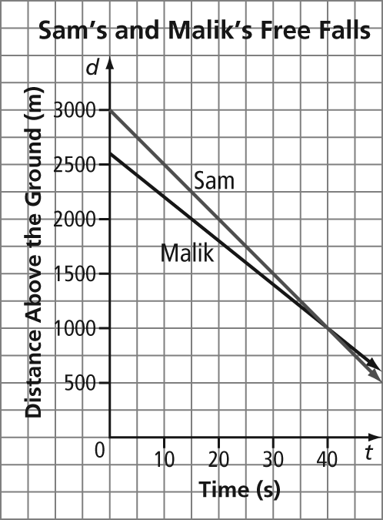
b) (40, 1000)
c) At 40 s they are both 1000 m above the ground.
7. wind: 55 km/h, plane: 365 km/h

BLM 8–6 Section 8.2 Extra Practice
1. a) Let x represent the small number. Let y represent the large number. The equations x + y = 42 and y = x + 8 form a linear system.
b) Let x represent Jim’s mass, in kilograms. Let y represent Terry’s mass, in kilograms. The equations
x = y – 10 and y + x = 105 form a linear system.
c) Let x represent the number of nickels. Let y represent the number of dimes. The equations
5x + 10y = 375 and 3y = x form a linear system.
d) Let x represent the price of a pen, in dollars. Let y represent the price of a notebook, in dollars. The equations 3x + 3y = 6.90 and 2y + x = 4.10 form a linear system.
2. a) Let x represent the amount invested at 8%, in dollars. Let y represent the amount invested at 10%, in dollars. The equations 0.08x + 0.10y = 496 and
x + y = 5200 form a linear system.
b) Let x represent the first part. Let y represent
the second part. The equations x + y = 12 and
2x + 3y = 29 form a linear system.
3. 0.75 km
4. Example: Option 2 is better for sales from $0 to less than $6250. For sales of $6250, the two payment options are equal. Option 1 is better for sales over $6250.
5. Gabriel will overtake Sakura in 100 s at a distance of 350 m.
6. 42 nickels, 33 dimes
7. 375 adult tickets, 125 child tickets
8. wind: 50 km/h, plane: 550 km/h
9. flat fee: $22.50, charge per kilometre: $0.09

BLM 8–7 Section 8.3 Extra Practice
1. a) One solution. The equations have different slopes.
b) Infinite number of solutions. Both equations have the same slope and y-intercept.
c) No solution. The equations have the same slope and different y-intercepts.
2. a) One solution. The equations have different slopes.
b) No solution. The equations have the same slope and different y-intercepts.
c) Infinite number of solutions. Both equations have the same slope and y-intercept.
3. a) b ≠ 4 b) not possible c) b = 4
4. a) not possible b) m ≠ –2 c) m = –2
5. a) m = 4, b ≠ –1
b) m ≠ 4, b is a real number
c) m = –4, b = –1
6. a) C ≠ 12 b) not possible c) C = 12
7. i) A and B, B and C
ii) A and D, B and D, C and D
iii) A and C

BLM 8–8 Chapter 8 Test
1. C 2. A 3. D 4. B 5. 9 6. 10.1
7. 21 8. (–2, –9)
9. a) The given point is the x-intercept of the first line.
b) The given point lies on the second line.
c) The given point is the y-intercept of both lines as well as the point of intersection.
10. a) (–6, –5) b) infinite number of solutions
c) (4, –11)
11. a) Let s represent Shirley’s age, in years. Let a represent Aaron’s age, in years. The equations
s – a = 6 and s = a – 2 form a linear system.
b) Age cannot be less than 0.
c) Shirley is 16 years old and Aaron is 10 years old.
12. a) (17.2, 603.4) b) 18 books

