Chapter 9 BLM Answers

BLM 9–2 Chapter 9 Prerequisite Skills
1. a) y = 2x + 5 b) y = x – c) y = 4x + 3
2. Example: 2c + 10. Let c represent Carole’s age.
3. a) 9 b) Let n represent the term number. 2n – 1
4. a)
Term Number | 1 | 2 | 3
Number of Squares | 3 | 5 | 7
b) Example: Continue the pattern in the chart, drawing the additional diagrams needed, or develop a formula to represent the pattern and use the formula to calculate the number of squares. c) 2t + 1
5. a) t – 5 b) Example: Let the original number of almonds in the bowl be n. n + 12 c) Example: Let your age be x. Your brother’s age is x + 10.
6.
Term Number | 1 | 2 | 3 | 8
Number of Squares | 8 | 12 | 16 | 36
7. a) 4x – 3
b) 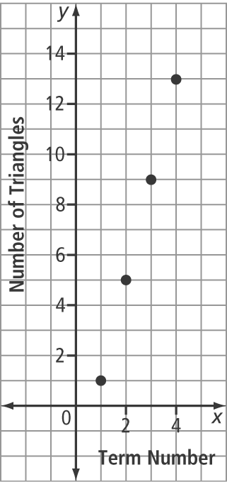
8. a) 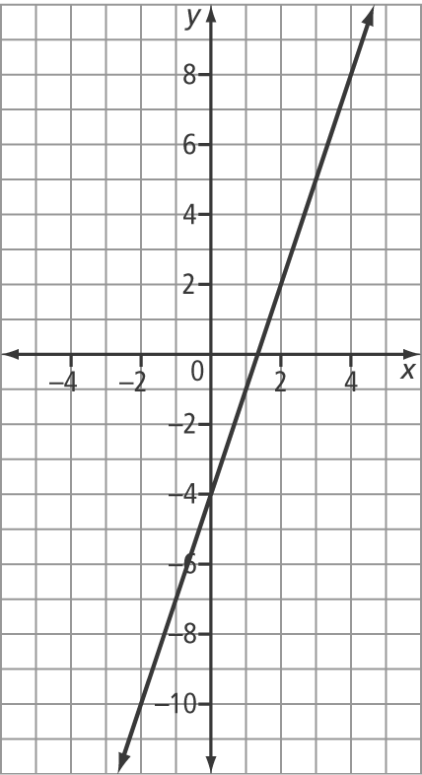
b) Example: No, the graph would not change, because the relationship between the variables has not changed. c) Example: No
d) No e) Example: When you multiply or divide both sides of an equation by the same value (other than zero), the line does not change.
9. a) c = 40 cm b) c = 27.5 cm c) Yes. Example: Substitute 600 for m to get c = 20. This means that the ground clearance is 20 cm. Because the curb is only 18 cm high, the bumper will clear it. d) 1000 kg

BLM 9–3 Chapter 9 Warm-Up
Section 9.1
1. the number of students who attended and the number of adults who attended
2. the cost to take a car on the ferry and the cost for an adult to ride the ferry
3. a) y = – 4 b) y = –– 10
4. a) x = 1 b) y =
5. a) –x + b) 2y –– 7

Section 9.2
1. Let s represent the number of students attending and let a represent the number of adults attending.
s + a = 100 and 2s + 5a = 520
2. Let m represent the number of muffins sold and let y represent the number of yogurts sold. m + y = 160 and 1.5m + 2y = 273.50
3. a) l = 2w – 1 b) w = 5 + l c) 2l + 2w = 24
4. a) 8x – 3y b) –20c – 10w
5. a) –2x – 7y b) 100c + 110w

Section 9.3
1. 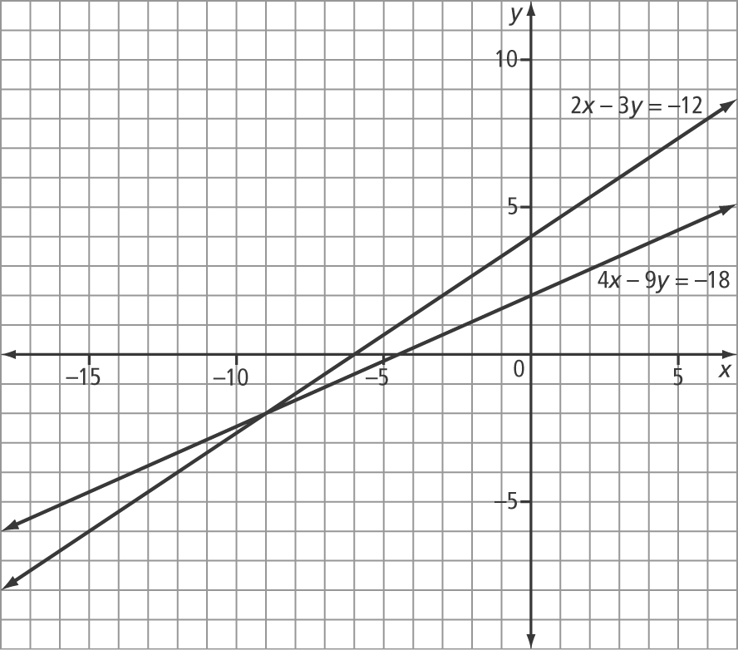
(–9, –2)
2. x = 1 and y = 1 3. y = 2 and x = 1
4. x = 1 and y = 2 5. A

BLM 9–5 Section 9.1 Extra Practice
1. a) x = –1 and y = 5 b) x = –2 and y = 9
c) x = –1 and y = –3
2. a) x = 3 and y = 6 b) x = –2 and y = –2
c) x = 4 and y = 4
3. a) x = –5 and y = –3 b) x = –4 and y = –15
c) x = 4 and y = 4
4. Example: The algebra is easier to do when you isolate y.
5. a) x = 15 and y = 0 b) x = –50 and y = 2000
c) x = 6 and y = –2
6. a) x = –0.5 and y = 6 b) x = 8 and y = 6
c) x = –15 and y = 9
7. a) 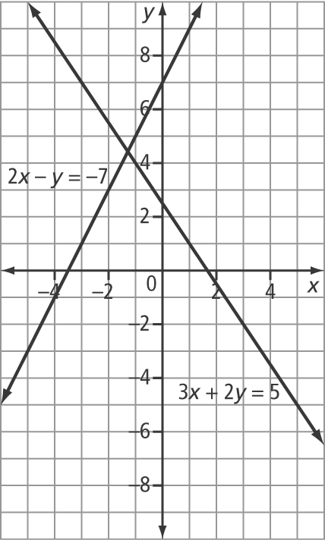
Approximate solution: (–1.25, 4.5)
b) x = and y = c) The answers are approximately the same, but the algebraic method gives the exact value.
8. $1.80 9. 6 cm by 18 cm 10. 5 and 51

BLM 9–6 Section 9.2 Extra Practice
1. a) x = 7 and y = –3 b) x = 3 and y = 8
c) x = 4 and y = 6
2. a) x = 0 and y = b) x = 2 and y = –4
c) x = 4 and y = 2
3. a) x = 4 and y = 7 b) x = 6 and y =
c) x = –2 and y = 3
4. a) x = –2 and y = 2 b) x = –and y = 6
c) x = 9 and y = –6
5. a) x = 3 and y = 5 b) x = –2 and y = 5
c) x = –1 and y = 7
6. a) no solution b) infinite number of solutions
c) no solution
7. 12 and 30 8. 5 km/h
9. $5000 at 6% and $10 000 at 8%
10. length = 30 m and width = 8 m

BLM 9–7 Section 9.3 Extra Practice
1. a) x = and y = –1
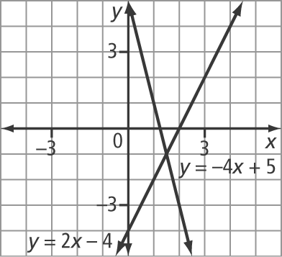
b) x = 4 and y = –10
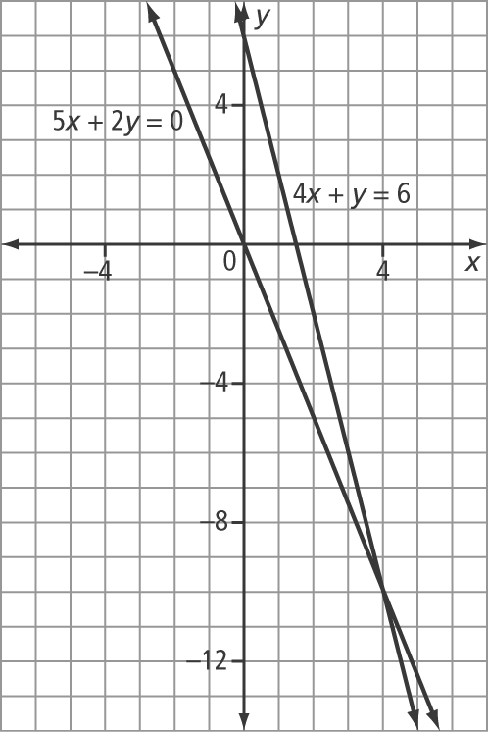

c) x = –2 and y = –1
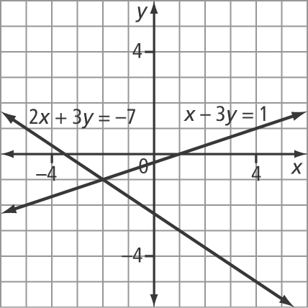
2. a) x = –5 and y = –7 b) x = –2 and y = 0
c) x = –6 and y = 12
3. a) x = –and y = b) no solution
c) infinite number of solutions
4. 28° and 62°
5. child: $8; adult: $15
6. The father is 40 years old and the daughter is 10 years old.
7. 40 kg of cashews and 60 kg of walnuts
8. x = 12 and y = 8
BLM 9–8 Chapter 9 Test
1. C 2. B 3. A 4. D
5. 4 6. 2 7. 350
8. a) Example: Substitution, because it is easy to isolate y in the first equation
b) Example: Elimination, because isolating a variable in either equation creates numbers that are difficult to work with
9. a) r = –3 and s = b) x = and y = 2
10. a) x = and y = – b) x = 4 and y = –6
11. a) W = 50 + 0.75T and W = 65 + 0.25T, where W represents the total amount earned by either Matt or Rebecca, and T represents the total amount in tips collected. $30 b) $72.50
12. apple: 90 g; pear: 360 g

