Chapter 5 Task B Solution

Solutions will vary. Sample answers:

1. a) AC = 26 cm, AB = 33 cm, BC = 20 cm

b) AB is fixed as 33 cm.
Length of AC | Length of BC | Measure of ∠C
30 cm | 16 cm | 86º
36 cm | 10 cm | 65º
23 cm | 23 cm | 92º
18 cm | 28 cm | 89º
38 cm | 8 cm | 52º
11 cm | 35 cm | 71º

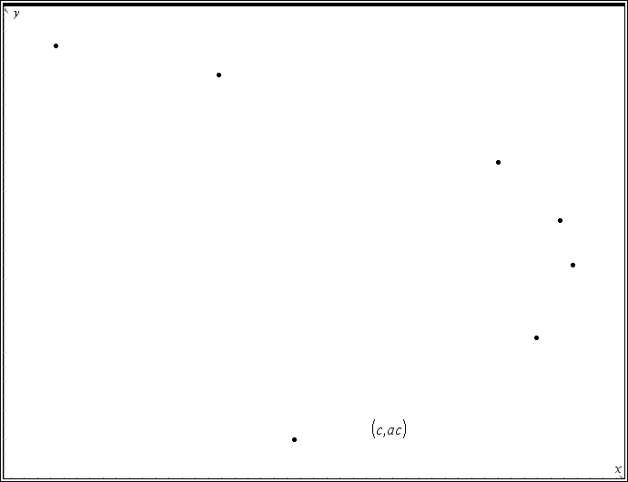
2.

The graph is similar to a sideways parabola. ∠C will have two reversed sets of side lengths for CA and CB, one when ∠A is obtuse and the reverse when ∠A is acute.

3. This relationship is not a function because it fails the vertical line test.

4. There are two different lengths for AC (and therefore two different triangles) that produce the same measure for ∠C. If the measure of an angle is known, you would not know which AC produced it, the ambiguous case.

