Graphs and Lines

1. Graph each linear relation.
a) y = −2x + 4 b) x = 3
c) 3x − 4y − 12 = 0 d) y = x + 4
2. For the graph of a linear relation, determine
the equation in slope y-intercept form.
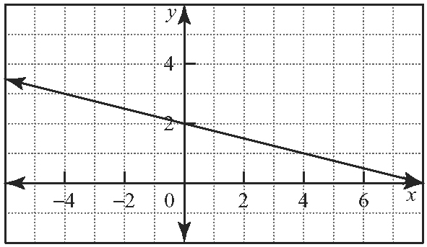

3. Determine the equation in the form y = mx + b for the line passing through each pair of points.
a) (−2, −6) and (4, −3) b) (3, 2) and (1, −4)
c) (3, −1) and (6, −3)
4. Use elimination to find the point of intersection
of each pair of linear relations.
a) 2x − 3y = −6 and x + y = 7
b) x − 2y = −6 and 3x − y = −8
5. Use substitution to find the point of intersection
of each pair of linear relations.
a) x + y = 2 and y = 4x + 1
b) 2x − y = 17 and x + 2y = − 4

Working With Polynomials

6. Expand and simplify each expression.
a) (2x − 1)(3x + 4) b) (2t − 3)²
c) 5(n + 4)(n − 3) d) (2x − 5)(6x + 1)
7. Factor completely.
a) x² − 2x + 1 b) x² + x − 20
c) 3x² + 3x − 6 d) −8x² − 8x + 6
8. Identify if each quadratic expression is a perfect square trinomial. For the perfect square trinomials, write the factored form.
a) x² + 2x + 12 b) 4n² − 4n + 1
c) x² + 8x + 16 d) 3x² + 6x + 9

9. Determine the value of k that makes each expression a perfect square trinomial.
a) x² + 4x + k b) x² − 12x + k
c) x² − x + k d) x² − 5x + k
10. Factor the rational coefficient of the x²-term
in each expression.
a) x² + 3x b) x² − x
c) x² + 12x d) x² + 4x

Quadratic Relations

11. For each quadratic relation, state
i) the coordinates of the vertex
ii) the equation of the axis of symmetry
iii) the direction of opening
iv) the y-intercept
Then, sketch a graph of the relation.
a) y = −3(x + 2)² + 7 b) y = (x − 4)² − 5
12. Determine the equation of the quadratic relation that corresponds to the graph. It has the same shape as y = x².
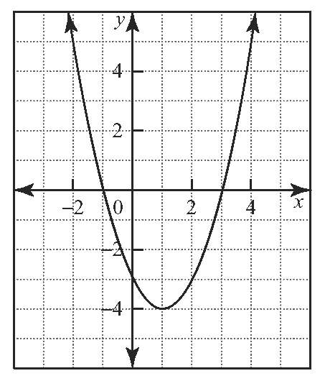
13. Complete the square to express each quadratic relation in the form y = a(x − h)² + k. Then, give the coordinates of the vertex.
a) y = x² − 2x + 4 b) y = 3x² + 18x + 16
14. a) Without graphing, predict how the graphs of the equations in each pair will differ. Explain your reasoning.
i) y = (x − 1)² − 4 and y = (x + 1)² − 4
ii) y = 2(x + 2)² + 2 and y = 2(x + 2)² − 2
b) Use Technology Verify your answers to
part a) by graphing the two equations using a graphing calculator.

