1.1 Functions, Domain, and Range

1. List the range for the domain {−2, −1, 0, 1, 2} for each relation.
a) y = 2x + 5
b) y =
c) x² + y² = 4

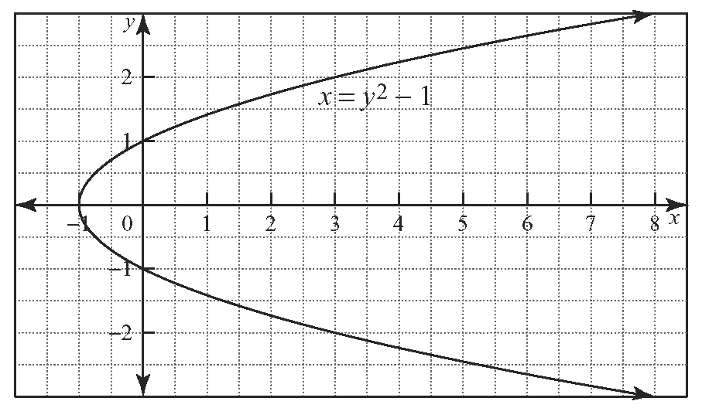
2. Determine the domain and range of each relation.
a)

b)
c) y = –3x² + 4

3. List the relations from questions 1 and 2 that are functions.

1.2 Functions and Function Notation

4. a) Complete the table of values for the relation
y = (x + 3)² − 5.
x | y
–6
–5
–4
–3
–2
–1
0
b) Graph the relation using the coordinates from the table of values.

5. The given graph represents the function.
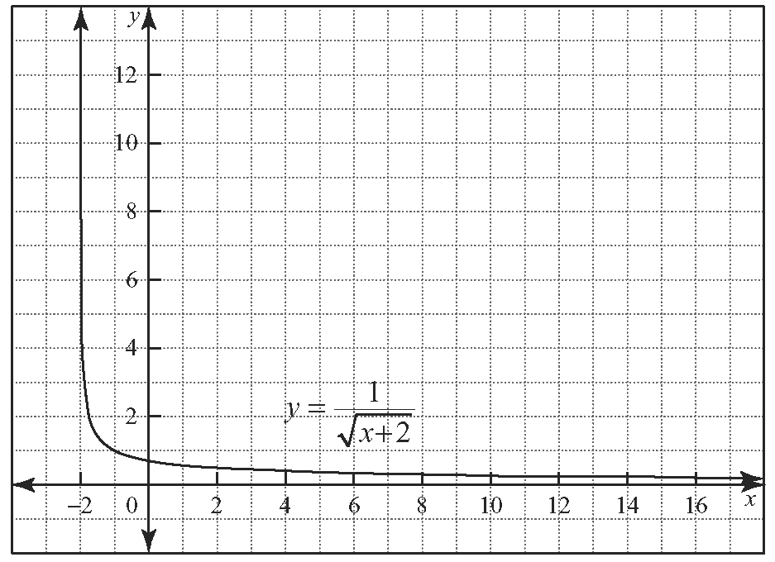
a) State the domain and range of the function.
b) Explain why x ≠ −2.
c) What is the line x = −2 called?

1.3 Maximum or Minimum of a Quadratic Function

6. Use partial factoring to locate the vertex. State if the vertex is a minimum or a maximum.
a) y = −x² + 4x + 11
b) y = 3x² − 18x + 14
c) y = 5x² + 14x − 21
d) y = −2x² − 11x + 1

7. A commercial airplane uses fuel at a rate, R, in litres per hour, given by the function
R (v) = , where v is the aircraft’s speed, in kilometres per hour.
a) At what speed is the airplane operating at the minimum rate of fuel consumption?
b) What is the minimum rate of consumption?
c) At this speed, how many litres of fuel will the plane use for a 1700-km flight?

1.4 Skills You Need: Working With Radicals

8. Simplify.
a)
b)
c)
d)

9. Find the simplified expression for the area of the given shape.
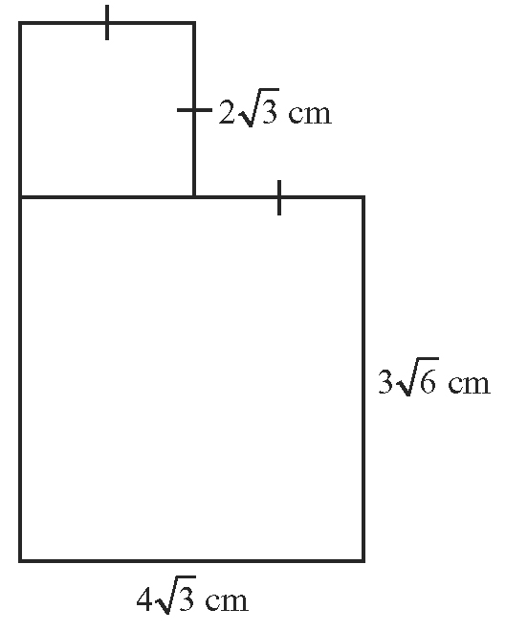

1.5 Solving Quadratic Equations

10. Solve the following equations by the indicated method.
a) 12x² + 52x − 40 = 0; factoring
b) –3x + 12x + 5 = 0; completing the square
c) 2x² + 4x − 5 = 0; quadratic formula

11. What value(s) of k will allow the equation
x² + kx = 10 to be solved by factoring?

12. The flight of a soccer ball can be approximated using the equation h(t) = 25t − 5t², where h is the ball’s height, in metres, and t is the time, in seconds, after the ball is kicked.
a) Determine the total length of time the soccer ball will be in the air.
b) When does the ball reach its maximum height?
c) What is the maximum height?
1.6 Determine a Quadratic Equation Given Its Roots

13. Jakob tells his friend Alex that for the relation
y = ax² + bx + c, the values for a and b do not have any effect on the y-intercept of the function. Is Jakob correct? Explain why or why not.

14. A quadratic function has roots of and passes through the point (1, −9). Find the equation of the function.

1.7 Solve Linear-Quadratic Systems

15. Determine the points of intersection of the line
y = −2x + 3 with the quadratic function
y = 2x² + 4x − 5.

16. For what y-intercept will the line y = 2x + b intersect the curve y = at one point?

17. Use Technology Verify the solution to
question 16 using a graphing calculator.

