For questions 1 to 5, select the best answer.

1. A horizontal line test can be used to determine
if a relation is a function.
A sometimes true
B always true
C never true
D depends on the function

2. The domain of the function y = −5x² + 4 is
A
B
C
D

3. The vertex of y = −2x² − 4x − 5 is
A (−4, −5)
B (−1, −3)
C (4, −5)
D (1, −3)

4. For the function f (x) = 2x² − 5x + 1, if f (a) = 4, what is the value of a?
A 4
B 3
C −3
D −4

5. The curve y = 3x² – 4x + 8 and the line y = 3x + 5 intersect at
A no point
B one point
C two points
D not enough information given to determine

6. Sketch a relation that
a) is not a function with
domain and
range
b) is a function with domain and
range

7. State the domain and range of each function.
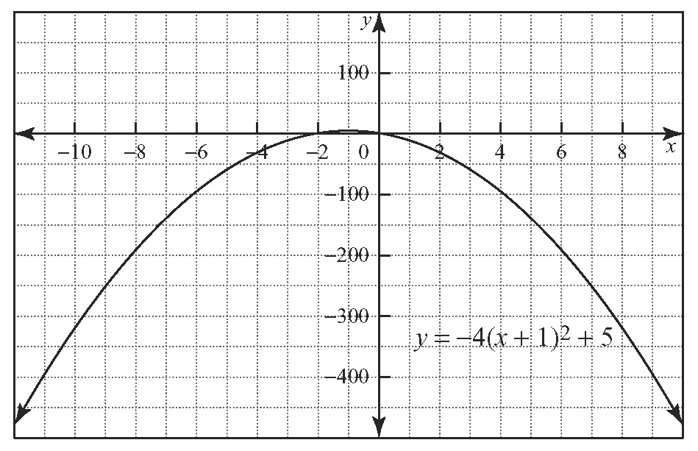
a)

b) | x | y
 | −1 | 10
 | 0 | 13
 | 1 | 14
 | 2 | 13
 | 3 | 10
 | 4 | 5

8. a) Find the vertex of the parabola defined by
f (x) = .
b) Is the vertex a minimum or a maximum?
c) Without finding them, how many x-intercepts does the parabola have? Explain.

9. The cost C, in dollars, to drive a car from
Toronto to North Bay is given by the function
C(v) = 0.04v² − 4v + 176, where v represents the average driving speed, in kilometres per hour.
a) Sketch the graph of C(v) for 20 ≤ v ≤ 100.
b) What average speed, will minimize the cost of the trip?
c) What is the minimum cost?

10. A ticket for the local play cost $11 last year, with a total of 400 tickets sold. This year, the theatre company plans to increase ticket sales to increase revenue. Studies show that for every $1 increase in ticket price, the company can expect to sell 20 fewer tickets.
a) What ticket price will maximize revenue?
b) What is the maximum revenue?

11. Two numbers have a difference of 8. Find the two numbers if their product is to be a minimum.

12. Determine the exact values of the x-intercepts of each quadratic function.
a) f (x) = 2x² − 9x − 1
b) g (x) = −3x² + 4x + 2

13. A quadratic function has zeros of 3 and 7
and has maximum value of 8. Determine
the equation of the quadratic function in factored form and in standard form.

14. Expand and simplify where possible.
a)
b)
c)

15. The diagonal of a square is 17 m. What is the exact length of each side?

16. Solve each quadratic equation.
a) 3x² − 15x = 42
b) 5x² + 11x + 1 = 0
17. A square garden is to be placed inside a square courtyard that has a side length of 40 m. What length should the sides of the garden be, so that the remaining courtyard is three times the area of the garden?

18. Determine the equation in standard form of a quadratic function with x-intercepts of 8 and −2, passing through the point (4, 48).

19. A banner is hung such that the ends are attached to the ceiling of the school cafeteria, 10 m apart. The centre of the banner hangs down 3 m. Determine the equation, in standard form, of a wire in the shape of a parabola used to support the top edge of the banner. Use the ceiling as the
x-axis and the line that would pass through the minimum point as the y-axis.

20. Determine the points of intersection of the quadratic function y = −2x² − 4x − 1 and the line
y = 2x − 9.

21. For what y-intercept will the line y = −x + b be tangent to the function y = 2x² + 3x − 5?

