2.1 Functions and Equivalent Algebraic
Expressions

1. Simplify each expression and state all restrictions on x.
a)
b)

2. Are the functions g(x) and h(x) equivalent in each pair?
a) g(x) =3(x − 1)(x + 4) − (x + 3)(x − 2)
and h(x) = 2(x² + 4x − 3)
b) g(x) = −2(x − 1)(x + 1) + 3(x − 2)(x + 2)
and h(x) = (x − 5)(x + 5)

2.2 Skills You Need: Operations With Rational Expressions

3. Simplify each expression.
a)
b)
c)

4. Simplify each expression.
a)
b)
c)

5. When two lenses are arranged so that they contact each other, their focal lengths combine to create a new focal length, f, according to the formula , where a represents the focal length of one lens and b represents the focal length of the other.
a) If two lenses each with a focal length of
100 mm are combined, what is the resulting focal length?
b) If lens a is replaced with a lens that has a focal length of x mm less than lens a, by how much does the overall focal length change?

2.3 Horizontal and Vertical Translations of Functions

6. Refer to the graph of f (x). Determine the image of the points under the indicated translations.
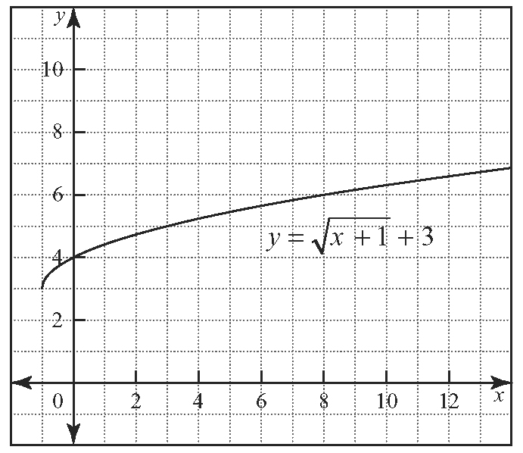
a) a(3) = f (3) + 4
b) b(4) = f (8) − 3
c) c(0) = f (3) + 1
d) d(−1) = f (0) − 8

7. Find the equation of the function g(x) for the base function f (x) = –2(x – 1)² + 3 under the indicated translations.
a) g(x) = f (x − 5)
b) g(x) = f (x) + 2
c) g(x) = f (x − 2) + 1
d) g(x) = f (x + 1) − 3

2.4 Reflections of Functions

8. Graph the function and its indicated reflection on the same axes.
a) f (x) = 3(x − 2)² + 1 and its reflection in the
x-axis
b) g(x) = and its reflection in the y-axis
c) h(x) = and its reflection in the x-axis
and y-axis

9. For the graphs in question 8, determine the equation of each reflection.

2.5 Stretches of Functions

10. For each function g(x), describe the transformation from a base function of
f (x) = x², f (x) = , or f (x) = . Then, transform the graph of the base function to sketch the graph of g(x).
a) g(x) = 3x²
b) g(x) =
c) g(x) =
d) g(x) =

11. While the time needed for two objects of different masses dropped from the same height to reach the ground is the same, the force with which they hit differs. The equation for this force is F = ma, where F represents the force
in Newtons, m represents the mass in kilograms, and a represents the acceleration due to gravity.
a) Using the acceleration due to gravity of
9.8 m/s², graph the function of force (on the
y-axis) versus mass (on the x-axis).
b) Explain the role of 9.8 in this equation.
c) How does the function change if the object accelerates at of the acceleration due to gravity?
d) Graph the function from part c) on the same set of axes as you used in part a).

2.6 Combinations of Transformations

12. Describe the transformations that must be applied to f (x) to obtain the function g(x) in each of the following.
a) g(x) = 3f [2(x − 1)] − 2
b) g(x) =

13. For the function f (x) = x² and
g(x) = −2f [3(x – 4)] + 6,
a) Determine the exact equation for g(x).
b) Simplify the equation for g(x) algebraically and express it in vertex form.
c) Describe the transformations that must be applied to f (x) to create the graph of g(x).
d) Create a graph of both f (x) and g(x) on the same set of axes.

2.7 Inverse of a Function

14. Determine the equation of the inverse for the given functions.
a) f (x) = x + 3
b) f (x) =
c) f (x) = x² + 4x + 4
d) f (x) =

15. The measure, A in degrees, of each interior angle of a regular polygon is given by
A(n) = , where n represents the number of sides of the polygon.
a) Determine the measure of the interior angle of a regular octagon.
b) Find the inverse of the function A(n).
c) Use the inverse function to find the type of regular polygon that has an interior angle measuring 144°.

