Exponent Rules

1. Describe each exponent rule and give an example.
a) Product rule
b) Quotient rule
c) Power rule

2. Simplify.
a) (x⁶)(x⁴) b) (y³)(y⁷)(y⁹)
c) m⁵ ÷ m⁴ d) h⁶ ÷ h⁸
e) f )
g) h)
i) j)

3. Evaluate.
a) 3² × 3³ b)
c) d)
e) f )
g) h)

Zero and Negative Exponents

4. Consider the function y = 3^{x}.
a) Copy and complete the table of values.
x | y
4 | 3⁴ = 81
3
2
1
0
b) Describe the pattern that exists in the y-values.
c) Extend the chart to include negative values from −1 to −3.
d) Explain how this extension can be used to explain the meaning of negative exponents.

5. Simplify. Express answers with positive exponents.
a) (−2)⁰ b) 3^{–3}
c) −4⁰ d) 4⁻⁵ × 4²
e) f ) (−2)⁻³
g) 3⁻² × 2⁻³ h) 6⁻¹ × 6⁰

6. Simplify each expression. Leave all answers with positive exponents.
a) b)
c) d)

Graph Functions

7. For the graph shown, state the
i) domain
ii) range
iii) x- and y-intercepts
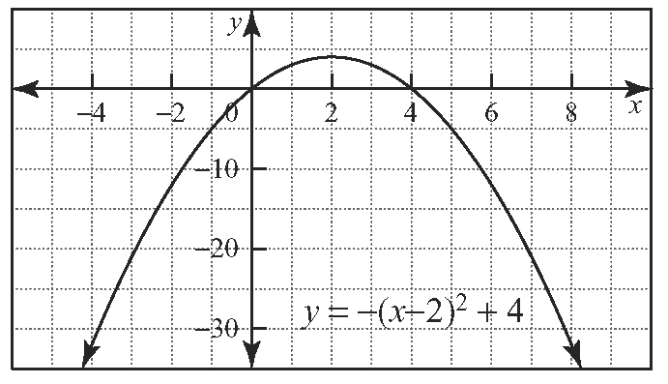

8. Sketch each function. Then, identify the
i) domain
ii) range
iii) x- and y-intercepts (if they exist)
a)
b)

Transformations of Functions

9. Graph each function by applying transformations to the base function y = x².
a) y = 2x² b) y = (x + 3)² − 1
c) y = −x² + 1 d) y = −(x + 5)² + 2

