1. Match each equation with its corresponding graph.
a) y = 2(3)^{x} b)
c) d)
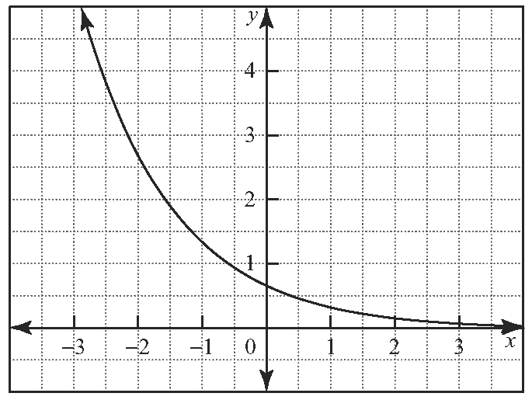
i)

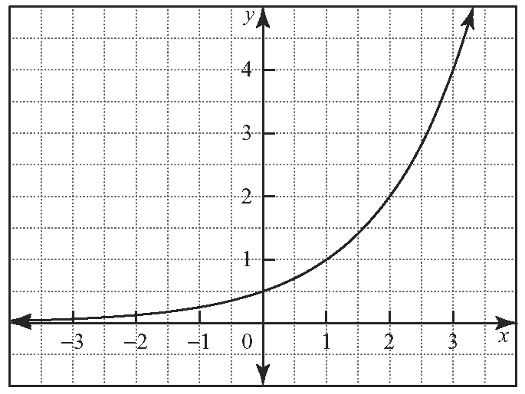
ii)

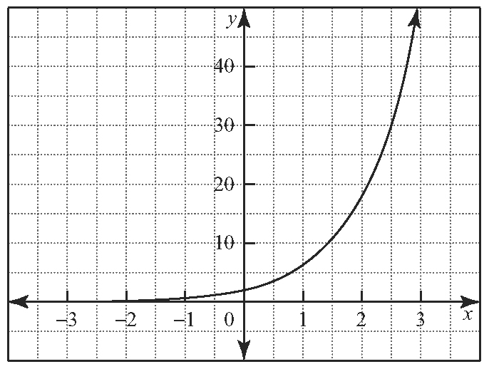
iii)

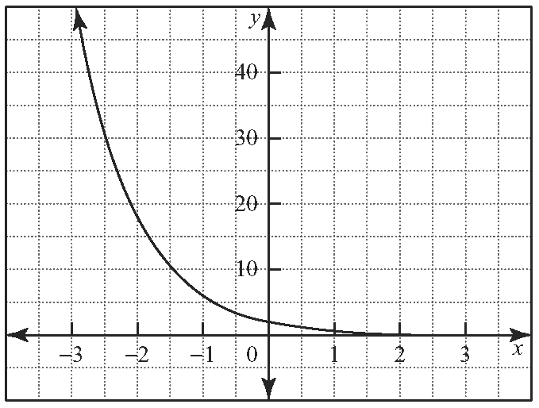
iv)

2. Simon and his parents agree to the following allowance system: At the end of week 1, he is to be paid 1 cent. At the end of week 2, he is to be paid
2 cents. At the end of week 3, he is to be paid
4 cents. The allowance is to continue to double at the end of each week for the next 4 months.
a) Model this allowance system with an equation that can be used to calculate the amount his allowance, A, in dollars, at the end of week x.
b) Use the equation in part a) to determine Simon’s allowance at the end of
i) week 4
ii) week 8
iii) week 16
c) Describe the effect on the value of the allowance if payments are based on a starting amount of
2 cents.

3. The graph illustrates the exponential growth in the value of an investment during a 10-year period.
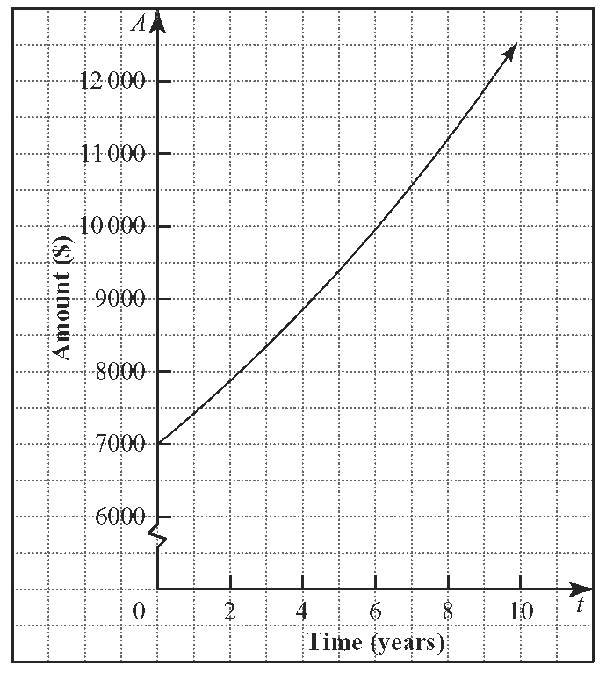
a) Estimate the values of a and b in A = a(b)^{t} for this function.
b) Explain the roles of a and b in this question as related to the investment.
c) Use the tool of your choice to determine the exponential model for this function.
d) Compare the result of this tool with your estimated function from part a).

4. The table shows the total amount of carbon dioxide (CO₂) emissions, in megatonnes (Mt), produced in Canada in selected years.
Year | CO₂ Emissions  (Mt)
1960 | 189
1965 | 254
1970 | 334
1975 | 381
1980 | 414
1985 | 385
1990 | 432
1995 | 452
2000 | 505
a) Modify the table of values to change each entry in the Year column to a relative year using 1960 as t = 0.
b) Plot the data using a scatter plot.
c) Use the tool of your choice to find an exponential function of the form y = ab^{x} to model the data.
d) Plot this function on the same set of axes as the data and comment on the fit.
e) Use this function to determine the amount of CO₂ emissions, in megatonnes, expected to be produced in Canada in 2015.
f ) How accurate do you expect your answer to
part e) will be? Explain.

5. Gurpreet is evaluating employment offers from two companies. Company A offers a starting salary of $40 000 with a yearly increase of 3%. Company B offers a starting salary of $44 000 with a yearly increase of 2%.
a) Make a table of values for both offers for t = 0 to t = 10 years.
b) Graph the data from the table of values.
c) Use the graph to determine the time, t, in years, before the two jobs pay the same annual salary.
d) What is this amount?
e) Which company should Gurpreet choose if she plans to work for that company for
i) 5 years?
ii) 10 years?

6. The table shows the average annual income, in dollars, for full-time workers in Canada, by gender, from 1990 to 1999.
Year | Average Income ($)
Year | Female | Male
1990 | 29 050 | 42 913
1991 | 29 654 | 42 575
1992 | 30 903 | 42 984
1993 | 30 466 | 42 161
1994 | 30 274 | 43 362
1995 | 30 959 | 42 338
1996 | 30 606 | 41 897
1997 | 30 484 | 43 804
1998 | 32 553 | 45 070
1999 | 32 026 | 45 800
Source: Statistics Canada
a) Modify the table of values to change each entry in the Year column to a relative year using 1990 as t = 0.
b) Make a scatter plot for the data in this modified chart.
c) Use the tool of your choice to find an exponential function of the form y = ab^{x} to model the two sets of data.
d) Based on these functions, which average income is growing at a faster rate? Explain.
e) Plot the functions on the same set of axes as the data and comment on their fit.
f ) Use these functions to determine the average incomes, to the nearest dollar, expected in the year 2015.
g) How accurate do you expect your answer to
part e) will be? Explain.

