3.1 The Nature of Exponential Growth

1. A bacterial colony has an initial number of 1000 cells. The number of cells quadruples every hour. The model that represents this exponential
growth is
A N = 1000(2)^{t}
B N = 2(1000)^{t}
C N = 1000(4)^{t}
D N = 4(1000)^{t}

2. a) Make a table of values for the first seven terms of a pattern where an initial number of 25 items doubles every day. Use column headings for the number of items and time, in days.
b) Explain why the pattern in the table represents an exponential relationship.

3. Match each equation to its corresponding graph.
a) y = 20(2)^{x}
b)
c) y = 2(4)^{x}
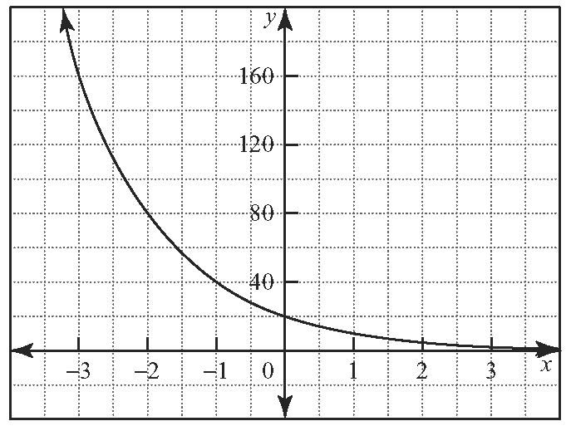
i)

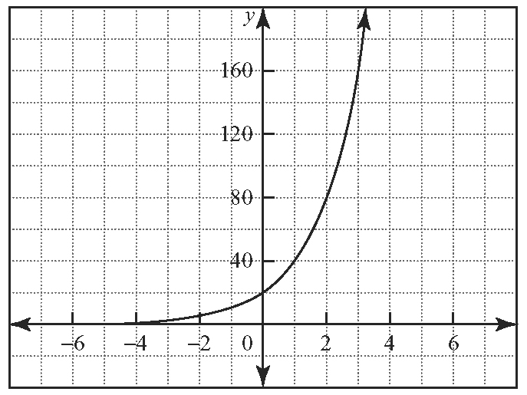
ii)

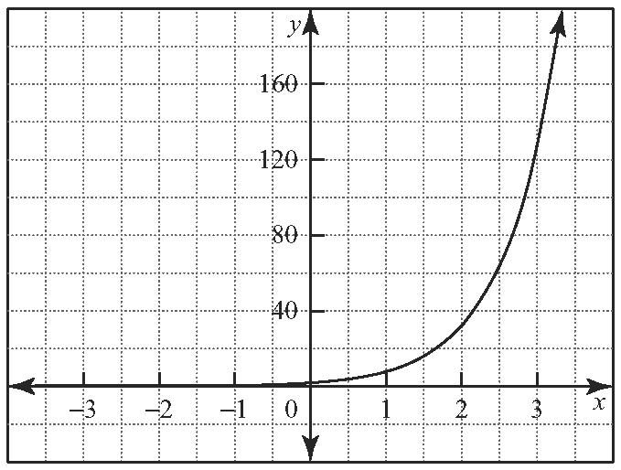
iii)

3.2 Exponential Decay: Connecting to Negative Exponents

4. Evaluate the following expressions.
a) 5⁻¹ b)
c) d)
e) f )

5. A radioactive material has a half-life of 10 days and an initial mass of 2000 mg.
a) Write the equation relating the mass of the radioactive material, m, in milligrams, to the time, t, in days.
b) Use this equation to determine the amount of radioactive material remaining after 40 days.
c) How long does it take for the amount of material remaining to be 7.8 mg?

6. a) Refer to question 5. Write the equation from part a) in a different form.
b) Explain how to illustrate that the two equations are equivalent.

7. Simplify. Express all answers using positive exponents.
a) b)
c) d)
3.3 Rational Exponents

8. Evaluate.
a) b)
c) d)

9. To calculate interest on investments, a financial institution uses the formula , where A represents the current amount, in dollars, of the investment; P represents the principal invested; i is the annual interest rate; N is the number of interest payments per year; and n is the number of years of the investment. How much is an investment of $10 000 worth at the end of
10 years if the investment earns interest at the
rate of
a) 6% per year compounded semi-annually?
b) 6% per year compounded monthly?
c) What do your answers to parts a) and b) indicate is the effect of increasing the number of times interest is paid on the final amount of an investment?

10. Refer to the formula question 9. If an investment of $5000 earns interest at the rate of 8% per year, compounded semi-annually, what is the value of the investment at the end of
a) 5 years?
b) 10 years?

3.4 Properties of Exponential Functions
11. Graph the function and identify the
a) domain
b) range
c) x- and y-intercepts (if they exist)
d) intervals of increase/decrease
e) equation of the asymptote

12. Write the equation of the exponential function in the graph shown.
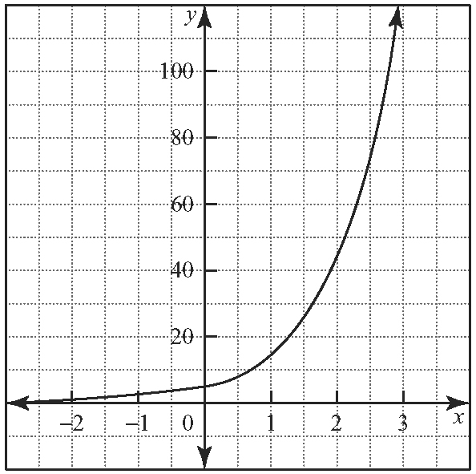

3.5 Transformations of Exponential Functions
13. Sketch the function and identify the
a) domain b) range
c) equation of the asymptote

14. Describe the transformation or series of transformations that must be applied to the base function y = 2 ^{x} to obtain each given function.
a) y = 5(2) ^{x − 1} b) y = 2^{x} + 4 c)
3.6 Making Connections: Tools and Strategies for Applying Exponential Models

15. The amount, in dollars, that an investment is worth at the end of each year is shown in the table.
Year | Amount ($)
0 | 25 000.00
1 | 27 500.00
2 | 30 250.00
3 | 33 275.00
4 | 36 602.50
5 | 40 262.75
a) Make a scatter plot of the data. Do the data appear to be exponential? Explain.
b) Find the equation of the exponential curve of best fit for the data and explain the meaning of the constants in the equation.
c) How much will the investment be worth at the end of 10 years?
d) How long will it take the investment to grow to $271 000?

