Classifying Triangles

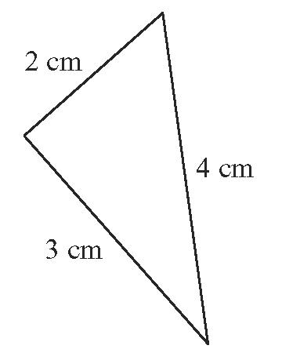
1. Classify each triangle by its sides.
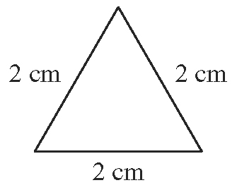
a) b)

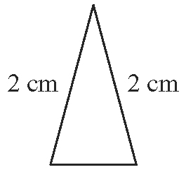
c)

Angle Sum of a Triangle

2. For each triangle, create a labelled sketch. Then, determine the indicated unknown value.
a) In ABC, ∠A = 20°, and ∠B = 50°. Determine the missing angle.
b) DEF is equilateral. Find the measures of all angles.
c) In GHI, HG = GI, and ∠H = 50°. Determine the measures of the other two angles.
d) JKL is isosceles and ∠L = 90°. Find the measure of the other two angles.

Use Similar Triangles

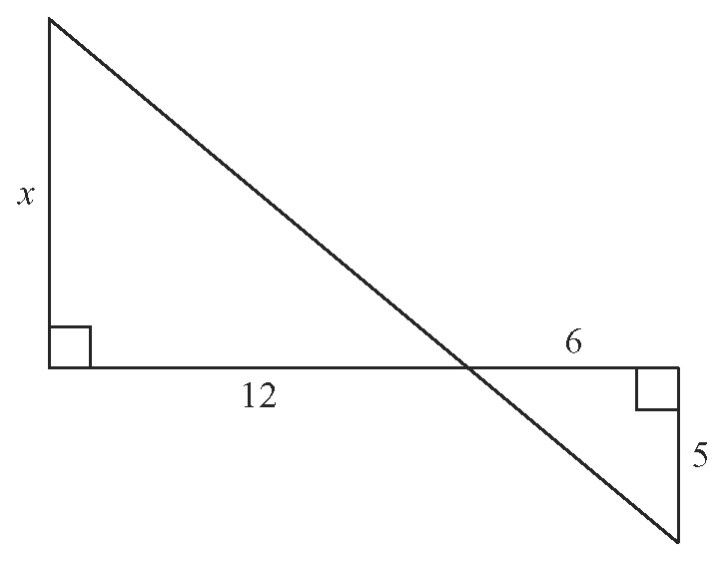
3. Use similar triangles to determine the unknown value in each figure.
a)

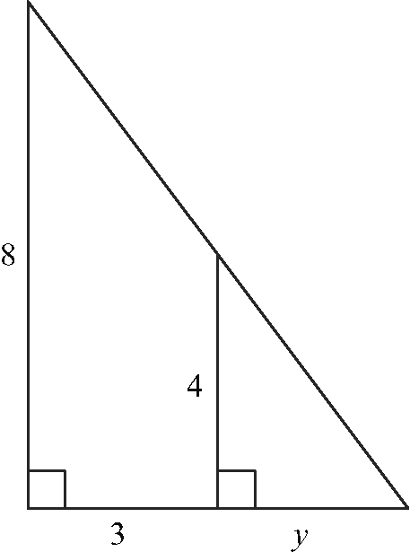
b)

Use the Pythagorean Theorem

4. Determine the measure of the unknown side in each triangle.
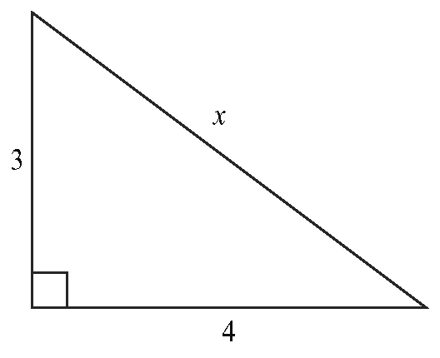
a)

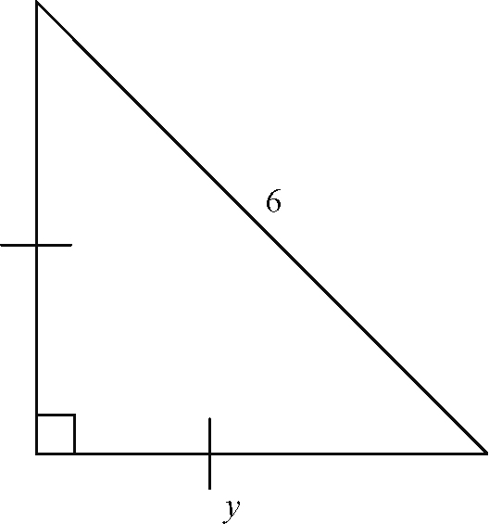
b)

Find Primary Trigonometric Ratios

5. For each triangle, determine the primary trigonometric ratios for ∠A and ∠C.
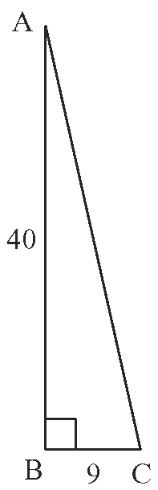
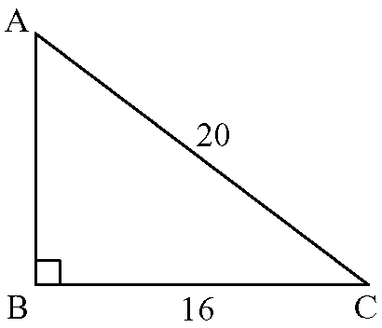
a) b)

6. Use a calculator. Find the value for the three primary trigonometric ratios for the given angles, to four decimal places.
a) 90° b) 180° c) 135°

Determine an Angle Given a Trigonometric Ratio

7. Find each angle measure, to the nearest degree.
a) cos A = 0.8314
b) sin B =
c) tan C =

Apply Trigonometric Ratios to Problems

8. In ABC, ∠B = 90°, ∠A = 60°, and b = 12 cm.
a) Sketch the triangle and mark all given measurements.
b) Determine the length of side AB.
c) Determine the measure of ∠C.
9. To build a secure roof truss (a structure that supports a roof), the angle that the truss makes with the horizontal should be no more than 45°. Richard is an architect who has just completed the plans for a new a house. Show that the roof trusses he has designed for the house will be secure.
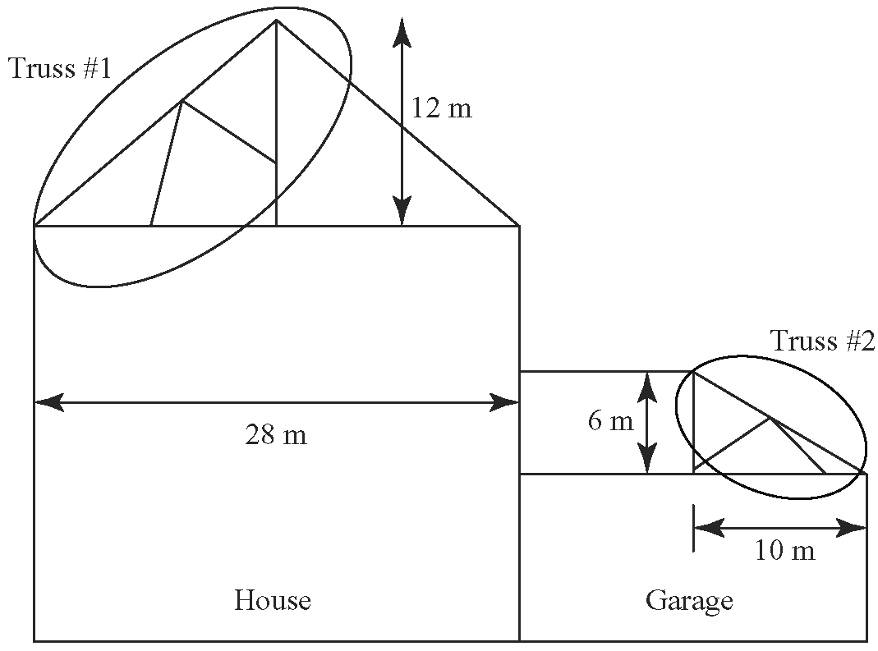

Apply the Sine Law and the Cosine Law

10. In ABC, ∠A = 85°, ∠B = 35°, and AC = 15 cm. Determine the length of side AB to the nearest centimetre.

11. Determine the length of side b.
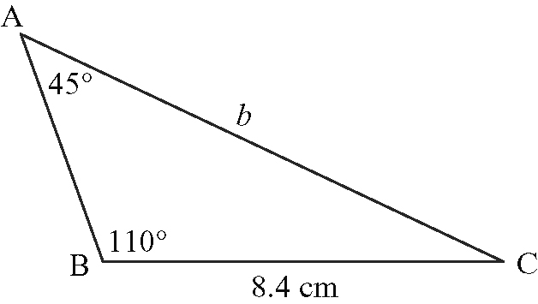
12. In DEF, d = 23.2 cm, f = 18.5 cm, and
∠D = 105.2°
a) Find the length of side DF.
b) Find the measure of ∠E and ∠F, to the nearest tenth of a degree.

13. You are given all side lengths in DEF. The question asks you to find the measure of ∠D. Which trigonometric tool would you use?

