4.1 Special Angles

1. Use a unit circle to determine the exact values for the primary trigonometric ratios for 225°. Check the results using a calculator.

2. A kite has a string that is 30 m long and makes an angle of elevation with the ground of 30°. The wind picks up and changes the angle of elevation to 60°. How much farther is the kite from the ground, to the nearest metre?

3. Two support wires are secured to the ground
12 m from the base of a main support of a circus tent. One wire makes an angle of 30° to the ground, and the other makes an angle of 45° to the ground. How much wire is needed, assuming an additional 2 m of wire is needed in total to secure all ends of the wires?

4.2 Co-terminal and Related Angles

4. One of the primary trigonometric ratios is given, as well as the quadrant in which the angle is located. Determine an exact expression for the other two primary trigonometric ratios.
a) sin A = second quadrant
b) cos B = third quadrant
c) tan C = fourth quadrant

5. Give two positive and one negative co-terminal angles for each of the following.
a) 120°
b) 225°

4.3 Reciprocal Trigonometric Ratios

6. For 0° ≤ x ≤ 360°, find two angles that have
a) a secant of −3
b) a cotangent of
c) a cosecant of 5

7. In STU, ∠T = 90°, t = 25 m, and s = 11 m. Determine exact expressions for the six trigonometric ratios for ∠S.

4.4 Problems in Two Dimensions

8. Jeremy has a new laser sight for golf that gives him the straight line distance to any object he points the sight at. From an elevated tee block, he uses the sight and finds that the straight line distance to the green is 378 m. He also determines that the angle of depression to the green is 52°. What is the height of the elevated tee block above the level of the green?

9. Brett owns a landscaping business. He went to the garden supply centre to buy edging for the perimeter of a triangular garden. When he got there, he realized he did not have all the measurements for the garden.
The triangular garden, ABC, has
∠A = 38°, c = 12 m, and a = 9 m.
a) Is there enough information to find the perimeter of the garden?
b) Find the perimeter of the garden (including a second possibility if one exists).

4.5 Problems in Three Dimensions

10. Consider this diagram.

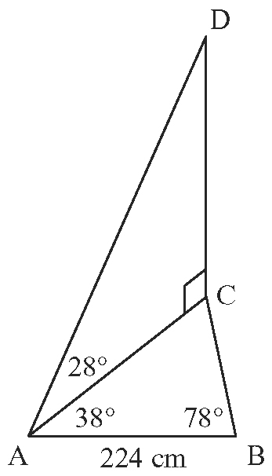

a) How many right triangles are there
in the diagram?
b) Determine the length of AC, to the nearest centimetre.
c) Determine the length of DC, to the nearest centimetre.

11. Raymond needs to determine the height of a bridge that is on the opposite side of a ravine. To do this, he measures 50 m along a line he labels as DE along the ravine. He then measures the angles from each side of this line to the base of a column support. From point D, the angle is 81° to the support column. From point E, the angle is 34° to the support column. He also determines that the angle of elevation to the top of the bridge directly above the support column from point E to be 22°. Determine the height of the bridge.
12. From the basket of a hot-air balloon that is 5 km in the air, Roxanna sees two small towns off in the distance. She measures the angle of depression to be 48° to one of the towns and the angle of depression to the other to be 45°. She estimates that if she were to land directly below her current position, the angle from one town to her position to the other town would be 120°. How far apart are the two towns in a straight line distance along the ground?

4.6 Trigonometric Identities

13. Rebecca has found that sin x = cos x when
x = 45°. She then states that this means
sin x = cos x is an identity. Is she correct? Explain your answer.

14. Prove that .

