For questions 1 to 4, select the best answer.

1. An equivalent expression for is
A cos² x
B cot x
C tan x
D sin² x

2. A co-terminal angle for 240° is
A 60°
B −120°
C 120°
D two of the above are correct

3. For the cosine law to be used, the information needed is
A two sides and their contained angle
B two sides and a non-contained angle
C all angles
D one side and two angles

4. The ambiguous case occurs for a triangle when which set of information is given?
A two sides and their contained angle
B two sides and a non-contained angle
C all angles
D one side and two angles

5. Two kites are being flown by two children at a park. The first child is using 28 m of kite string and has her kite flying at an angle of 60° to the ground. The second child is using 22 m of kite string and his kite is flying at an angle of 45° to the ground.
a) Which kite string is casting the longer shadow on a sunny day when the sun is directly overhead?
b) Determine the length of the longer shadow.

6. ∠K is located in the third quadrant with a secant of −6. Find exact expressions for the other five trigonometric ratios for ∠K.

7. Find two angles for 0° ≤ x ≤ 360° with
a) a cosecant of 8
b) a secant of −3
c) a cotangent of

8. In ABC, ∠A = 28°, a = 12 cm, and b = 17 cm.
a) Determine two possible measures for ∠B.
b) Determine the two possible lengths for side c.

9. Sarah drives east for 45 min at 80 km/h, and then makes a 45° turn onto a dirt road, on which she drives for 30 min at 40 km/h.
a) Determine an exact expression for her distance travelled.
b) Use a calculator to determine the distance to the nearest kilometre.

10. Albert wishes to determine the height of a small mountain that is at the other end of a provincial park, so he takes the measurements shown. Determine the height of the mountain.
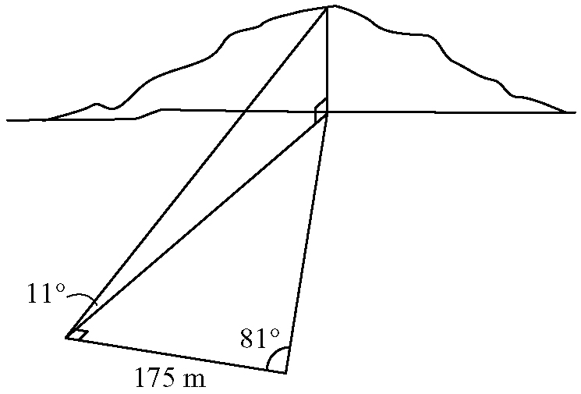

11. Prove that sin² θ − sin⁴ θ = cos² θ − cos⁴ θ.

12. Use reciprocal trigonometric ratios to prove that
1 + cot² x = csc² x is also an expression of the Pythagorean identity.

13. Prove that .

