Prerequisite Skills
1. a) equilateral b) scalene
c) isosceles
2. a) 110° b) 60°
c) ∠G = 80°, ∠I = 50° d) ∠J = 45°, ∠K = 45°
3. a) x = 10 cm b) y = 3
4. a) x = 5 b) y =
5. a) sin A = , cos A = , tan A = , sin C = ,
cos C = , tan C =
b) sin A = , cos A = , tan A = , sin C = ,
cos C = , tan C =
6. a) sin 90° = 1, cos 90° = 0, tan 90° is undefined
b) sin 180° = 0, cos 180° = −1, tan 180° = 0
c) sin 135° = 0.7071, cos 135° = −0.7071, tan 135° = −1
7. a) 34° b) 42° c) 60°
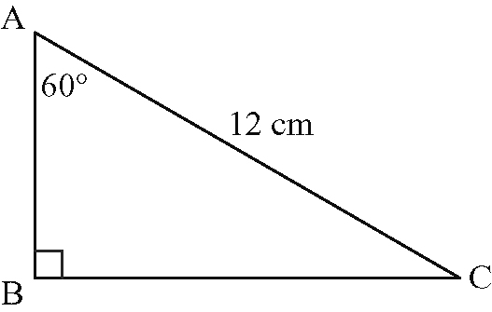
8. a)

b) 6 cm c) 30°
9. House truss angle = 41°, garage truss angle = 31°
10. 23 cm
11. 11.0 cm
12. a) 10 cm b) ∠E = 25°, ∠F = 50°
13. The cosine law.

4.1 Special Angles
1. a) 45°
b) sin 225° = , cos 225° = , tan 225° = 1
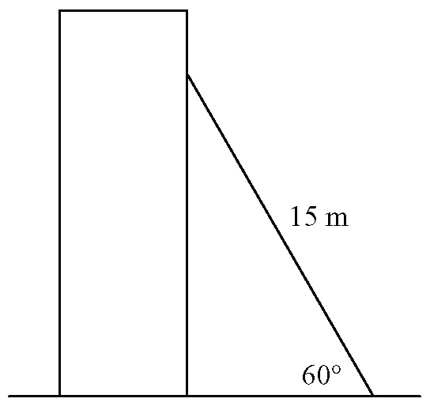
2. a) b) m

3. m
4. a) m b) 3.2 m

5. a) 21.2 km
b) 21.2 km; checked using the Pythagorean theorem
6. a)
θ | sin θ | Quadrant | Sign
60° | 0.8660 | first | positive
120° | 0.8660 | second | positive
240° | –0.8660 | third | negative
300° | –0.8660 | fourth | negative
b) The signs are as expected.
c)
θ | cos θ | Quadrant | Sign
30° | 0.8660 | first | positive
150° | –0.8660 | second | negative
210° | –0.8660 | third | negative
330° | 0.8660 | fourth | positive
d) The signs are as expected.
7. a) 55.73 m b) 3.87 m
c) Answers may vary. Sample answer: These two lengths are related to the length of the shortest side by the Pythagorean theorem.
8. a) 7.5 m b) 10.6 m c) 20.5 m

4.2 Co-terminal and Related Angles
1. a) sin θ = , cos θ = , tan θ = 3
b) sin θ = , cos θ = , tan θ =
c) sin θ = , cos θ = , tan θ =
d) sin θ = , cos θ = , tan θ =
2. a) sin θ = , cos θ = , tan θ =
b) sin θ = , cos θ = , tan θ =
c) sin θ = , cos θ = , tan θ =
d) sin θ = , cos θ = , tan θ =
3. a) cos A = , tan A =
b) sin B = , tan B =
c) sin C = , cos C =
d) sin D = , cos D =
4. Answers may vary. Sample answers:
a) sin 120°, cos 30° b) cos 130°, cos 590°
c) tan 20°, tan 560° d) sin 30°, cos 60°
5. Answers may vary. Sample answer: 510°, 870°
6. a)
b) sin θ = , cos θ = , tan θ =
7. a) the first and fourth quadrants
b) first quadrant: (12, 35); fourth quadrant: (12, −35)
c) fourth quadrant
d) sin F = , tan F =

4.3 Reciprocal Trigonometric Ratios
1. a) A = 8° b) B = 65° c) C = 47°
2. sin θ = , cos θ = , tan θ = , csc θ = ,
sec θ = , cot θ =
3. 45°, 315°
4. Answers may vary. Sample answer: Since the sine ratio is positive in the second quadrant, the cosecant cannot be negative.
5. a) 19°, 161° b) 166°, 346° c) 120°, 240°
6. sin B = , cos B = , tan B = , csc B = ,
sec B = , cot B =
7. a) cos B = b) k > 2

4.4 Problems in Two Dimensions
1. 10 m
2. m
3. m
4. m

5. Answers may vary. Sample answer: The ambiguous case occurs when two possible triangles can be drawn for the given information.
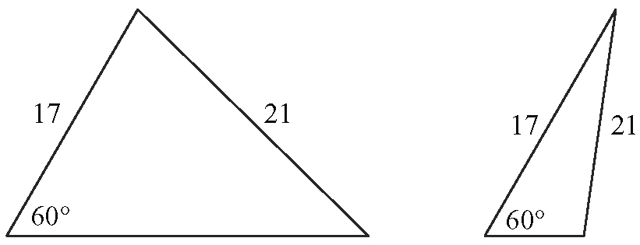
6. km
7. 112 m
8. a) 23.8 cm
b) Answers may vary. Sample answer: The side must be at least 23.8 cm long to complete the triangle. This creates a right triangle. If the side is any longer, then the ambiguous case may exist. Any shorter, and the side does not complete the triangle.

4.5 Problems in Three Dimensions

1. a) Adrian's route b) 15.1 s faster
2. 1.4 km
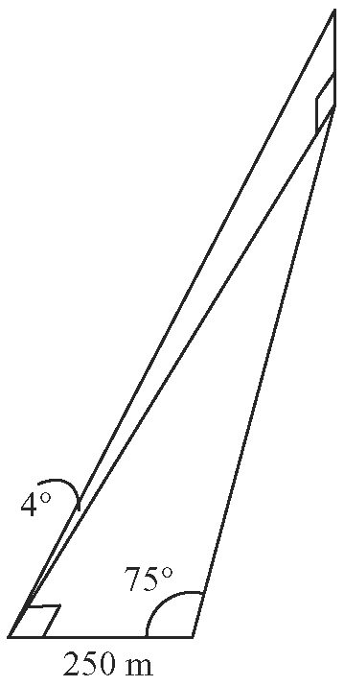
3. a) b) 933 m
c) 65 m

b) 290 m
c) 148 m
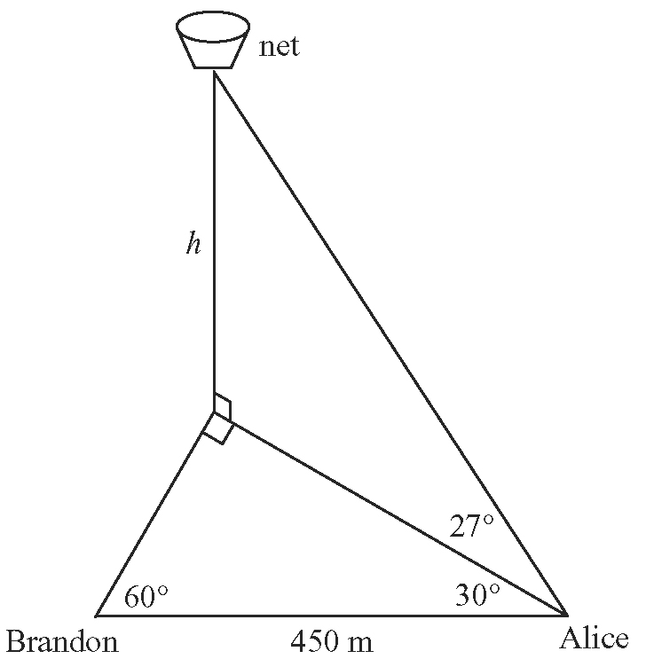
4. a)

5. 2.5 m
6. 1.6°

4.6 Trigonometric Identities
d) Answers may vary. Sample answer: Showing that an equation is true for specific values of the variable is not a proof. If there is any value of the variable for which the equation is not valid, then the equation is not an identity. An identity must be true for all allowable values of the variable.
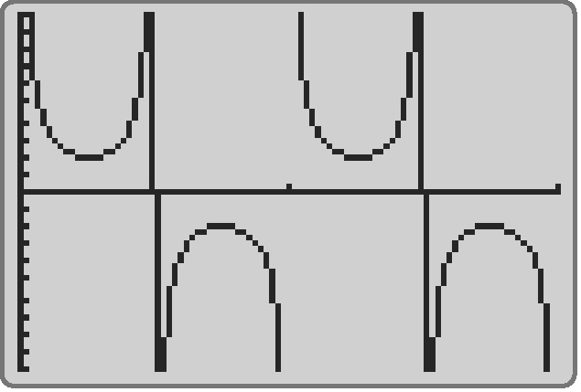
5. a)

b)

c) Answers may vary. Sample answer: The two graphs overlap for all values in the given interval.
d) Answers may vary. Sample answer: No, this does not constitute a proof. Not all values of the variable were tested, only values from 0° to 360°.
Both expressions equal the same value so
tan x + cot x = sec x csc x is an identify.
7. Answers may vary. Sample answer: No, this is not a valid proof. He moved expressions from one side to the other, which is not allowed. A correct proof must leave all terms on their original sides and the two sides must be shown to be equal.

Chapter 4 Review
1. sin 225° = , cos 225° = , tan 225° = 1
2. 11 m
3. 33 m
4. a) cos A = , tan A =
b) sin B = , tan B =
c) sin C = , cos C =
5. a) −240°, 480°, 840° b) −135°, 585°, 945°
6. a) 109°, 251° b) 104°, 284° c) 12°, 168°
7. sin S = , cos S = , tan S = , csc S = ,
sec S = , cot S =
8. 289 m
9. a) Answers may vary. Sample answer: There is not enough information to determine the exact triangle, because the information given creates the ambiguous case for a triangle.
b) 25.3 m, 35.6 m
10. a) one b) 244 cm c) 139 cm
11. 22 m
12. 7.8 km
13. Answers may vary. Sample answer: No, she is not correct, because she has only found a value that makes the expression true. A counterexample such as x = 30° shows that the expression is not always equal, and therefore is not an identity.

Chapter 4 Practice Test
1. C 2. B 3. A 4. B
5. a) the kite with 28 m of kite string and a 60° angle to the ground
b) 16.17 m
6. sin K = cos K = tan K =
csc K = cot K =
7. a) 7°, 173° b) 109°, 251° c) 143°, 323°
8. a) 42°, 138° b) 24 cm, 6 cm
9. a) km b) 75 km
10. 215 m

