1. Jason is playing a simple video game. The paddle controlled by the player is moved so that it hits a ball against a wall, and then the ball returns for the player to once again make contact with the paddle. Explain how Jason can take advantage of a periodic motion to take a break from the game to go and get a snack, without stopping the game.

2. Identify which of the following graphs are periodic. For the graphs that are periodic, determine the period of the function.
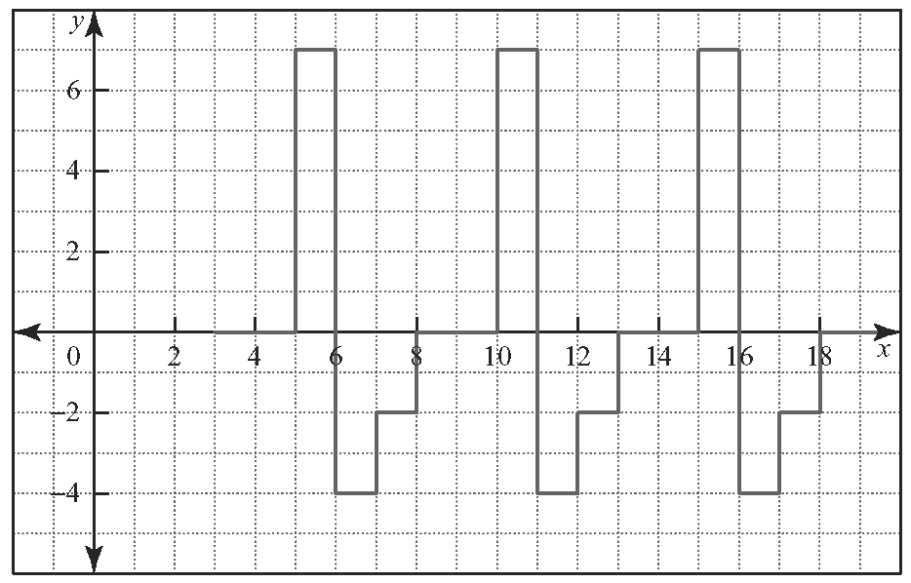
a)

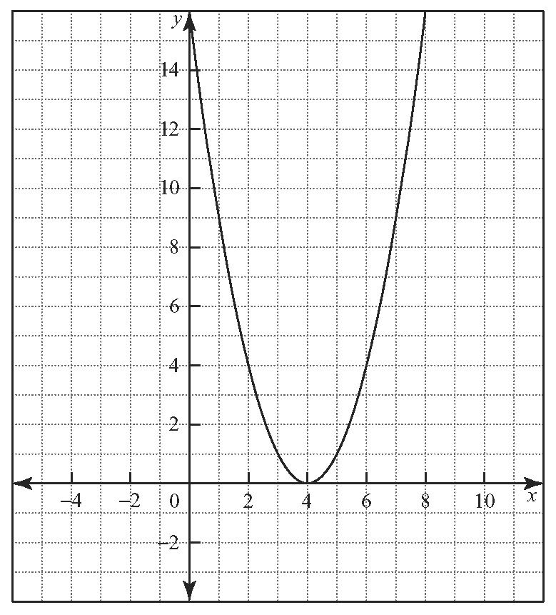
b)

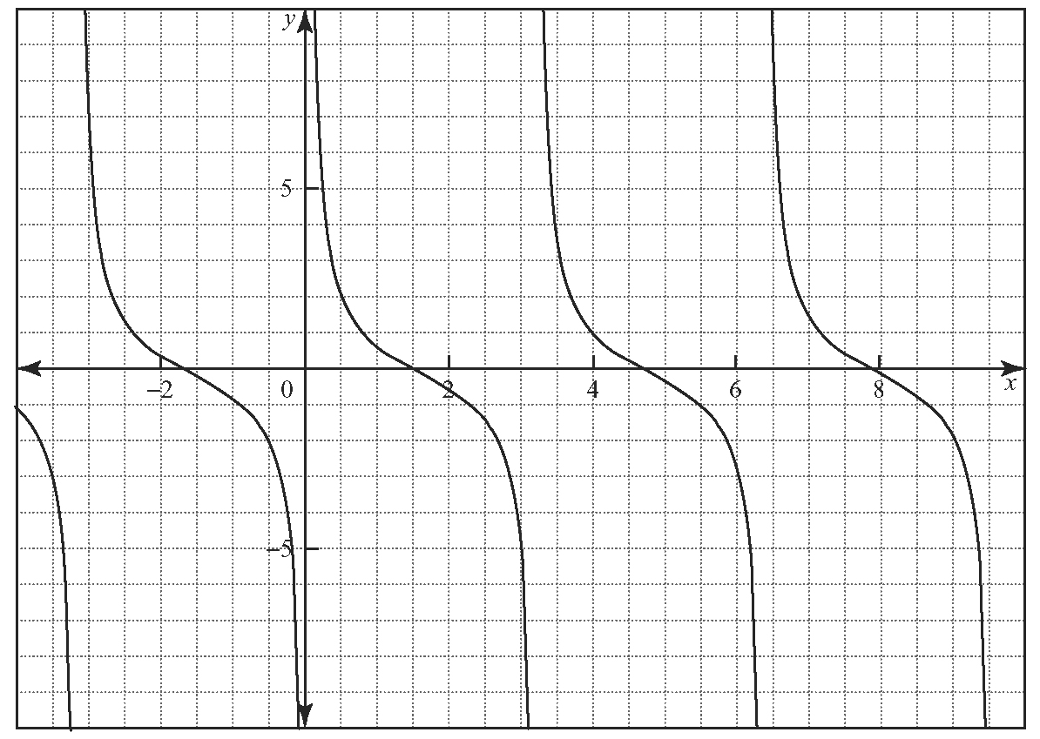
c)

3. a) Sketch the graph of a periodic function f (x) with a minimum value of 3, a maximum value of 11, and a period of 4.
b) Determine the value of this function at
x = 1.
c) Determine two other values of x where the function has the same value as in part b).

4. Erin is studying a graph and finds that f (25) = f (1). She also notices that there are a total of three repeating patterns within these two points. What is the period of the function f (x)? Explain your answer.

5. Consider the function shown.
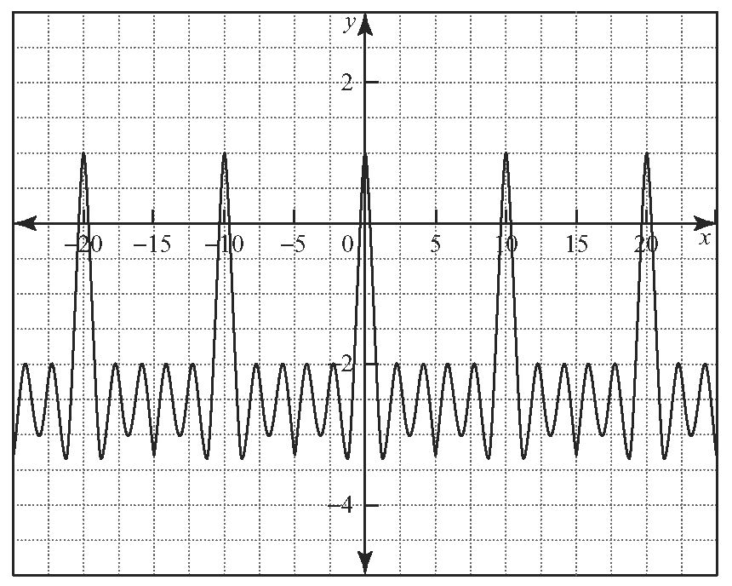
a) Determine the period of the function.
b) Determine the minimum value of the function.
c) Determine the maximum value of the function.
d) Use your answers to parts b) and c) to find the amplitude of the function.
6. At the airport, an unclaimed piece of luggage keeps going around the luggage carousel. It takes 45 s to make a complete lap of the circular carousel, which has a radius of
4 m.
a) What value does the 45 s represent?
b) What does the value of 4 m represent?
c) What is the closest and farthest the piece of luggage would be to a person standing at the edge of the carousel?
d) Is the motion of the piece of luggage an example of period motion? Explain why or why not.
7. In her job at the assembly plant, Rosie puts three small parts together to form a larger piece that she then takes to a second area and attaches to the car that is being assembled. After that, she returns to the first bench to repeat the process. It takes her 20 s to put the three pieces together at the first bench, and
10 s to attach the larger piece to the car at the second area. She takes 15 s to walk each way between the two areas, which are 5 m apart.
a) Construct a graph of this periodic motion for three cycles.
b) How many cycles can she complete in an hour?
c) At this pace, how many times does she repeat this process in an 8-hour daily shift?
d) If she works 200 days a year, how many times does she perform this pattern per year?
e) If she plans to work at this job for 35 years, how many times will she repeat this process in this time?

