1. a) Describe the transformations that must be applied to the graph of the function
f (x) = cos x to obtain the graph of the function g (x) = 2 cos 2x − 2.
b) State the domain and range of f (x) and g (x).
c) Determine the equation of the function h(x) if h(x) is g(x) translated 45° to the left.

2. A sinusoidal function has an amplitude of
2 units, a phase shift of 30° to the right, a period of 120°, and is translated 3 units up.
a) Model this information using a sine function.
b) Model this information using a cosine function.

3. Consider the function
f (x) = 5 sin [2(x − 30°)] − 5.
a) Determine the period, amplitude, phase shift, and vertical shift with respect to the function y = sin x.
b) What are the maximum and minimum values of f (x)?
c) Determine the first three x-intercepts to the right of the origin.
d) Use the first x-intercept to the right of the origin and the period of the function to find the first x-intercept to the left of the origin.
e) Determine the y-intercept of the function.

4. Consider the function
f (x) = 10 sin [3(x + 60°)] − 4.
a) Describe each step in the transformation from the function g(x) = sin x.
b) State the domain and the range of f (x)
and g(x).
c) Create a graph showing both f (x) and g (x) for 0° to 360°.

5. Consider the graph shown.
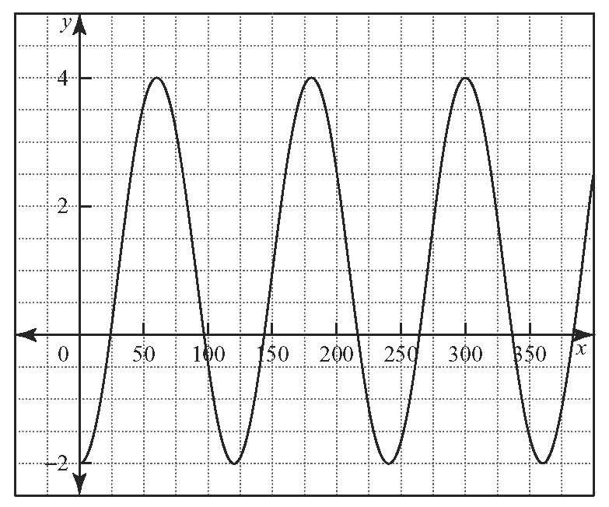
a) Determine the equation of a sine function that matches the graph.
b) Determine a cosine function that matches the graph.

6. a) Sketch the graph of y = cos x over two cycles.
b) Use the graph from part a) to sketch the function.
c) Use your graph from part b) to sketch the graph of .

7. Determine the domain and range of each graph in question 6.

