5.1 Modelling Periodic Behaviour

1. Explain why a programmable thermostat would cause the temperature in your home to follow a periodic function every week.

2. Consider the graph shown.
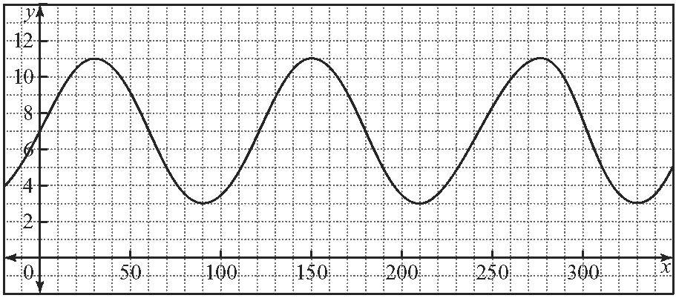
a) What is the period of the function?
b) What is the minimum value?
c) What is the maximum?
d) What is the amplitude?
e) Determine the equation of the function.

5.2 The Sine Function and the Cosine Function

3. When a car is approaching you with its windows down and the music very loud, the music often sounds distorted. It becomes more distorted the faster the car is travelling. What property of the sound wave do you think is being affected by the motion of the car? How is this property being affected?

4. Without using technology, sketch a graph of the sine function for values of x from −270° to 810°.

5.3 Investigate Transformations of Sine and Cosine Functions

5. Consider the function y = 2 sin [2(x + 30°)] − 2.
a) What is the amplitude?
b) What is the period?
c) Determine the phase shift.
d) Determine the vertical shift.
e) Graph the function for values of x from 0° to 360°.
f) What would be the effect on the function if the phase shift were to double?

5.4 Graphing and Modelling With
y = a sin[k(x − d)] + c and
y = a cos[k(x − d)] + c

6. A function has an amplitude of 12, a period of 90°, is translated 15° to the right and is moved up 8 units.
a) Use this information to write an equation using a sine function.
b) Determine an equivalent cosine function to the sine function in a).
c) Use technology to graph the functions from a) and b) to check your answer. Explain how this will check your answer.

7. A function that was developed to model the height of the tide at a small costal village is
h = 6 cos [30(t − 2)] + 8. The height is measured on a pole that is placed out in the bay. Here h is in metres and t is in hours after midnight.
a) State the period, amplitude, phase shift and vertical shift of the function.
b) What is the water level at low tide?
c) What is the water level at high tide?
d) State the domain and range for the function.
e) What would be the effect on this function if the measuring pole were to be moved further out into the water? Explain.

5.5 Data Collecting and Modelling

8. Calls received per hour by a technology help line are recorded.
Time | Calls
5 to 6 a.m. | 25
6 to 7 a.m. | 12
7 to 8 a.m. | 13
8 to 9 a.m. | 24
9 to 10 a.m. | 38
10 to 11 a.m. | 37
11 to 12 a.m. | 25
12 to 1 p.m. | 11
1 to 2 p.m. | 13
2 to 3 p.m. | 24
3 to 4 p.m. | 39
a) Add a column to express the times as a scale value. Use t = 0 for the hour of 5 to 6, t = 1 for the hour of 6 to 7, and so on.
b) Display the data on a scatter plot.
c) Construct a model of the data using a cosine function.
d) Display the function and the data on the same axes. Comment on the fit of the curve to the data.
e) Use your model to predict the number of calls expected from 9 to 10 p.m.
5.6 Using Sinusoidal Functions to Model Periodic Phenomena Not Involving Angles

9. A pebble is imbedded into the tread of a truck tire which has a radius 35 cm. As the truck moves through a distance of d metres, the height of the pebble above the road is given by the equation
h = −35 .
a) From what height above the road does the pebble start?
b) How far has the truck travelled once the pebble returns to a height of zero?
c) Determine a second method of finding this distance.
d) What is the height of the pebble when the truck has travelled 165 m?

