For questions 1 to 8, select the best answer.

1. The graph of the cosine function is the same as the graph of the sine function translated
A 90° to the right
B 90° to the left
C 180° to the right
D 180° to the left

2. Which of the following is not an example of something periodic?
A the tides
B average monthly temperature at the North Pole
C the value of the dollar
D the rotation of Earth

3. The maximum value of the function
y = sin x − 6 is
A 1
B −5
C −6
D 5

4. The period of the function shown is approximately
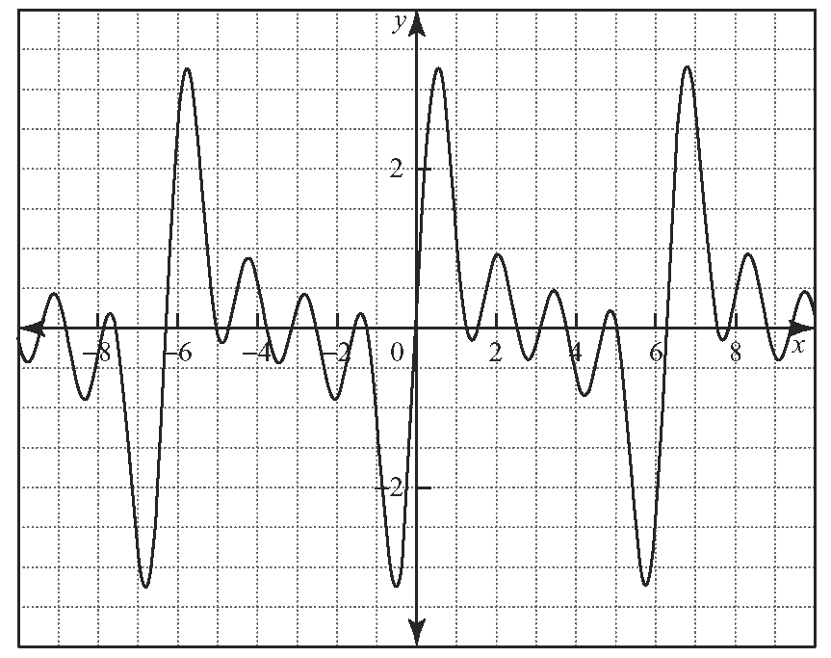
A 8
B 6
C 4
D 2

5. Determine how many x-intercepts the function
y = 3 cos x + 5 has from 0° to 360°.
A 0
B 2
C 4
D 6

6. For the function y = 30 cos[2(x + 15°)] − 60, the phase shift is
A 30° to the right
B 15° to the left
C 15° to the right
D 60° to the right

7. For the function f (x) = 12 cos x + 30, the value of f (30) is
A 40
B 30
C 36
D 12

8. The minimum value of the function is
A
B
C
D 0

9. Give three examples of items associated with the motion of Earth that are periodic. Explain why each is periodic.

10. Consider the function y = 4 cos [3(x − 60°)] + 1.
a) What is the amplitude of the function?
b) What is the period?
c) Determine the phase shift.
d) Determine the vertical shift.
e) Write the equation as a sine function.

11. A sinusoidal function has an amplitude of
4 units, a period of 180°, and a maximum
point at (0, 9).
a) Represent this information as a cosine function.
b) Create a graph of this function over two cycles.

12. Consider the function .
a) Determine the amplitude.
b) Determine the period.
c) State the phase shift.
d) State the vertical shift.
e) Determine the minimum and maximum values of the function.
f ) State the domain and range.

13. Monthly ice cream sales at an ice cream shop
are recorded in the following table, where t = 0 represents the month of January.
Month | Sales (in thousands  of dollars)
0 | 310
1 | 340
2 | 418
3 | 525
4 | 633
5 | 711
6 | 740
7 | 713
8 | 633
9 | 525
10 | 415
11 | 340
a) Create a scatter plot of the data.
b) Use the graph to create a sine function that models the information.
c) Display the data and the sine function on the same set of axes.
d) Comment on the fit of the function.

14. The minute hand of a clock has a length of
1.5 cm.
a) Using the centre of the clock face as the reference point, model the motion with
h representing the horizontal displacement and t representing time in minutes.
b) Using the 12 as the reference point, model the motion with v representing the vertical displacement and t representing time in minutes.
c) Graph both functions on the same set of axes for three cycles.

