6.1 Sequences as Discrete Functions

1. Describe the pattern and write the next three terms.
a)
b) 3, 4, 4, 4, 5, 4, 6, 4, …
c) 11, −16, 21, −26, …
d)

2. Determine the explicit formula for the nth term of each sequence. Use each formula to find t₁₀.
a) 3, 7, 11, 15, 19, …
b)
c)
d) 1, 4, 9, 16, 25, 36, …

6.2 Recursive Procedures

3. Write the first four terms for each recursion formula.
a)
b)
c)
d)

4. On her 10th birthday, Rukan’s parents invested $2000 into an educational saving plan that pays 5% per year. On each birthday after her 10th
(up to her 18th birthday), they invest $2000 more into the savings plan. Let A represent the amount in the investment after each deposit is made on her birthday.
a) Show that the sequence for n = 10 to n = 18 is given by the recursion formula
.
b) Use this formula to find A₁₈.
c) How much of this total is interest and how much is money her parents invested?

6.3 Pascal’s Triangle and Expanding Binomial Powers

5. A fountain of bowls is set up such that water pours into the top level, and when it fills, it overflows into the other bowls below, as shown.
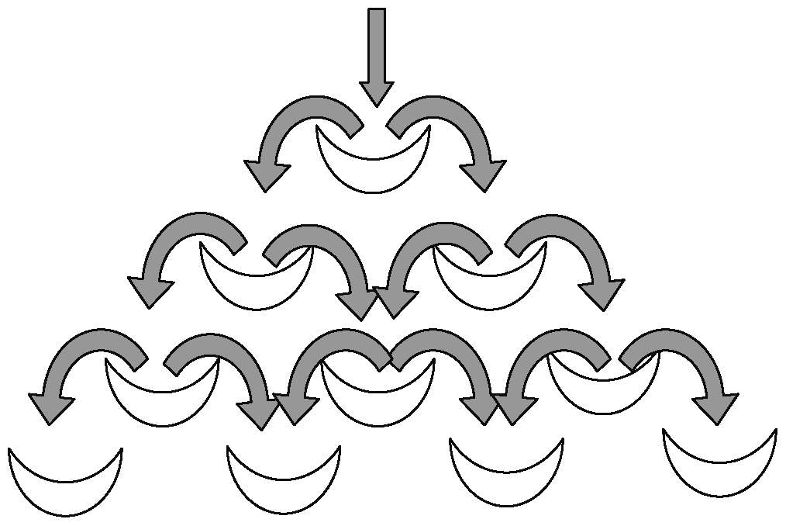
a) Trace all of the possible paths that the water can take to get to each bowl in the fountain. Write this number in an array that looks like the bowl set-up in the fountain.
b) Describe how this relates to Pascal’s triangle.

6. What row of Pascal’s triangle has each row sum?
a) 32 b) 512
c) 128 d) 32768

6.4 Arithmetic Sequences

7. Determine the number of terms in each arithmetic sequence.
a) 4, 10, 16, 22, … , 112
b) 9, 7, 5, 3, … , −75
c) 6, 9, 12, 15, … , 72
d)

8. A company offers a new employee a starting annual salary of $32 000 and a $1600 raise each year. What will this employee’s salary be after
a) 8 years?
b) 13 years?
c) 25 years?
9. In an effort to increase memberships at a tennis club, the organization offers the following. Anyone interested in joining is asked to come to a meeting, where their names are placed in a hat. The first 10 people picked will have to pay $200 to join. The next 10 people picked will have to pay $190. If the cost continues to drop by $10 for each group of 10 picked, how much would it cost the 75th person picked to join?

6.5 Geometric Sequences

10. Are the following sequences geometric? Explain.
a) Camera shutter speeds in seconds:
b) Frequency of A notes on a piano, in hertz: 27.5, 55, 110, 220, 440, 880, 1760

11. In a geometric sequence, t₁ = 3 and t₇ = 192.
a) Find a and r.
b) Explain why there are two possible values
of a.
c) Write the first five terms in the sequence.

12. For the sequence 3, 12, 48, 192, …
a) Find the ninth term.
b) Which term has a value of 12 288?

6.6 Arithmetic Series

13. Consider the sequence 4, 7, 10, 13, 16, 19, … .
a) Determine the 14th term in the sequence.
b) Find the sum of the first
i) 10 terms
ii) 14 terms
c) What is the sum of the series if the last term
is 82?

14. Jason started a lawn cutting business for the
10 weeks of summer. In his first week, he earned $80. Each week after the first, his earnings grew by $10 per week. How much did he make over the 10 weeks of summer?

15. The sum of the first 9 terms of an arithmetic series is 144, and the sum of the first 14 terms
is 329. Find the first 4 terms of the series.

6.7 Geometric Series

16. Consider the series 3 − 9 + 27 − 81 + … .
a) Find the sum of the first
i) 5 terms
ii) 11 terms
b) Use your answers from part a) to determine the sum of the 6th term to the 11th term.

17. An employee is paid $3600 for the first month. She is paid an additional 1% at the end of the second month, which means a total of $3636. She continues to receive a 1% raise each month for a full year. What is her total salary at the end of the year?

18. The sum of the first two terms of a geometric series is 4. The sum of the first four terms of the same series is 40. Determine the first five terms of the series.

