Prerequisite Skills

1. a) 32, 64, 128 b) 17, 19, 23
c) g, H, i d) x⁵y⁴, x⁴y⁵, x³y⁶
2. a) −15 b) 12t + 13 c) −4 d) 8m − 15
3. a) 19 b) −1 c) d) 8x⁴ − 2x² − 2
4. a) 5 b) c) d) 3(4)^{k} + 2
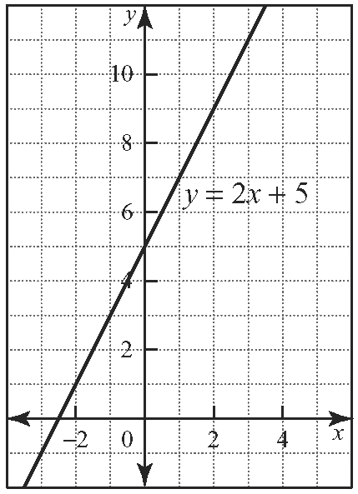
5. a)

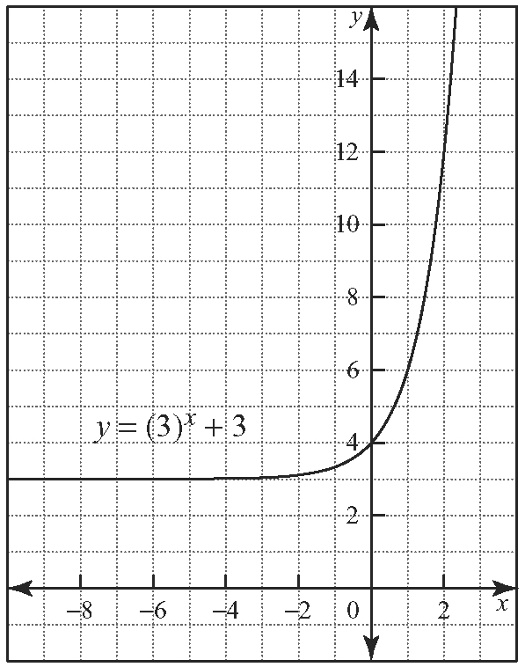
b)

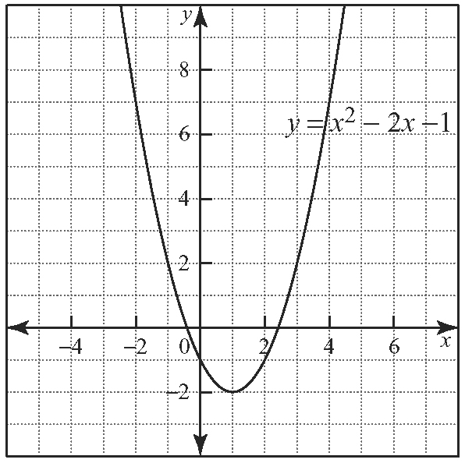
c)

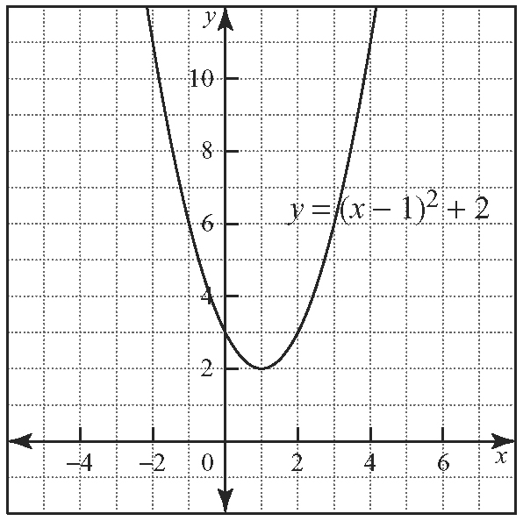
d)

6. a) −11 b) −2 c) 4 d) 24
7. a) 33.6 b) 7.29 c) 36 d) 0.18
8. a) b) c) d) 42
9. a)
x | y | First Differences | Second Differences
−3 | 44 | First Differences | Second Differences
−3 | 44 | −20 | Second Differences
−2 | 24 | −20 | 6
−2 | 24 | −14 | 6
−1 | 10 | −14 | 6
−1 | 10 | −8 | 6
0 | 2 | −8 | 6
0 | 2 | −2 | 6
1 | 0 | −2 | 6
1 | 0 | 4 | 6
2 | 4 | 4
quadratic
b)
x | y | First Differences | Second Differences
−1 |  | First Differences | Second Differences
−1 |  | −0.5 | Second Differences
0 | 4 | −0.5 | −0.5
0 | 4 | −1 | −0.5
1 | 3 | −1 | −1
1 | 3 | −2 | −1
2 | 1 | −2 | −2
2 | 1 | −4 | −2
3 | −3 | −4 | −4
3 | −3 | −8 | −4
4 | −11 | −8
neither
10. a) 6
b) Answers may vary. Sample answer: The coefficient of the x²-term multiplied by 2 gives the constant second difference.
c) −8
d) Answers may vary. Sample answer:
x | y | First Differences | Second Differences
1 | −5 | First Differences | Second Differences
1 | −5 | −14 | Second Differences
2 | −19 | −14 | −8
2 | −19 | −22 | −8
3 | −41 | −22 | −8
3 | −41 | −30 | −8
4 | −71 | −30 | −8
4 | −71 | −38 | −8
5 | −109 | −38 | −8
5 | −109 | −46 | −8
6 | −155 | −46
11. a) (1, −2) b) (−3, −4) c) (4, 15)

Exploring Patterns and Sequences

1. T, F, S (initials of days of the week, starting at Sunday)
2. 256, 289, 324 (squares of numbers, starting at 12)
3. T, D, R (musical notes, starting at Do)
4. −5, 0, −7 (increase by 5, decrease by 7, starting at 3)
5.
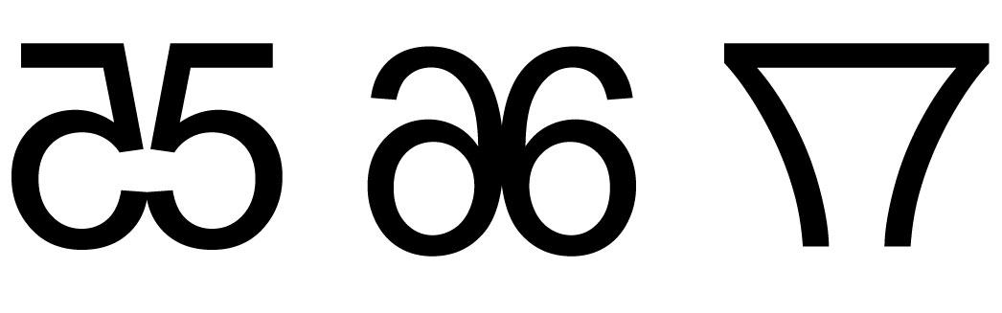
6.

(numbers with their mirror images)

6.1 Sequences as Discrete Functions

1. a) t_{n} = 2^{n} b) t_{n} = −3n + 4
2. Answers may vary. Sample answers:
a) The terms start at −2 and increase by 2. The next three terms are 8, 10, 12.
b) The starting two terms are 1 and 2, and the next term is the addition of the two terms before the term of interest. The next three terms are 21, 34, 55.
c) The first term is , and the terms increase by a factor
of 3. The next three terms are 9, 27, 81.
d) The first term is 3, and the terms increase by a factor
of . The next three terms are.
3. a) yes; is a multiple of 6
b) no; is not a multiple of 6
c) no; is not a multiple of 6
d) yes; is a multiple of 6
4. a)
Year | Value ($)
0 | 8000
1 | 6800
2 | 5780
3 | 4913
4 | 4176.05
5 | 3549.64
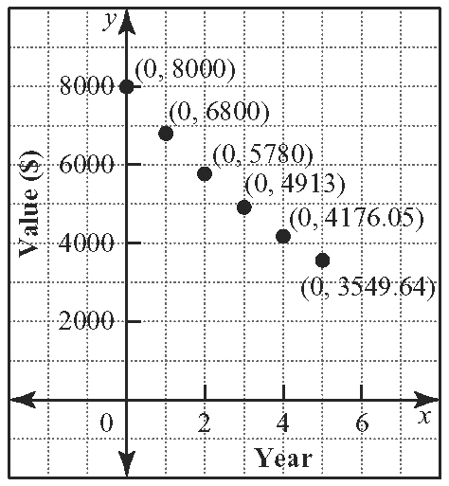
b)

c) Answers may vary. Sample answer: This trend will not continue because at some point the car will break down and cost too much to repair when compared to the value of the car at the time the repair is needed.
5. a) t_{n} = 3n b) t_{n} = 2n + 1 c) t_{n} = d) t_{n} =
6. a) i) 24 ii) 48 iii) 72 b) i) 17 ii) 33 iii) 49
c) i) ii) iii) d) i) ii) iii)
7. a) 100, 120, 144, 173 b) i) 249 ii) 516 iii) 743
c) week 14
8. a) 125, 160, 195, 230 b) t_{n} = 35n + 90
c) i) 335 ii) 440 d) 15 weeks

6.2 Recursive Procedures

1. a) 11, 13, 15, 17 b) 729, 243, 81, 27
c) −2, −4, −7, −12 d) 1, 2, 2, 4
2. a) t₁ = 4, t_{n} = t_{n − 1} + 3 b) t₁ = 3, t_{n} = t_{n − 1} + 2n + 1
c) t₁ = 1, t_{n} = t_{n − 1} + 2n − 5 d) t₁ = 2, t_{n} = t_{n − 1} + n²
3. a) $5000, $5300, $5618, $5955.08, $6312.38, $6691.13, $7092.60, $7518.15
b) t₁ = $5000, t_{n} = 1.06 × t_{n − 1}
c) $9491.49
4. a) 256, 16, 4, 2 b) 2, 3, 6, 18
c) 2, 4, −2, −14 d) 0, 1, ,
5. a) 1, 2, 6, 24, 120
b) 1!: 1 × 1, 2!: 2 × 1 = 2, 3!: 3 × 2 × 1 = 6,
4!: 4 × 3 × 2 × 1 = 24, 5!: 5 × 4 × 3 × 2 × 1 = 120
6. a) 3, 10, 38, 150 b) t₁ = 3, t_{n} = 4t_{n − 1} − 2
c)
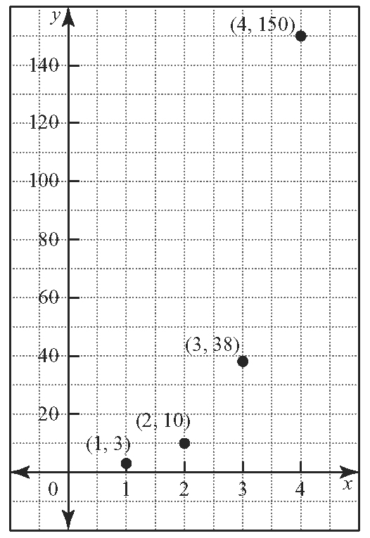

7. a) 1, 2, 4, 8, 16, 32, … b) t₁ = 1, t_{n} = 2 × t_{n − 1}
c) Answers may vary. Sample answer: This represents discrete data, since the number of people that are told is a natural number.

6.3 Pascal’s Triangle and Expanding Binomial Powers

1. a) x³ + 12x² + 48x + 64 b) 1 − 8x + 24x² − 32x³ + 16x⁴
c) 9x² + 6xy + y²
d) x⁵ − 25x⁴ + 250x³ − 1250x² + 3125x − 3125
2. a) 32 b) 1024 c) 8192
3. a) 7 b) 12 c) 16 d) 13
4. a) 256 b) 8 c) 5 d) 3
5. 3
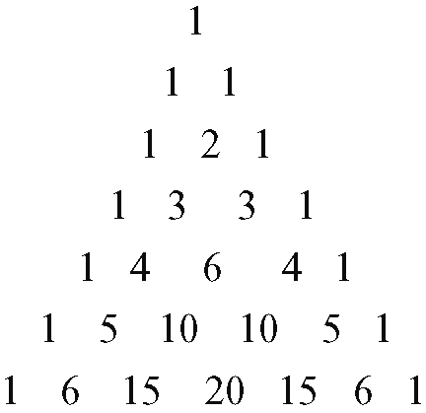
6. a)

b) t₁ = 1, t_{n} = t_{n − 1} + n c) 21, 28, 36
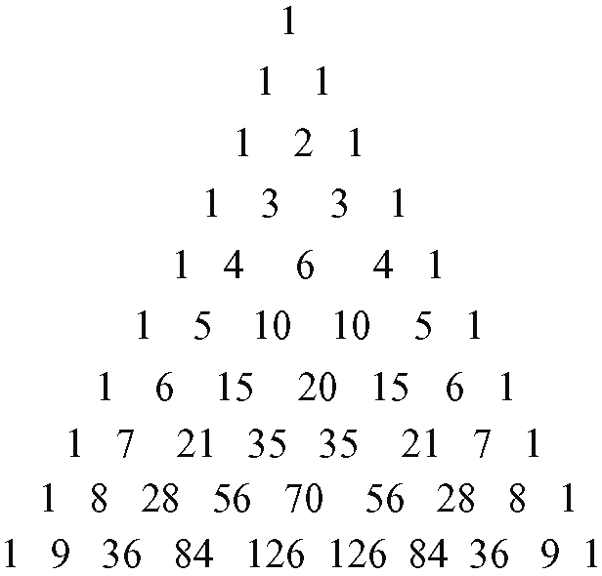
d)

7. a)
Row | Sum
0 | 1
1 | 0
2 | 0
3 | 0
4 | 0
5 | 0
6 | 0
b) 0
c) row 11: 1 − 11 + 55 − 165 + 330 − 466 + 466 − 330 + 165 − 55 + 11 − 1 = 0
8. S₁ = 1, which is equal to 2¹ − 1
S₂ = 3, which is equal to 2² − 1
S₃ = 7, which is equal to 2³ − 1
S₄ = 15, which is equal to 2⁴ − 1

6.4 Arithmetic Sequences

1. a) t_{n} = 3 − n b) t_{n} = −1 − 3n
c) t_{n} = −9 + 2n d) t_{n} = 9 + 4n
2. a) i) t₂ = −7 ii) t₁₀ = −15 iii) t₁₄ = −19
b) i) t₂ = 4 ii) t₁₀ = −36 iii) t₁₄ = −56
c) i) t₂ = 6 ii) t₁₀ = 62 iii) t₁₄ = 90
d) i) t₂ = 29 ii) t₁₀ = 61 iii) t₁₄ = 77
3. a) 26 b) 51 c) 43
4. a) 26 b) 44 c) 100 d) 61
5. Answers may vary. Sample answer: For the sequence 5, 10, 15, 20, 25, … , a = 5 and d = 5, which means that the sequence is arithmetic.
6. a) a = 6, d = −2 b) a = 6, d = 5
c) a = −9, d = 2 d) a = −41, d = −2
7. a) t₁ = 6, t_{n} = t_{n − 1} − 2
b) t₁ = 6, t_{n} = t_{n − 1} + 5
c) t₁ = −9, t_{n} = t_{n − 1} + 2
d) t₁ = −34, t_{n} = t_{n − 1} − 3
8. 19 months
9. 9

6.5 Geometric Sequences
1. a) 4 b) −3 c) d)
2. a) 2, −6, 18, −54 b) 40, 20, 10, 5
c) , , 2, 8 d) −2, 10, −50, 250
3. a) 8 b) 10 c) 11 d) 8
4. a) geometric; a = 500 r = 0.25 b) neither
c) geometric; a = 7, r = 2 d) arithmetic; a = 11, d = 3
5. 10
6. 81
7. 409 600
8. a) a = 1600, r = 0.5 b)
c) i) 1000 mg ii) 15.625 mg iii) 62.5 mg
6.6 Arithmetic Series

1. a) 480 b) 75 c) −90 d) −225
2. a) 252 b) 4620 c) 1020 d) −400
3. 2077
4. a) 28, 25, 22, 19, 16 b) −10
5. −588
6. 207
7. a) n² + n b) n²
8. a) 306 b) 289

6.7 Geometric Series

1. a) 8188 b) −5.9065 c) 820 d) −341
2. a) 12 285 b) 19 682 c) 198.4375 d) 1066.601 563
3. 2, 10, 50, 250
4. 13 120
5. 62 m
6. $1.20
7. $659 840
8. 1.1068 × 10¹⁵ kg

Chapter 6 Review

1. Answers may vary. Sample answers:
a) The first term is 1, and each successive term is found by multiplying the previous term by .
b) The first term is 3, and each odd term after the first is obtained by adding 1 to the previous odd term. All even terms are the value 4.
c) The first term is 11. The absolute value of each term is increased by 5, then multiplied by (−1)^{n + 1}.
d) The first term is . In each successive term, the values in the numerator and denominator increase by 1.
2. a) t_{n} = 4n − 1, t₁₀ = 39 b)
c) d) t_{n} = n², t₁₀ = 100
3. a) 5, 10, 15, 20 b)
c) 1, 7, 11, 1 d) −3, 0, 9, 30
4. b) $22 053.13
c) $18 000 was invested; $4053.13 is interest
5. Answers may vary. Sample answers:
a) A diagram of the first four rows of Pascal’s triangle
b) The values in the arrangement are the values of the first four rows of Pascal’s triangle.
6. a) 5 b) 9 c) 7 d) 15
7. a) 19 b) 43 c) 23 d) 20
8. a) $44 800 b) $52 800 c) $72 000
9. $135
10. Answers may vary. Sample answers:
a) No, since the terms are not a constant multiple of each other as you move from term to term.
b) Yes, since to move from term to term, the frequency doubles
11. a) a = 3, r = ±2
b) Answers may vary. Sample answer: The sequence can alternate from positive to negative or be all positive and still have the same 1st and 7th terms.
c) 3, ±6, 12, ±24, 48
12. a) 196 608 b) seventh
13. a) 43 b) i) 175 ii) 329 c) 1161
14. $1250
15. 4, 7, 10, 13
16. a) i) 183 ii) 132 861 b) 132 678
17. $45 648
18. −2 + 6 − 18 + 54 − 162

Chapter 6 Practice Test

1. B 2. C 3. C 4. A 5. D
6. a) x⁴ + 16x³ + 96x² + 256x + 256
b) 27x³ − 54x² + 36x − 8
c) x⁶ + 6x⁵y + 15x⁴y² + 20x³y³ + 15x²y⁴ + 6xy⁵ + y⁶
d) x¹⁰ − 5x⁸ + 10x⁶ − 10x⁴ + 5x² − 1
7. Answers may vary.
8. a) 7, 17, 47, 137, 407 b) 11, 19, 29, 41, 55
c) 10, 12, 14, 16, 18 d), 1, 3, 9, 27
e) −6, −7, −8, −9, −10 f) 1, 2, , 4, 8
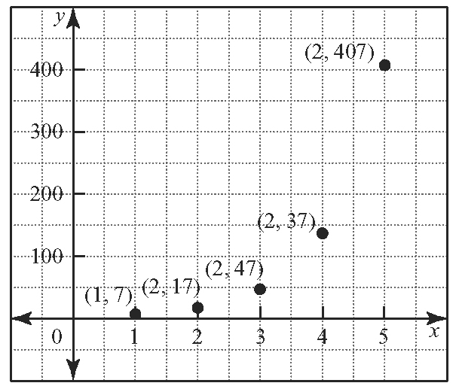
9. a) i)

ii) neither
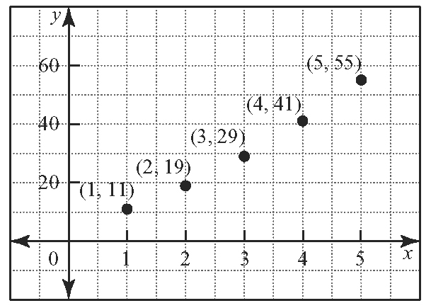
b) i)

ii) neither
c) i)
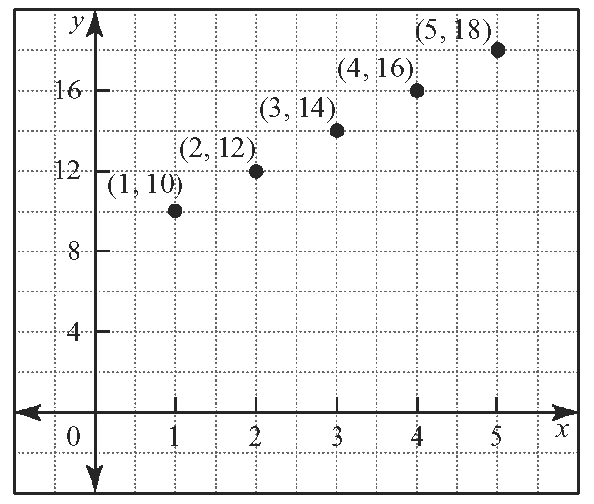

ii) arithmetic
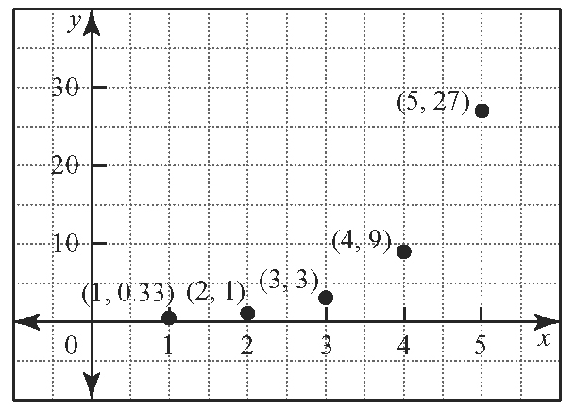
d) i)

ii) geometric
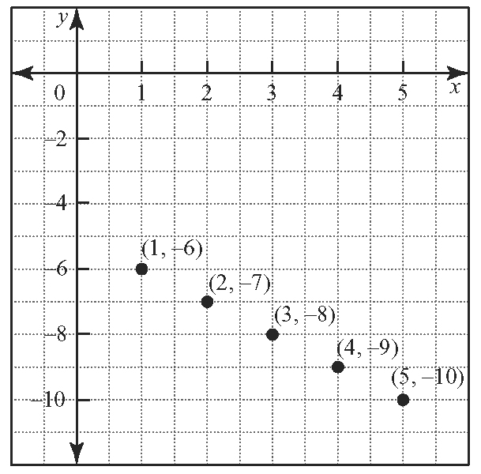
e) i)

ii) arithmetic
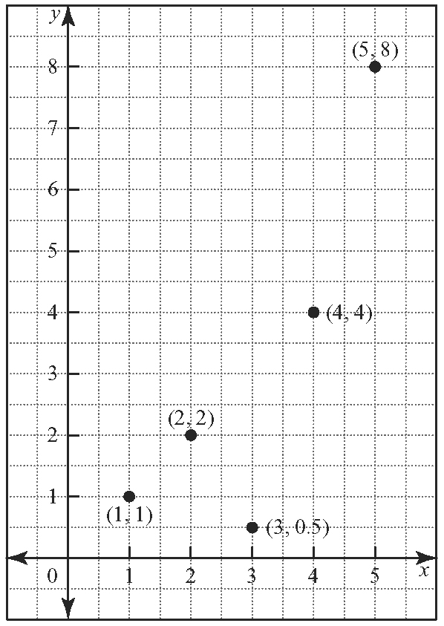
f) i)

ii) neither
10. a) 7 b) 10 c) 315 d) 9
11. a) 9 b) 2044
c) Answers may vary. Sample answer: Use the sum of a series formula to find the sum of the first 4 terms and then the sum of the first 8 terms. Then subtract the results.
12. Plan B; (Plan A: $1 100 000, Plan B: $10 737 418.23)
13. a) 16 383 b) 6120 c) 3069 d) −616
14. a) 13; 9; 5 b) −6; 0; 6 c) 7; 9; 13
15. a) 3; 192; 768 b) 320; −160; 80 c) 1000; 5062.5
16. 63
17. 1440
18. $55 847.82

