Examine each sequence of numbers, letters, or diagrams. Determine the next three terms in each sequence. There may be more than one solution for some of the sequences. Compare your solutions with those of your classmates and discuss the similarities and differences.

1. S, M, T, W, …

2. 144, 169, 196, 225, …

3. D, R, M, F, S, L, …

4. 3, 8, 1, 6, −1, 4, −3, 2, …

5. 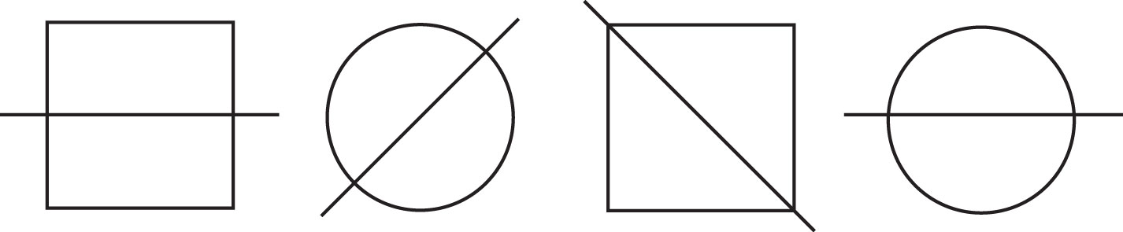

6. 